<https://www.youtube.com/watch?v=ZVFeW798-2I&list=PLblh5JKOoLUICTaGLRoHQDuF_7q2GfuJF&index=61>

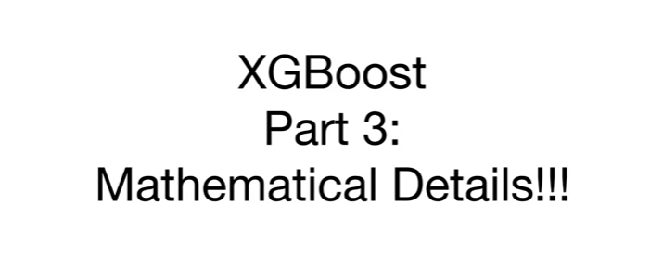

Today we're gonna talk about XGBoost part 3 mathematical details.

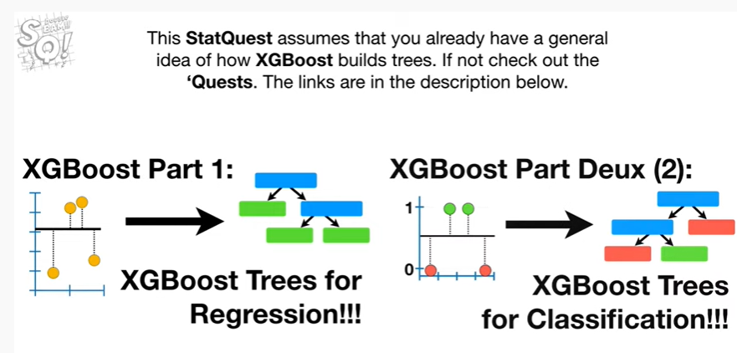

This stat quest assumes that you already have a general idea of how XGBoost builds trees if not check out the quests, the links are in the description below.

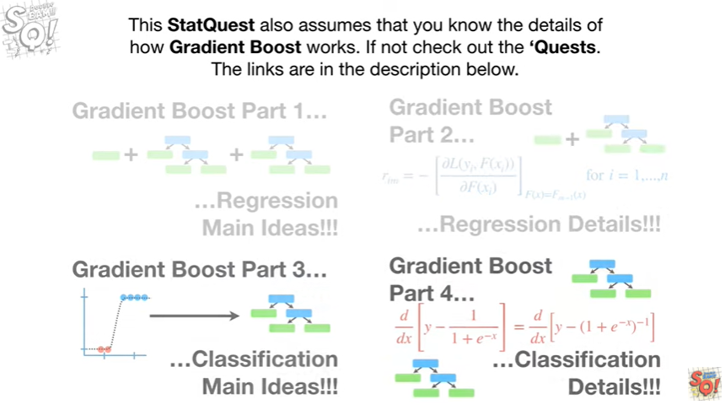

This stat quest also assumes that you know the details of how gradient boost works, if not check out the quests.

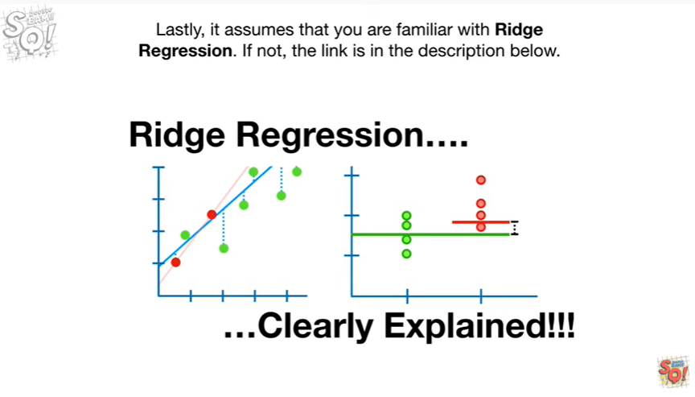

Lastly, it assumes that you are familiar with Ridge regression, if not the link is in the description below.

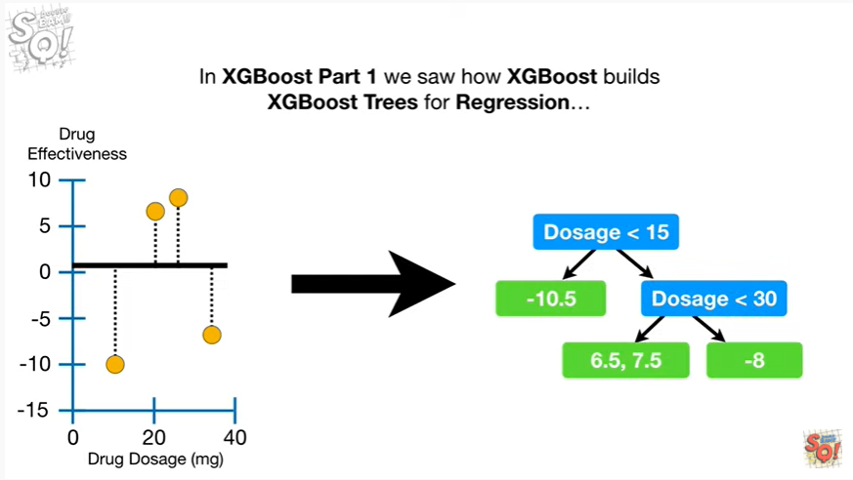

In XGBoost part 1, we saw how XGBoost builds XGBoost trees for regression

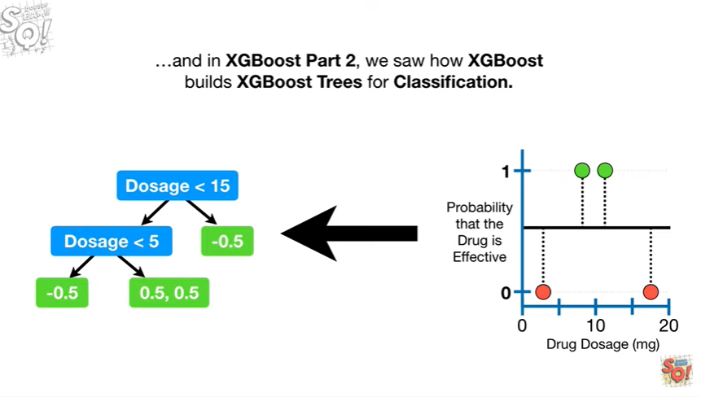

and in XGBoost part 2, we saw ha XGBoost builds XGBoost trees for classification.

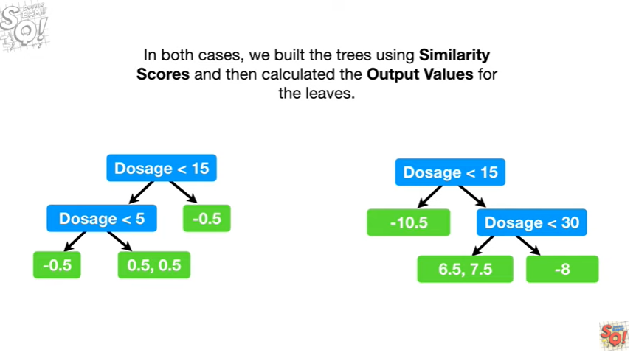

In both cases, we build the trees using similarity scores and then calculated the output values for the leaves.

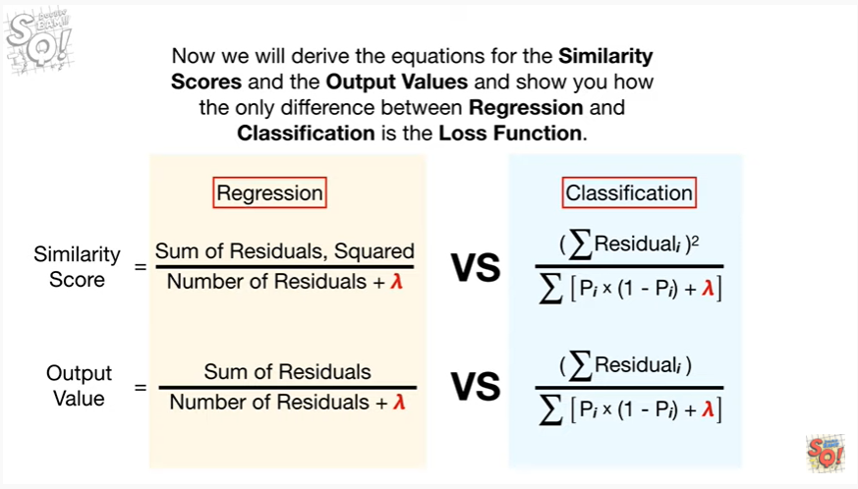

Now we will derive the equations for the similarity scores in the output values and show you how the only difference between regression and classification is the loss function.

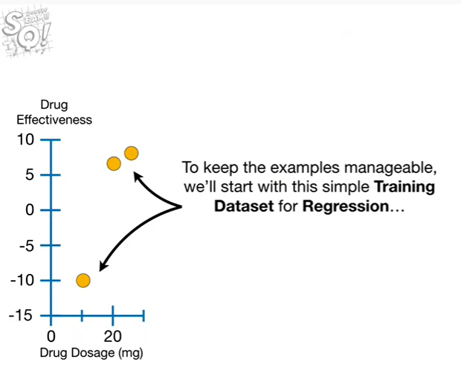

To keep the examples manageable, we'll start with a simple training data set for regression

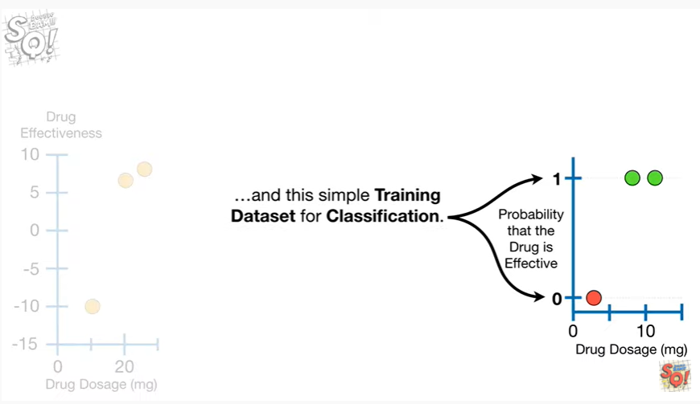

and this simple training data set for classification.

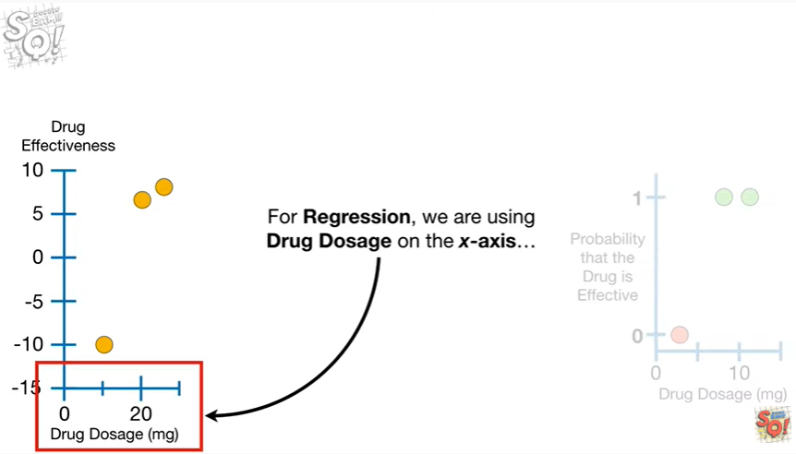

For regression we are using drug dosage on the x-axis

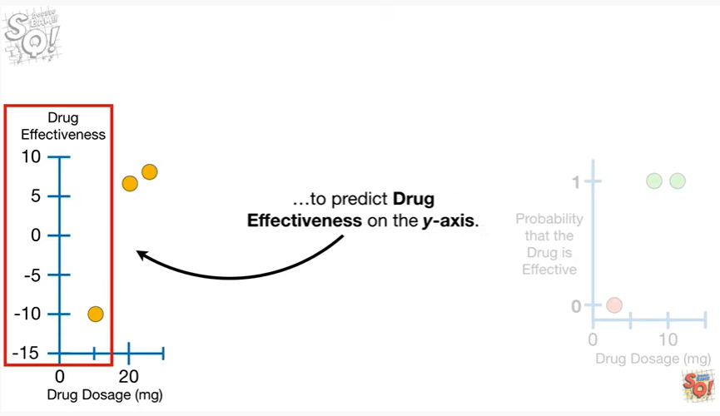

to predict drug effectiveness on the y-axis.

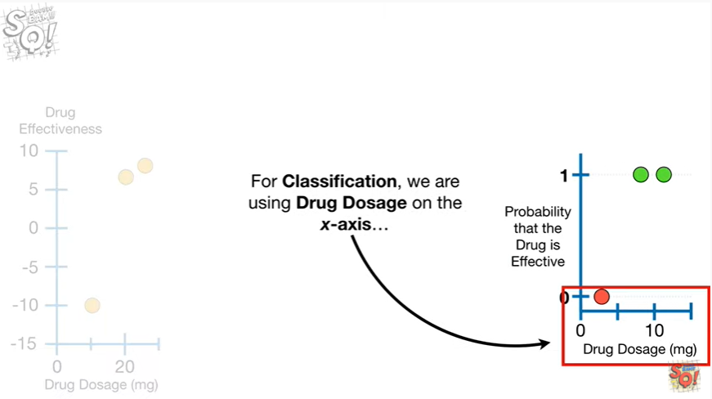

For classification, we are using drug dosage on the x-axis

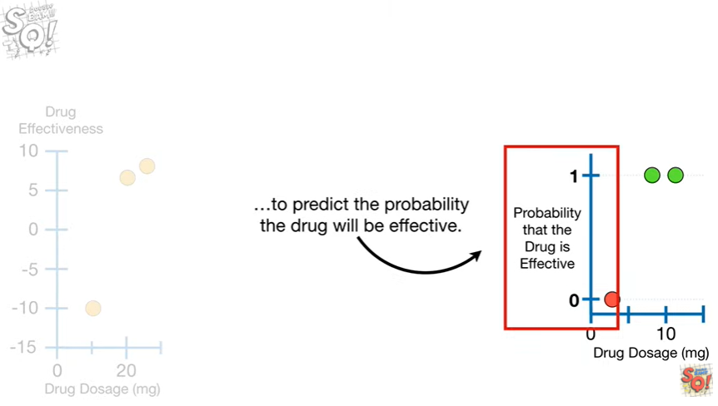

to predict the probability the drug will be effective.

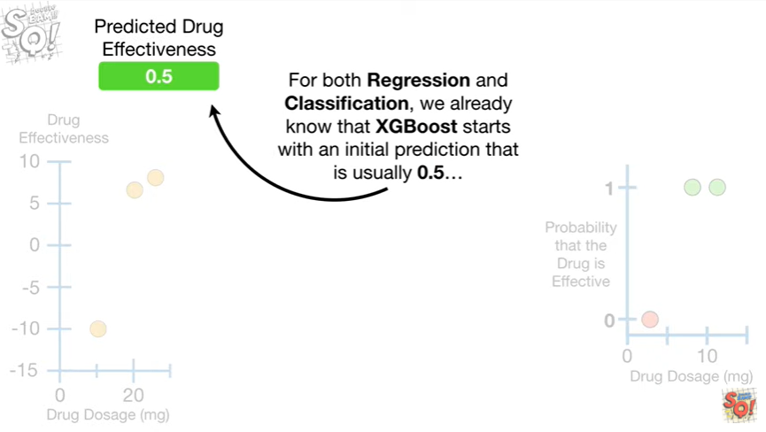

For both regression and classification, we already know that XGBoost starts with an initial prediction that is usually 0.5

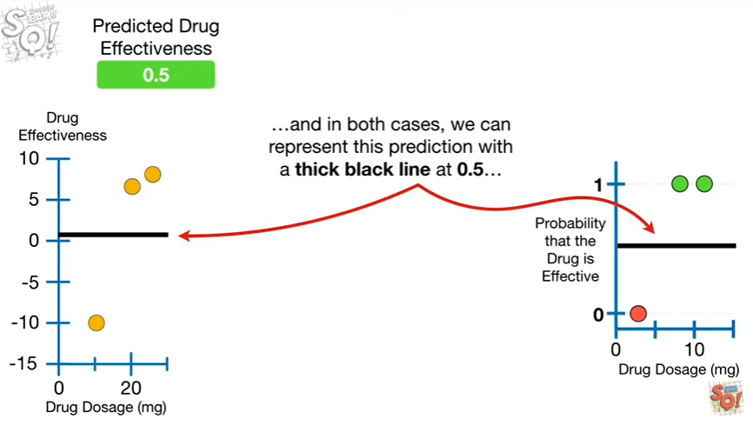

and in both cases we can represent this prediction with a thick black line at 0.5

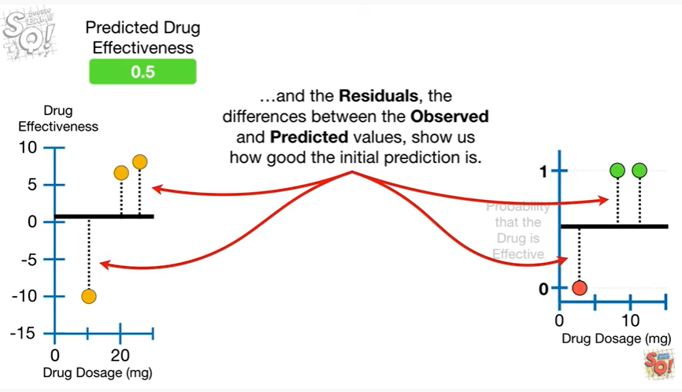

and the residuals, the differences between the observed and predicted values, show us how good the initial prediction is.

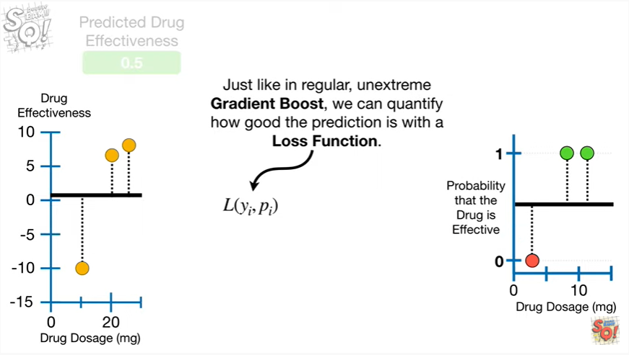

Just like in regular, unextrem gradient boost, we can quantify how good the prediction is with a loss function.

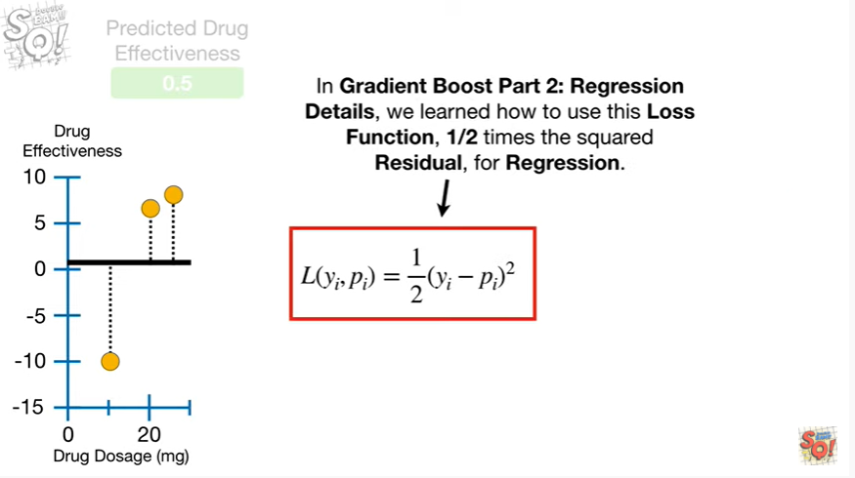

In gradient boost part two, regression details, we learned how to use this loss function, 1/2 times the squared residual, for regression.

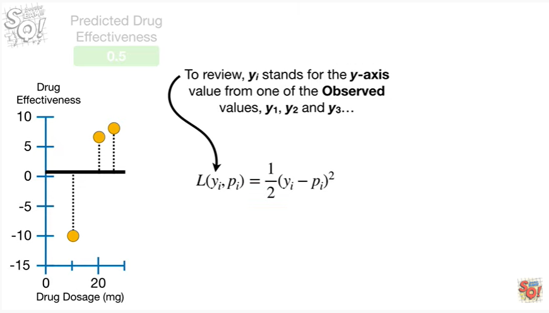

To review, y sub i stands for the y-axis value from one of the observed values,

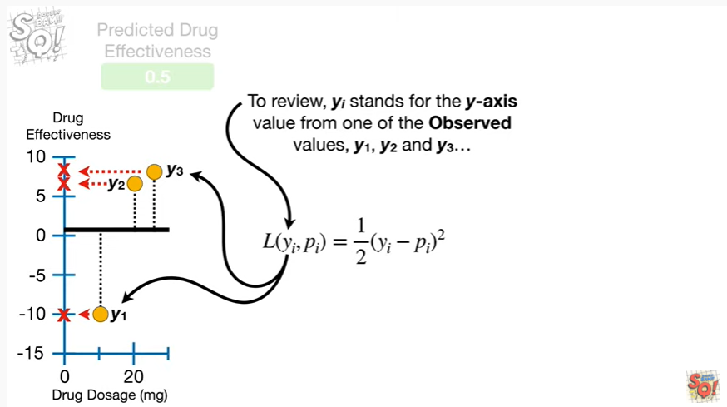

y sub 1, Y sub 2 and Y sub 3

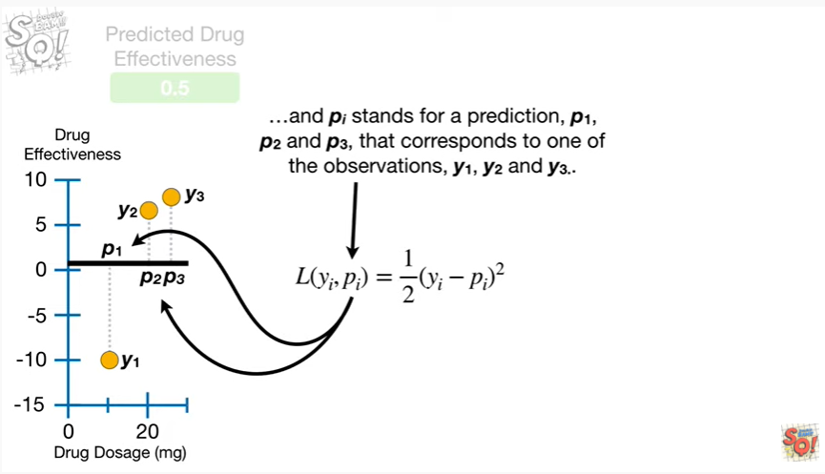

and P sub i stands for a prediction, P sub 1, P sub 2, and P sub 3 that corresponds to one of the observations y sub 1, Y sub 2 and Y sub 3.

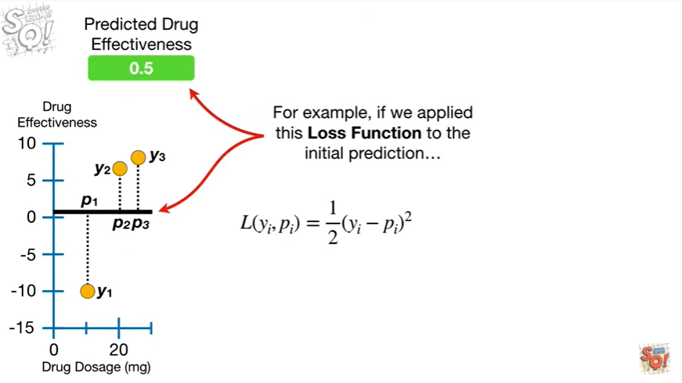

For example, if we applied the loss function to the initial prediction

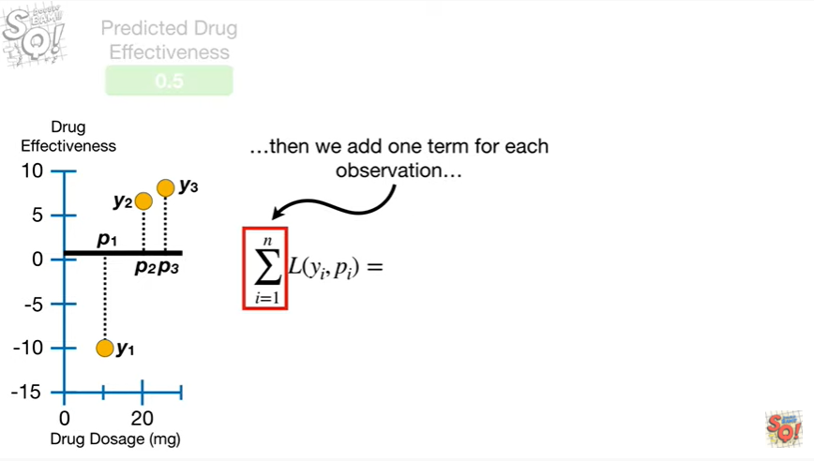

then we would add one term for each observation

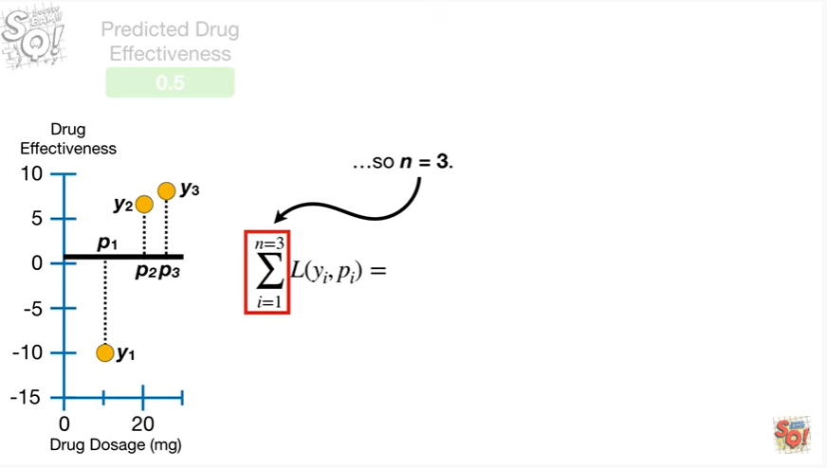

so N equals three.

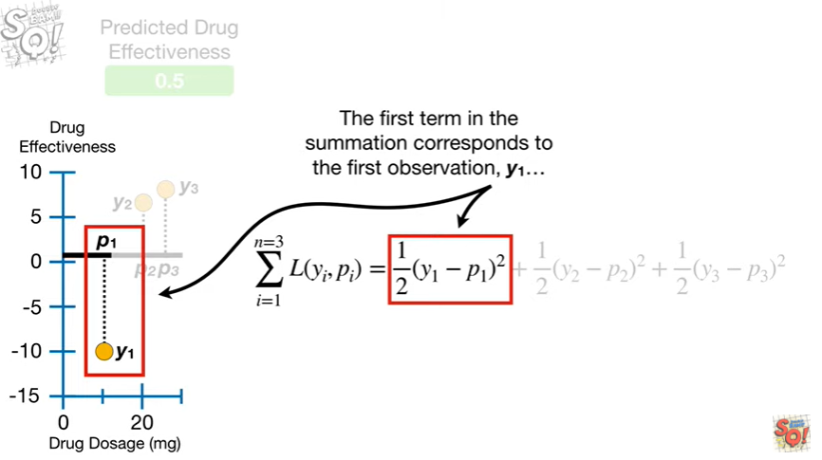

The first term in the summation corresponds to the first observation y sub one

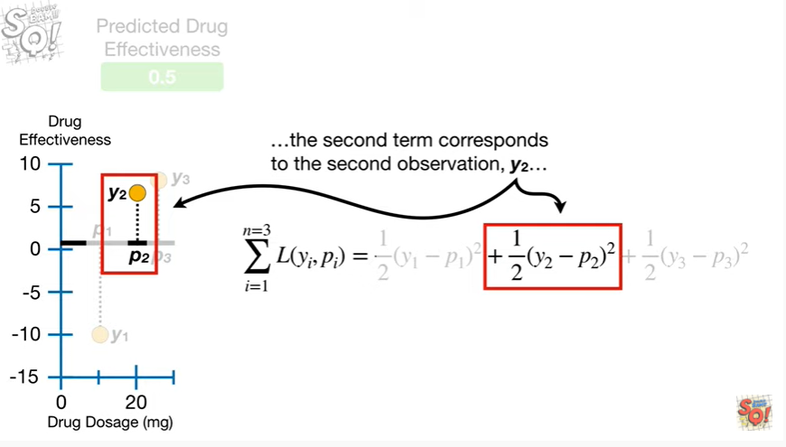

the second term corresponds to the second observation y sub two

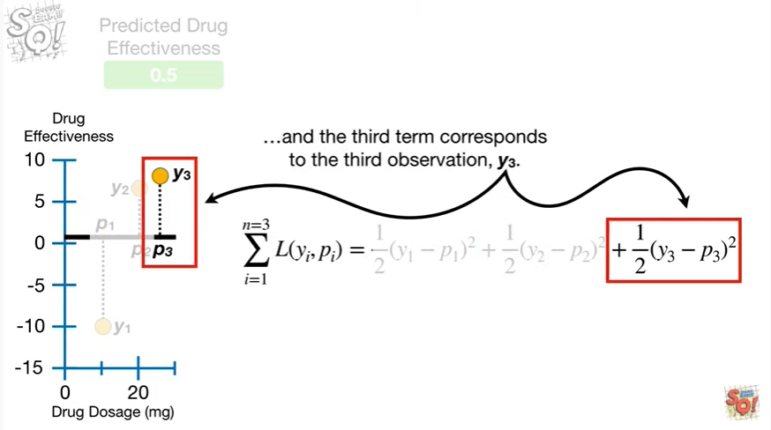

and the third term corresponds to the third observation, y sub three.

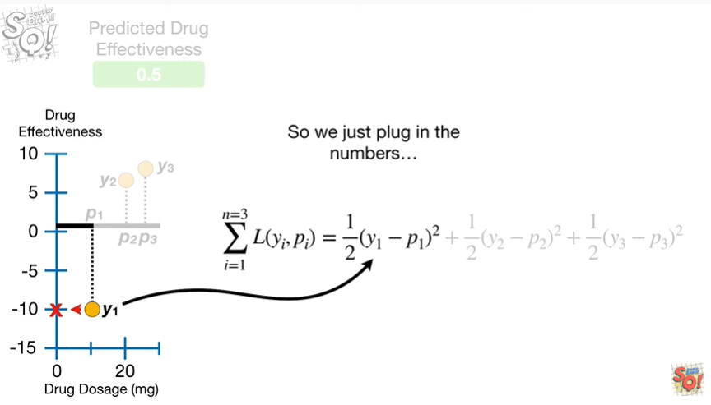

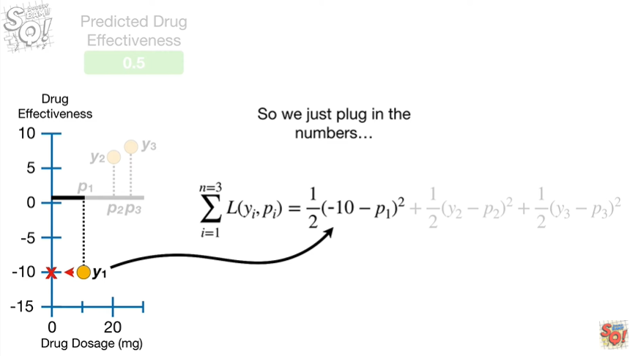

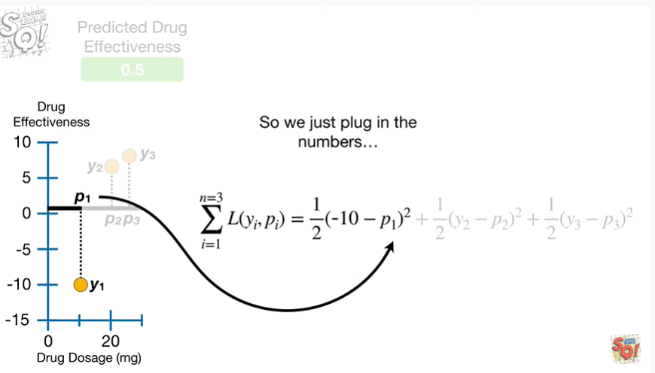

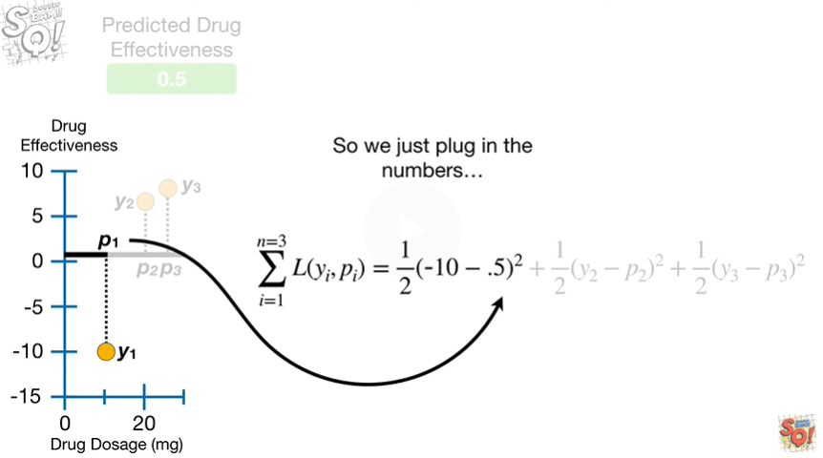

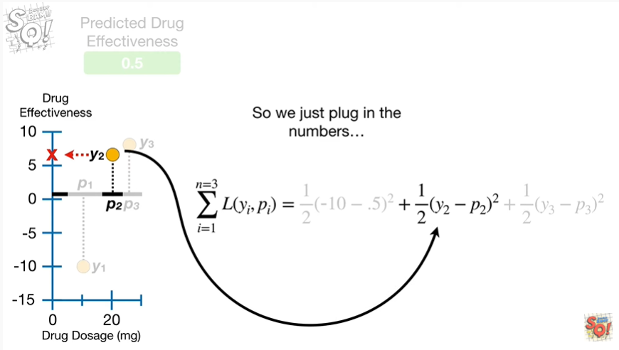

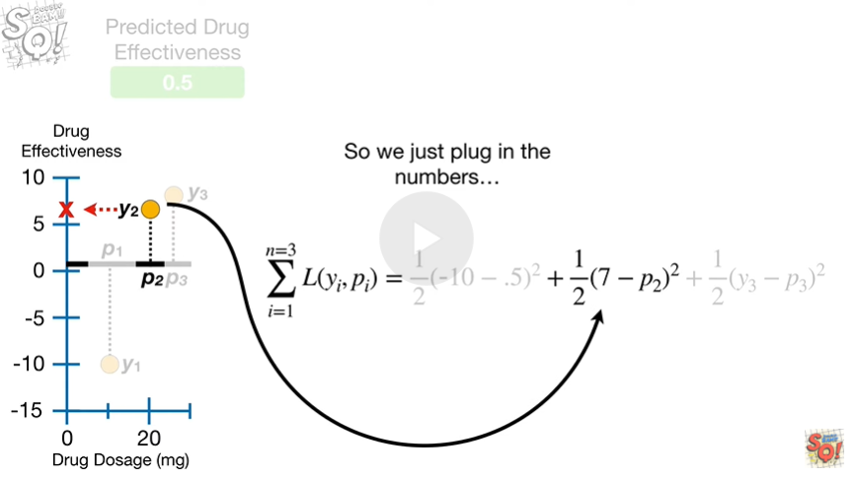

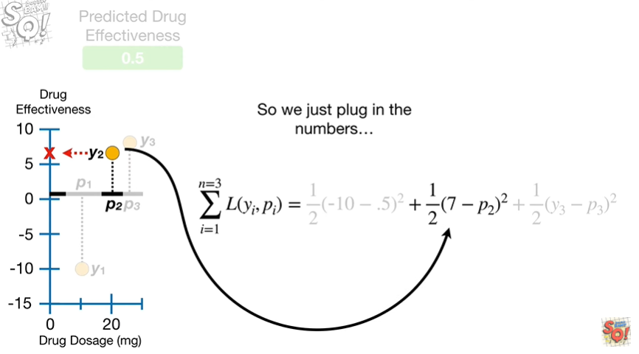

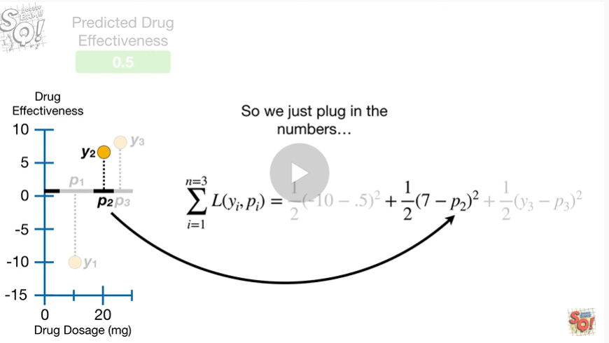

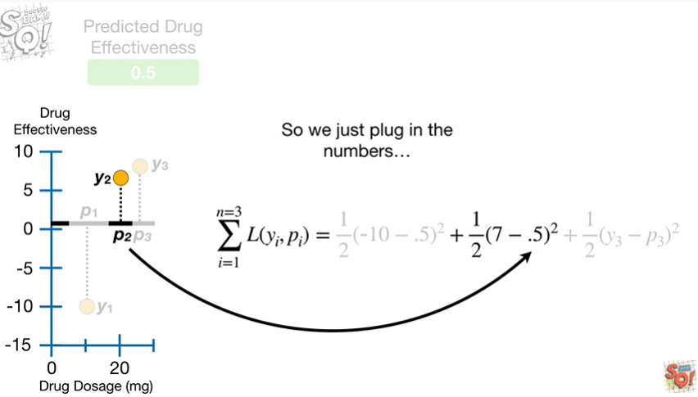

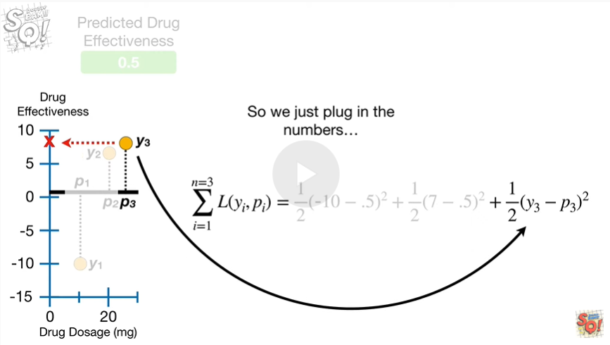

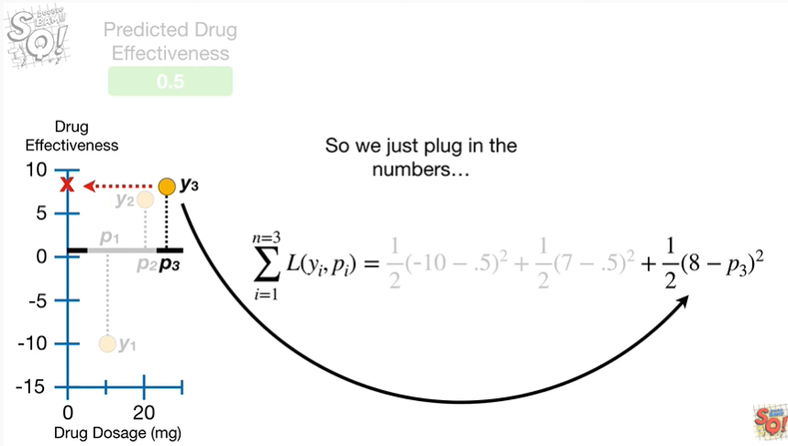

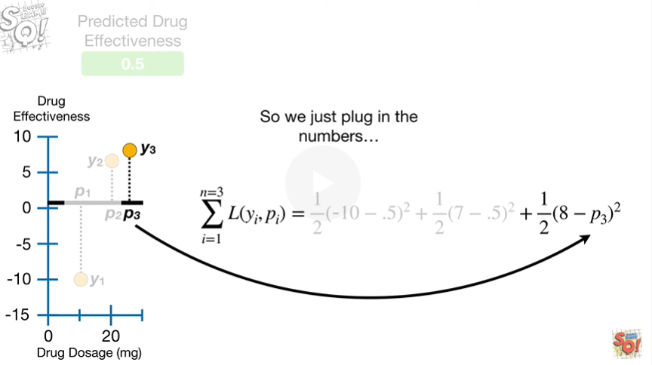

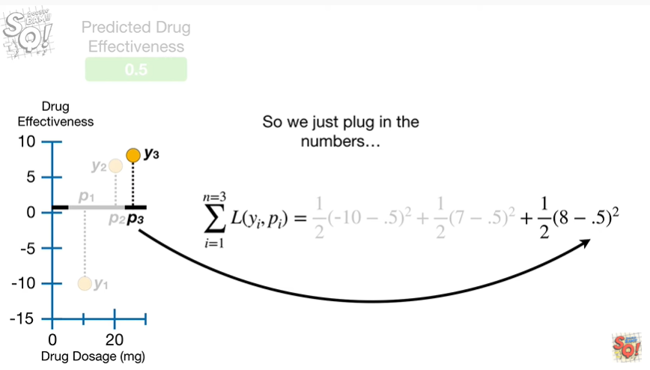

So we just plug in the numbers

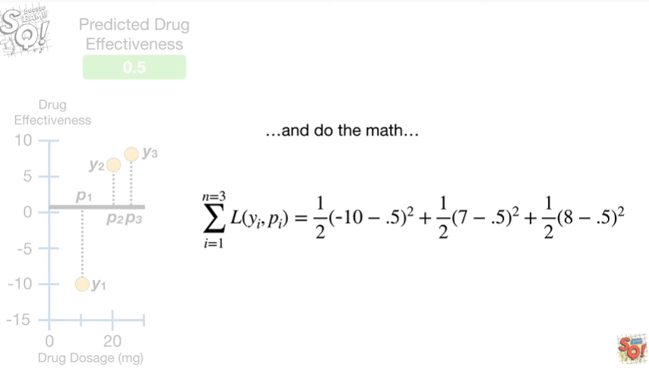

and do the math

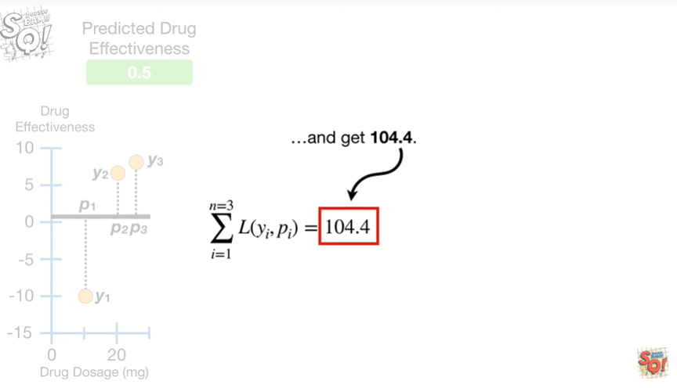

and get 104.4.

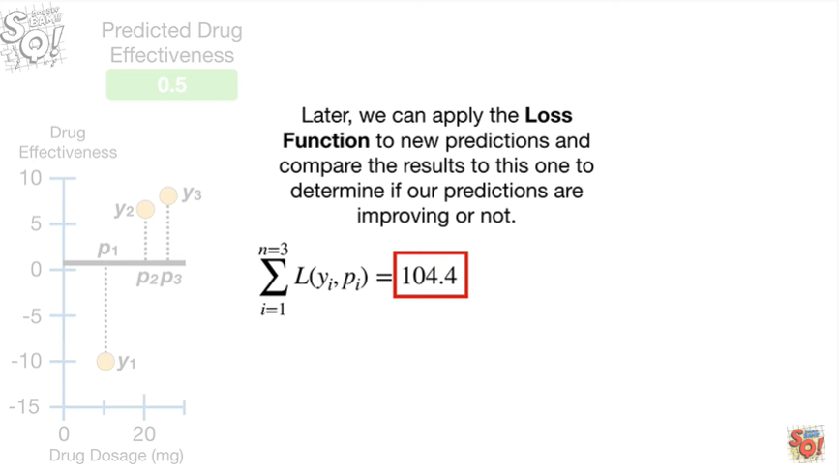

Later, we can apply the loss function to new predictions and compare the results to this one to determine if our predictions are improving or not.

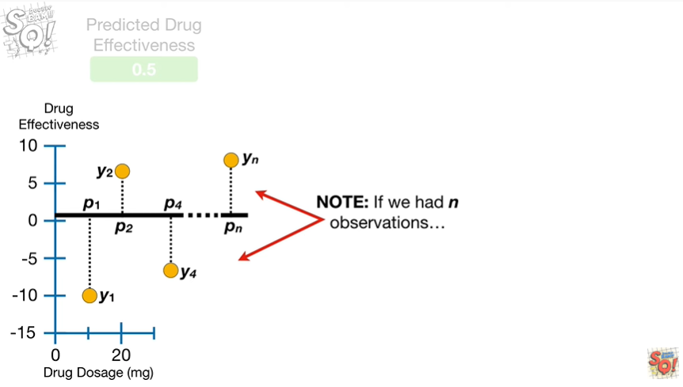

Note : if we had in observations

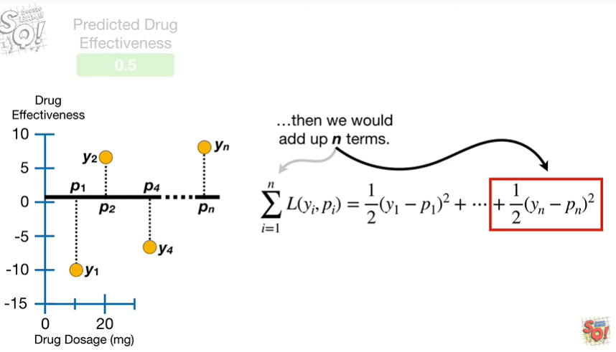

then we would add up in terms, no big deal.

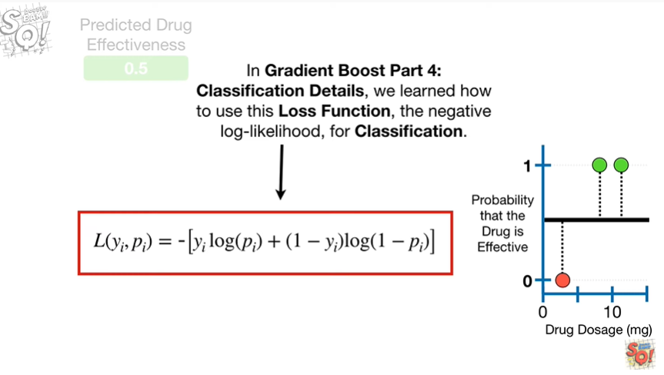

In gradient boost part 4, classification details, we learned how to use this loss function, the negative log likelihood, for classification.

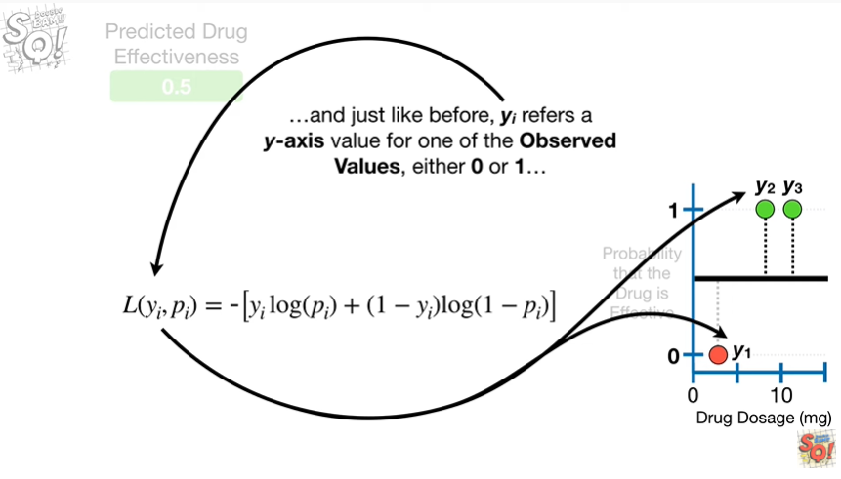

And just like before whysa by refers to a y-axis value for one of the observed values which is either 0 or 1

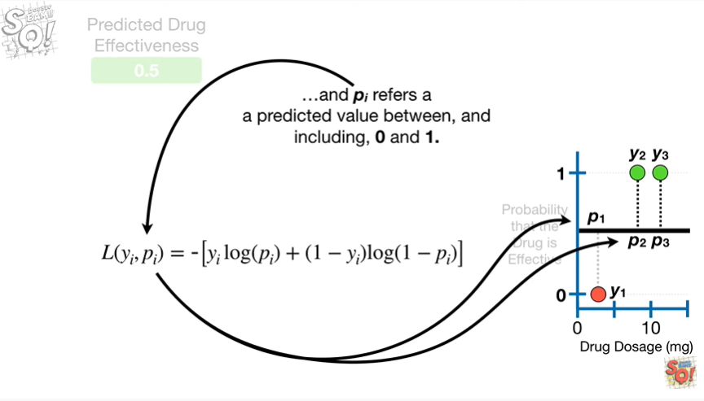

and P sub I refers to a predicted value between and including 0 and 1.

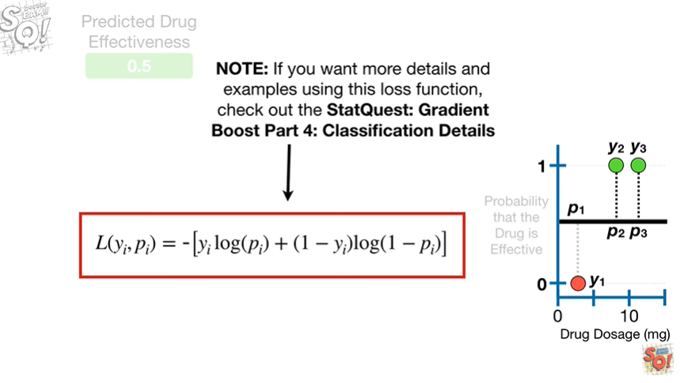

Note : if you want more details and examples using this loss function, check out the stat quest, gradient boost part 4, classification details.

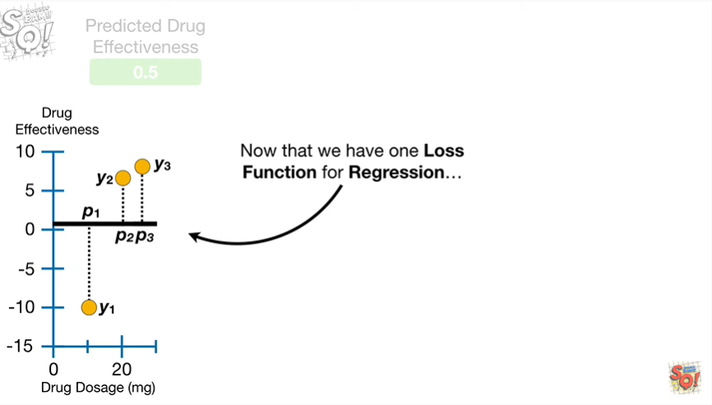

Now that we have one loss function for regression

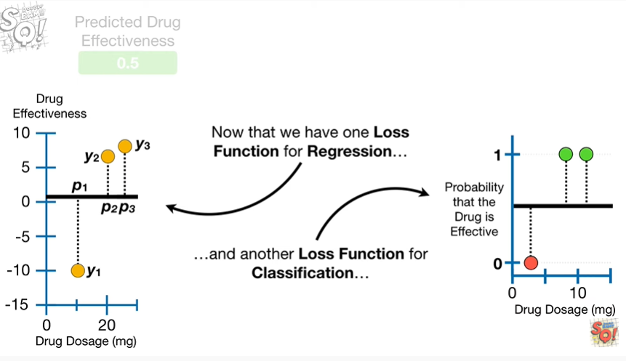

and another loss function for classification

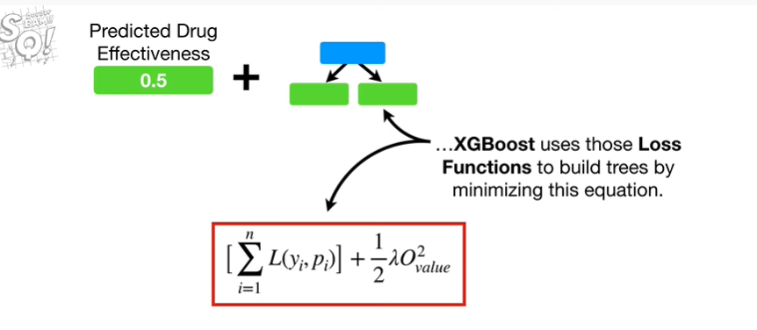

XGBoost uses those loss functions to build trees by minimizing this equation.

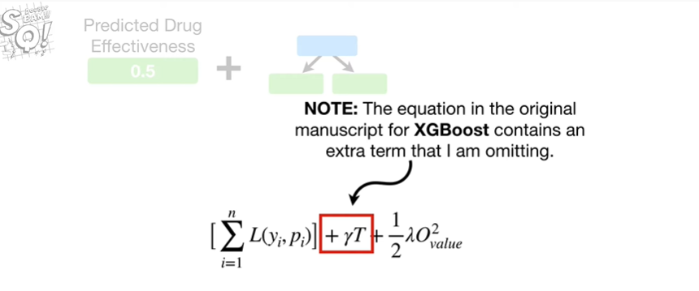

Note : the equation in the original manuscript for XGBoost contains an extra term that I'm omitting.

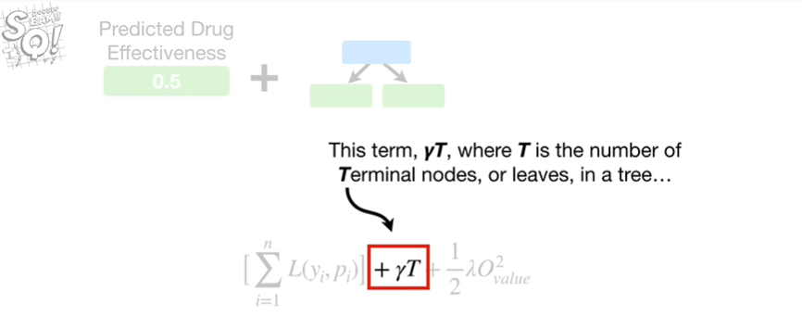

This term, gamma times T, where T is the number of terminal nodes, or leaves in a tree

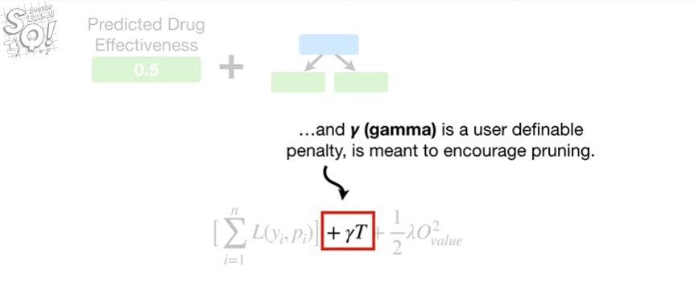

and gamma is a user definable penalty, is meant to encourage pruning.

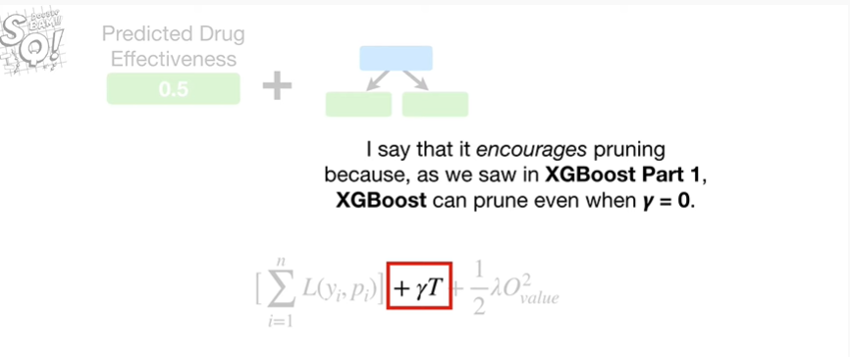

I say that it encourages pruning because, as we saw an XGBoost part 1, XGBoost can prune even when gamma equals 0.

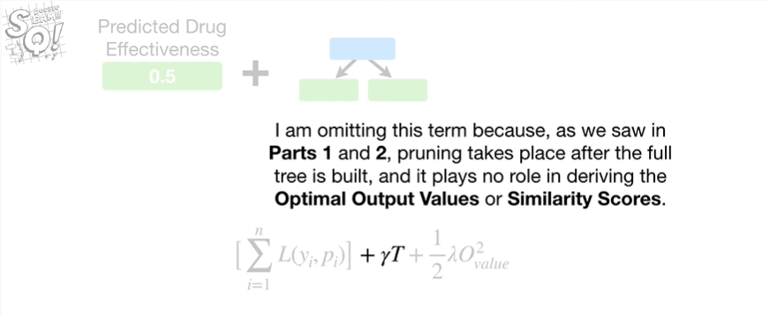

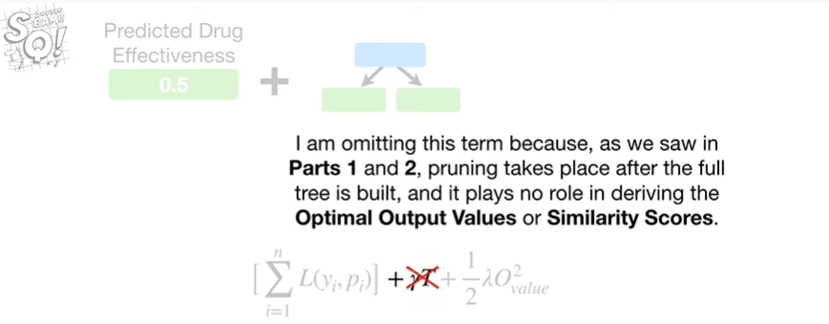

I'm omitting this term because, as we saw in parts 1 & 2, pruning takes place after the full tree is built, and it plays no role in deriving the optimal output values or similarity scores.

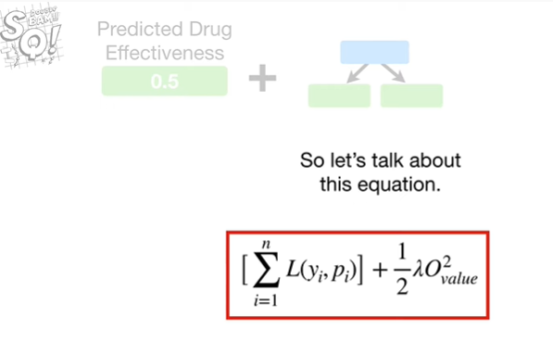

So let's talk about this equation.

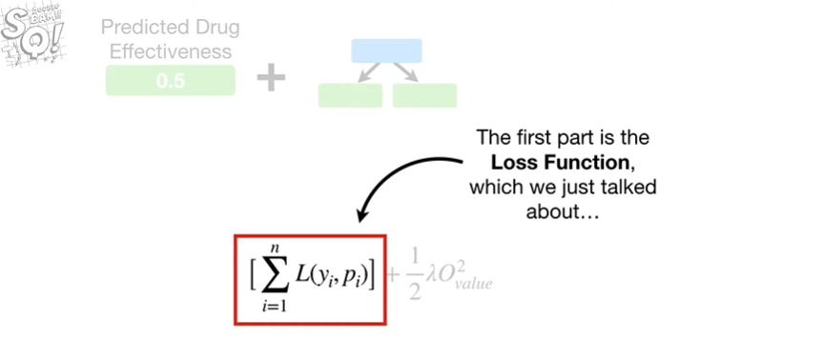

The first part is the loss function which we just talked about

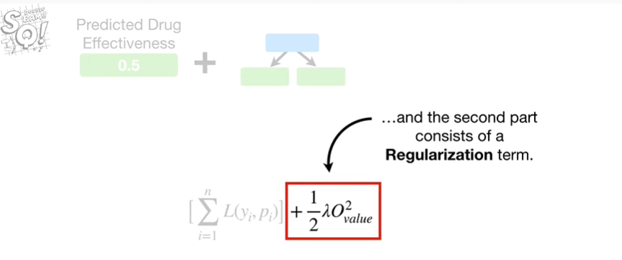

and the second part consists of a regularization term.

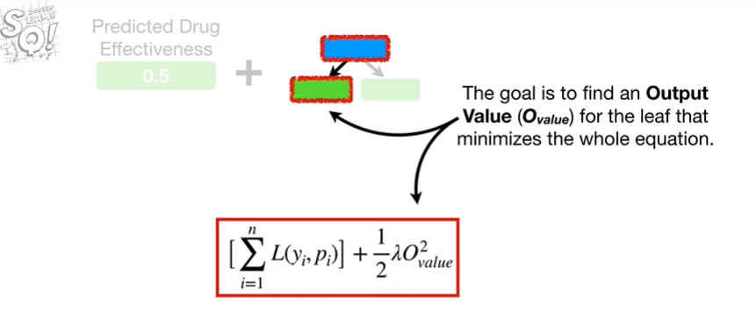

The goal is to find an output value for the leaf that minimizes the whole equation.

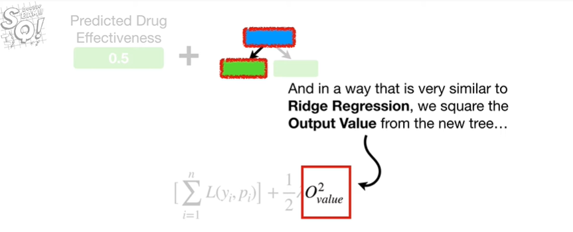

And in a way that is very similar to Ridge regression, we square the output value from the new tree

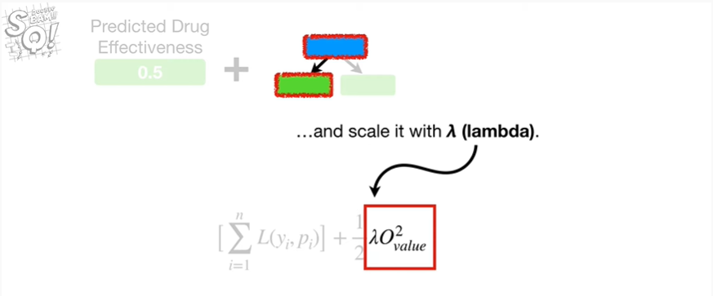

and scale it with lambda.

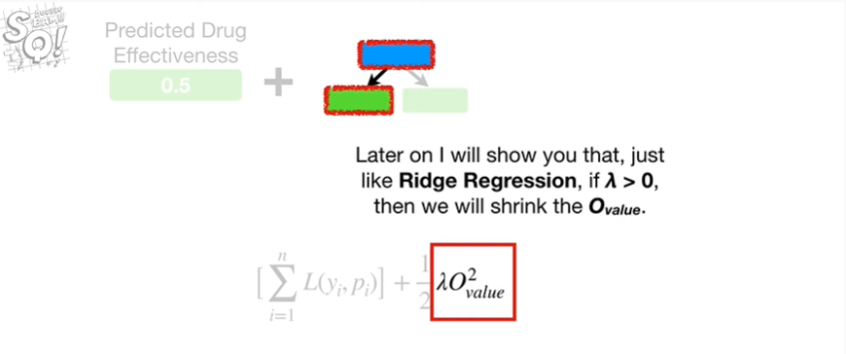

Later on I will show you that, just like Ridge regression, if lambda is greater than 0, then we will shrink the output value.

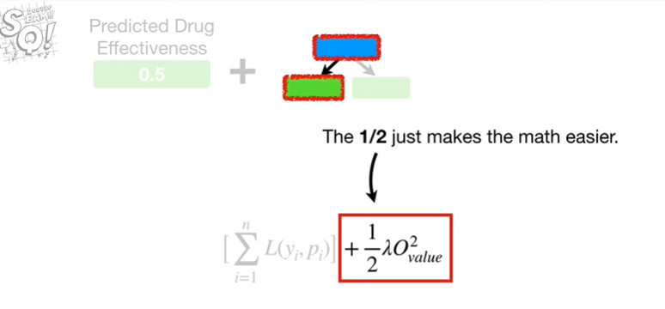

The 1/2 just makes the math easier.

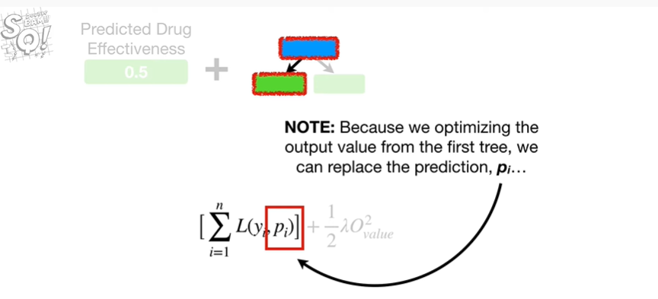

Note : because we are optimizing the output value from the first tree we can replace the prediction P sub I

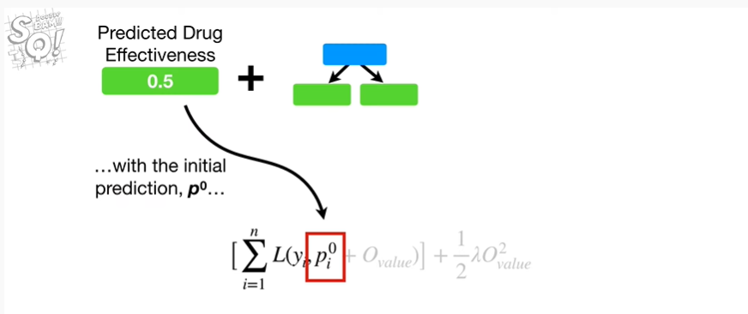

with the initial prediction P of 0

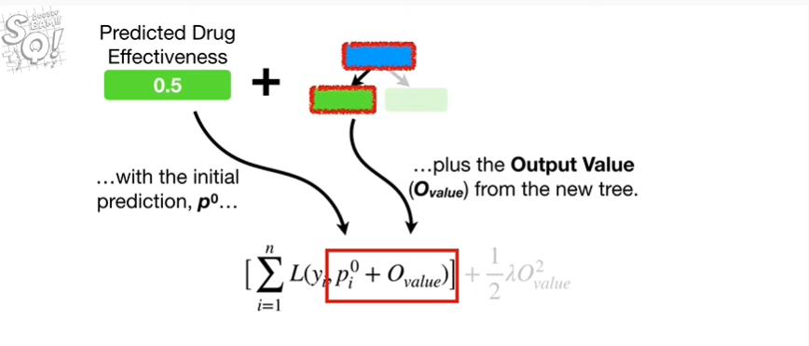

plus the output value from the new tree.

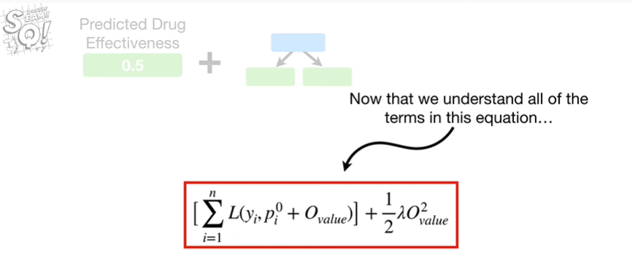

Now that we understand all of the terms in this equation

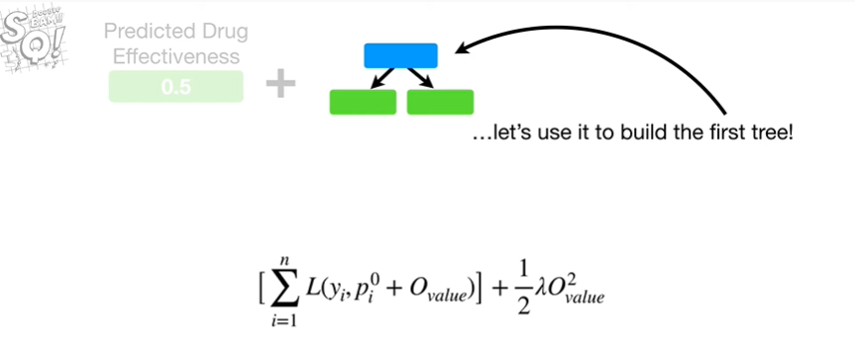

let's use it to build the first tree.

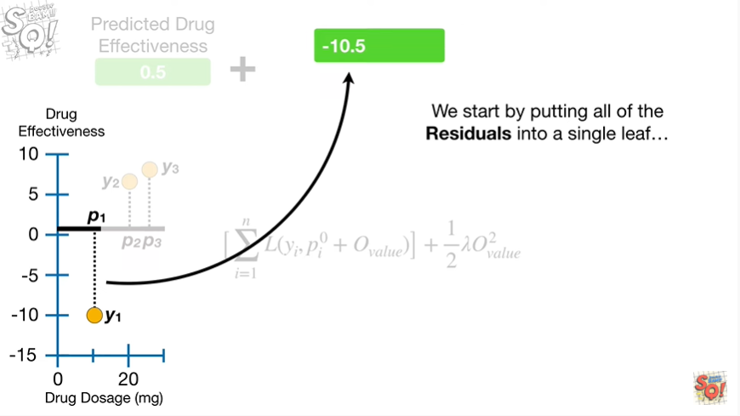

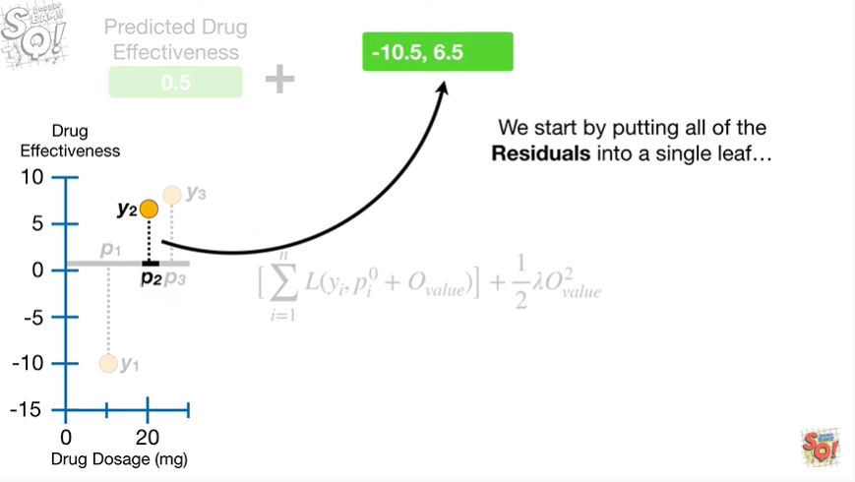

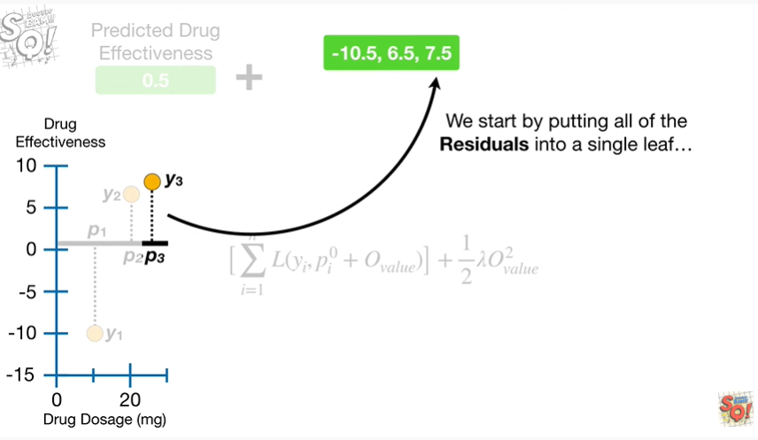

We start by putting all of the residuals into a single leaf

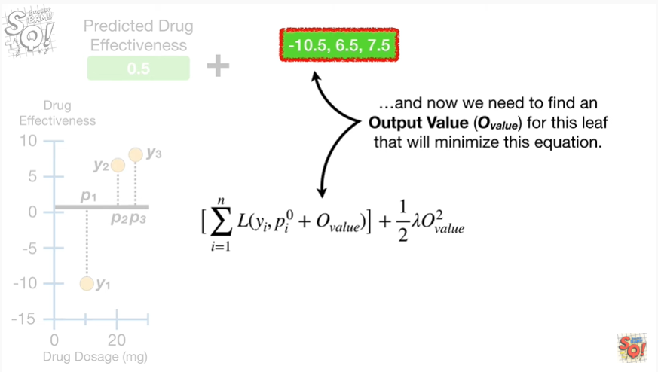

and now we need to find an output value for this leaf that will minimize this equation.

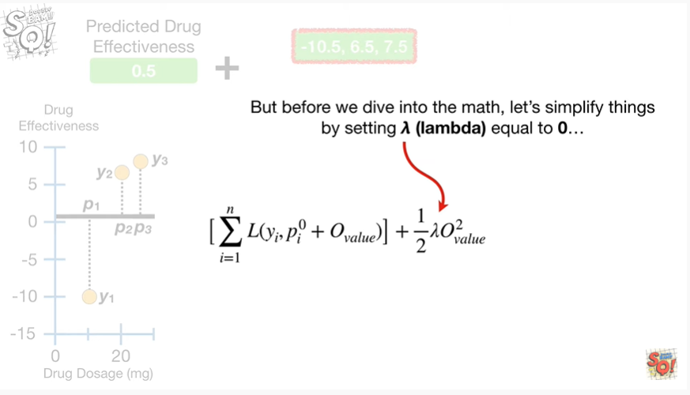

But before we dive into the math, let's simplify things by setting lambda equal to zero

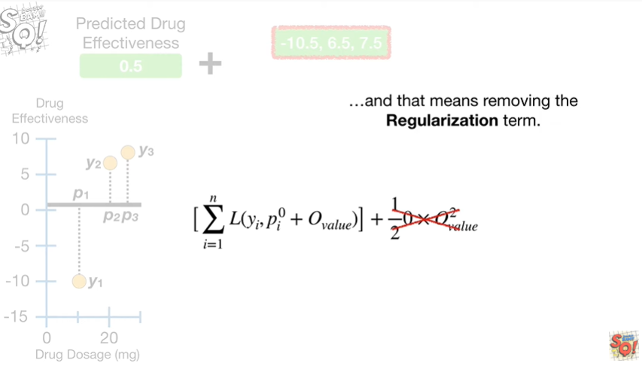

and that means removing the regularization term.

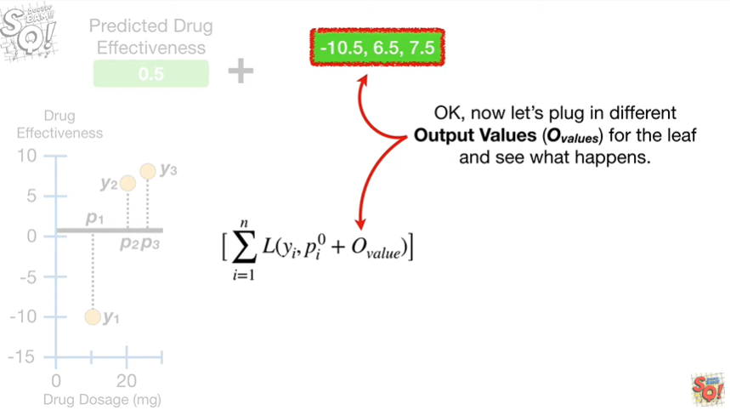

Okay, now let's plug in different output values for the leaf and see what happens.

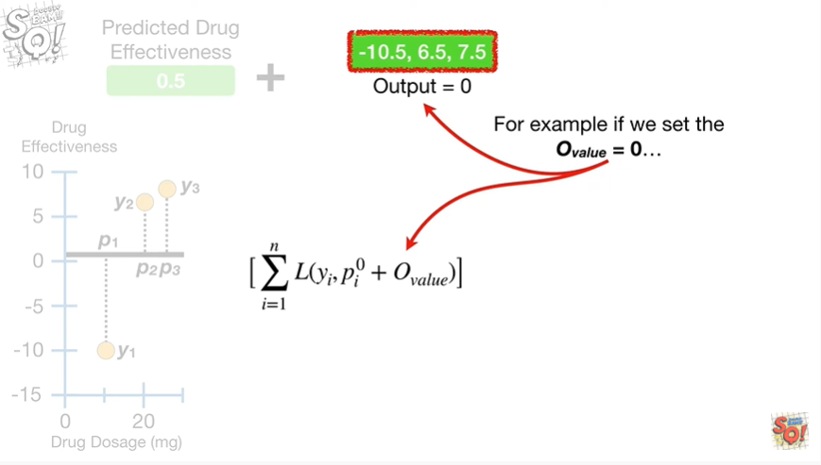

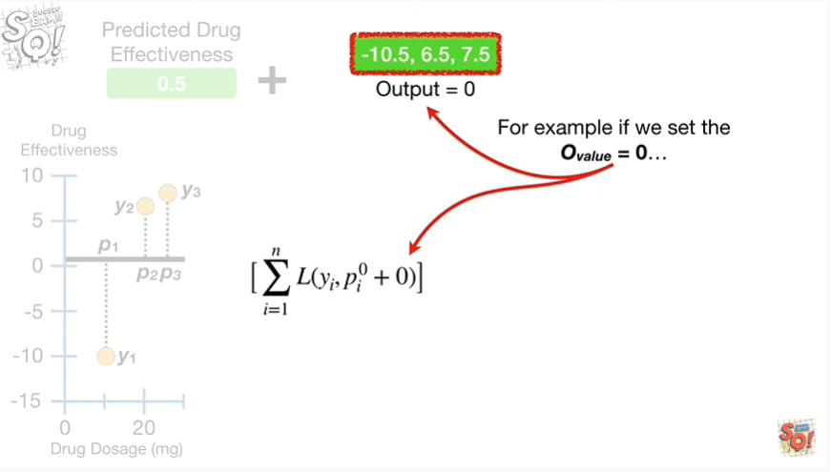

For example if we set the output value equal to zero

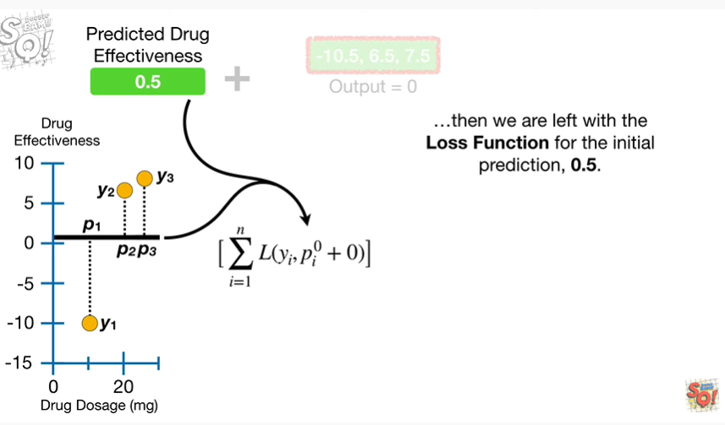

then we are left with the loss function for the initial prediction zero point five.

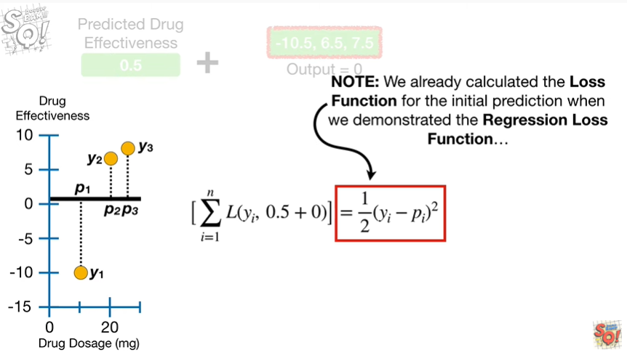

Note : we already calculated the loss function for the initial prediction when we demonstrated the regression loss function

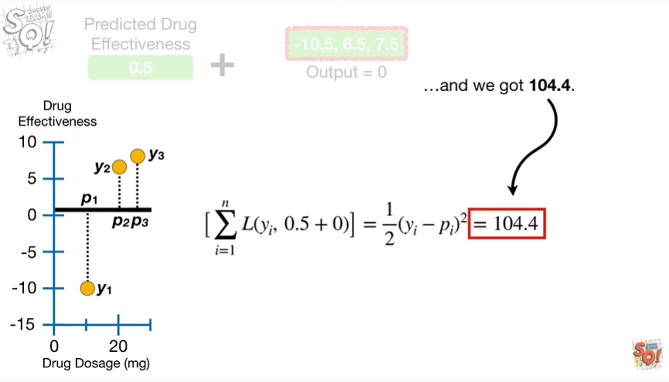

and we got 100 four point four.

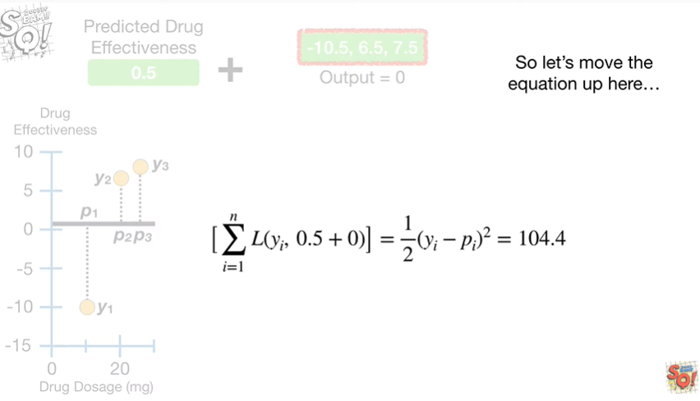

So let's move the equation up here

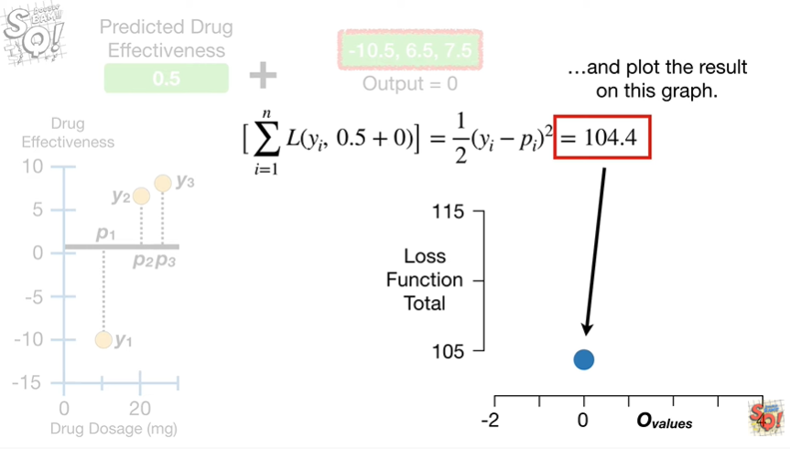

and plot the result on this graph.

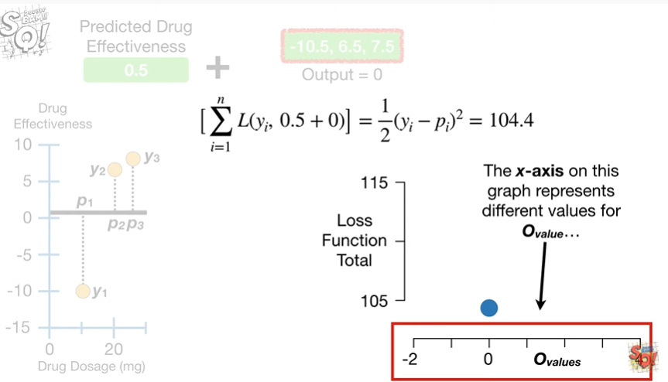

The X-axis on this graph represents different values for the output value

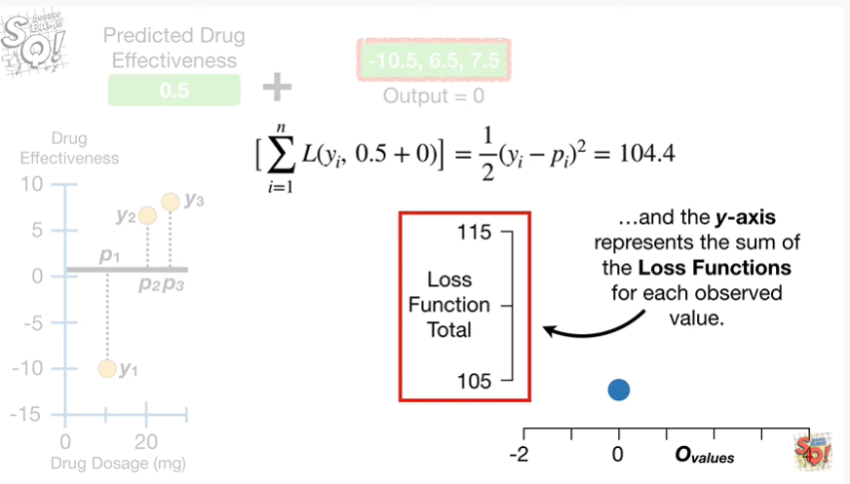

and the y axis represents the sum of the loss functions for each observed value.

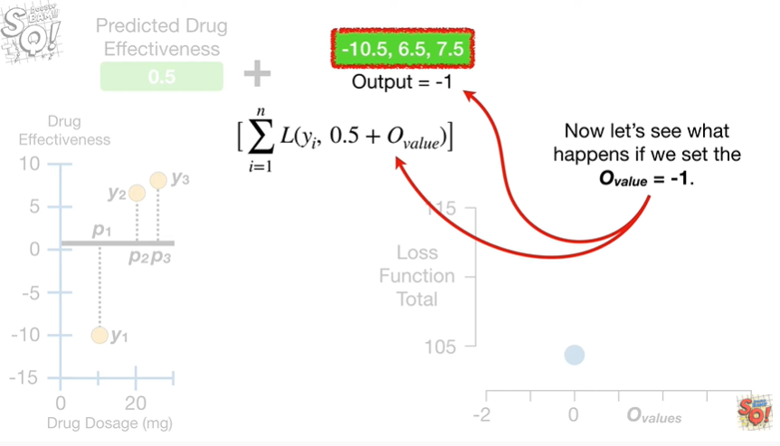

Now let's see what happens if we set the output value equal to negative one.

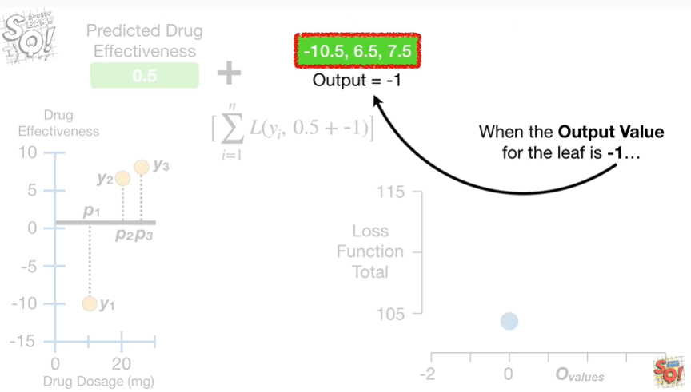

When the output value for the leaf is negative 1

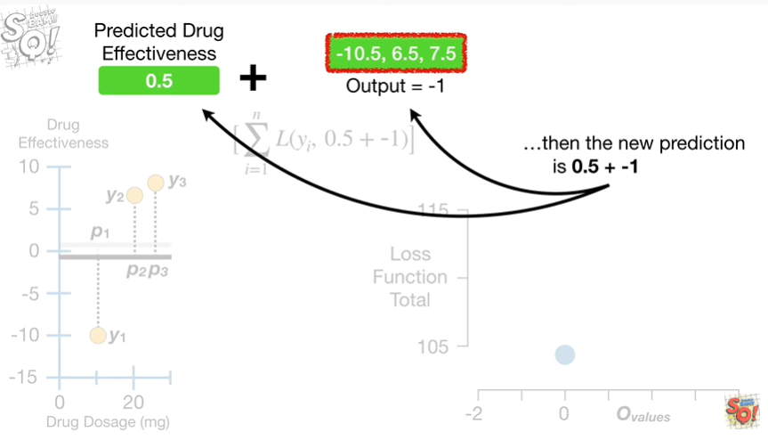

then the new prediction is 0.5 plus negative 1

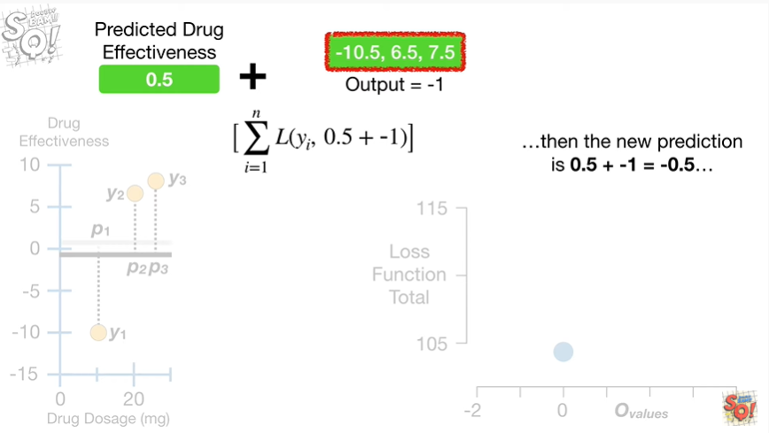

which equals negative 0.5

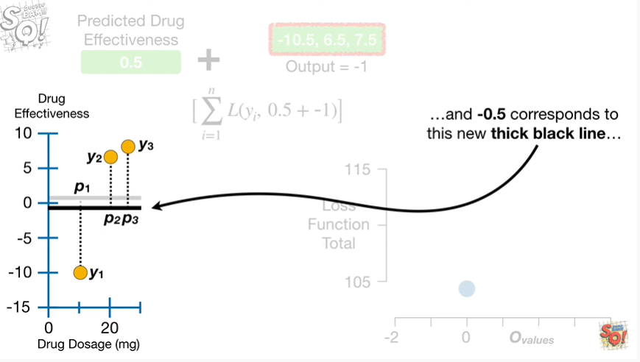

and negative 0.5 corresponds to this new thick black line

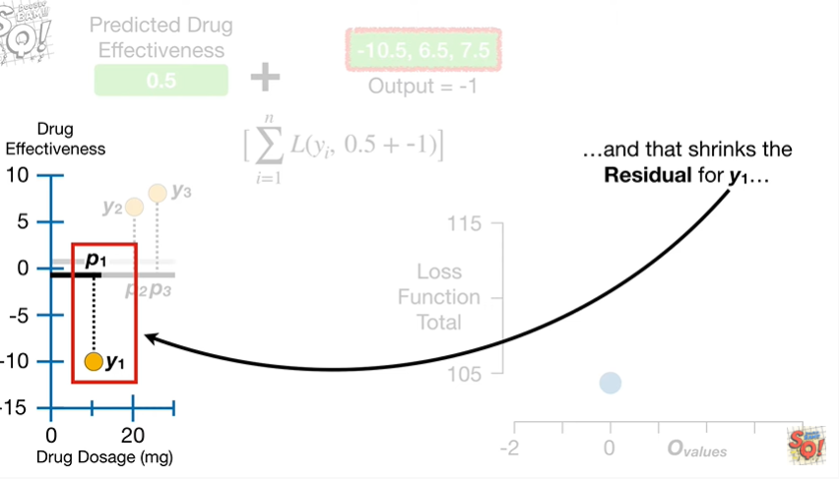

and that shrinks the residual for y sub 1

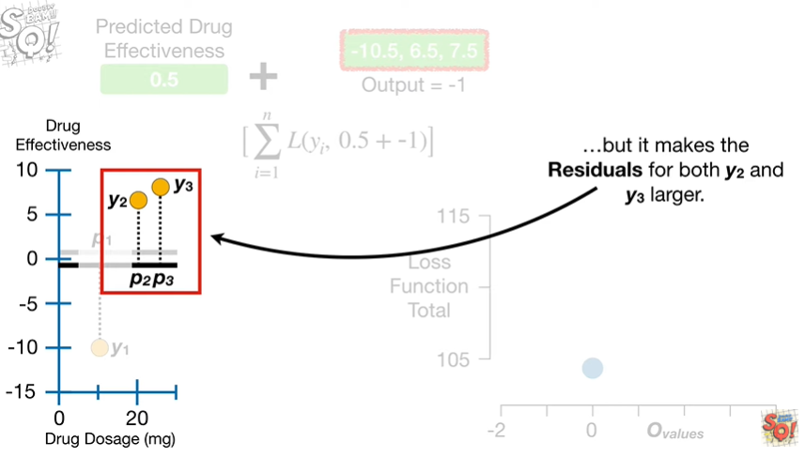

but it makes the residuals for both y sub 2 and y sub 3 larger.

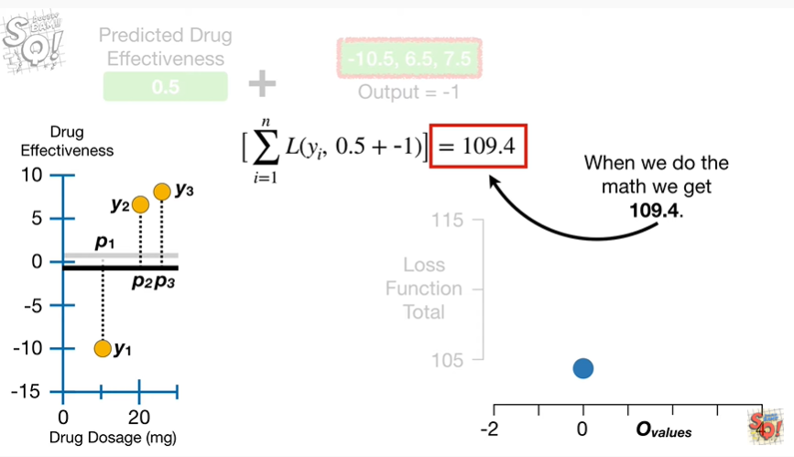

When we do the math we get 109 point 4.

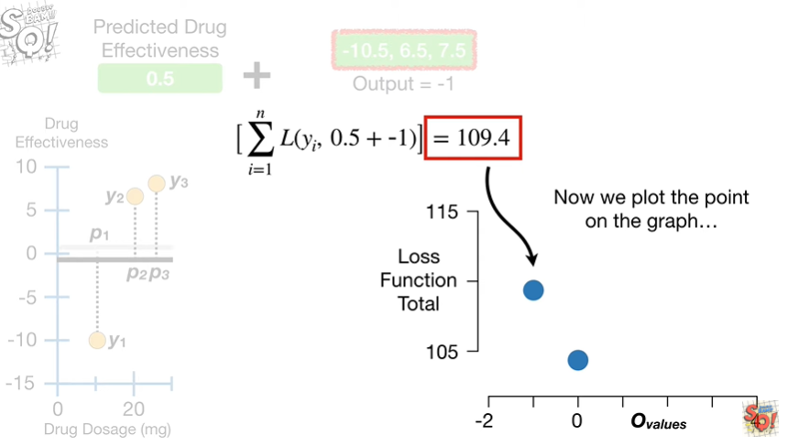

Now we plot the point on the graph

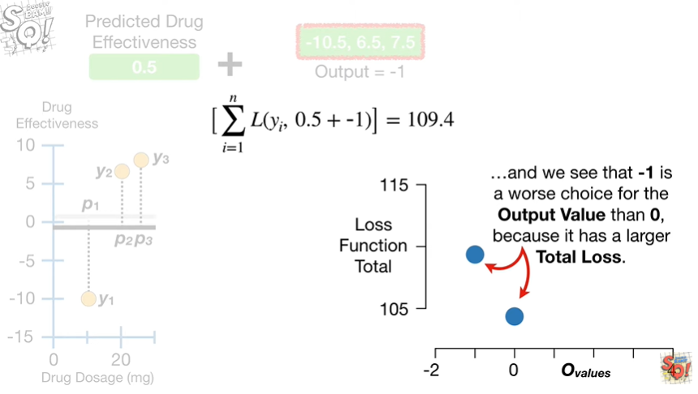

and we see that negative one is a worse choice for the output value than zero because it has a larger total loss.

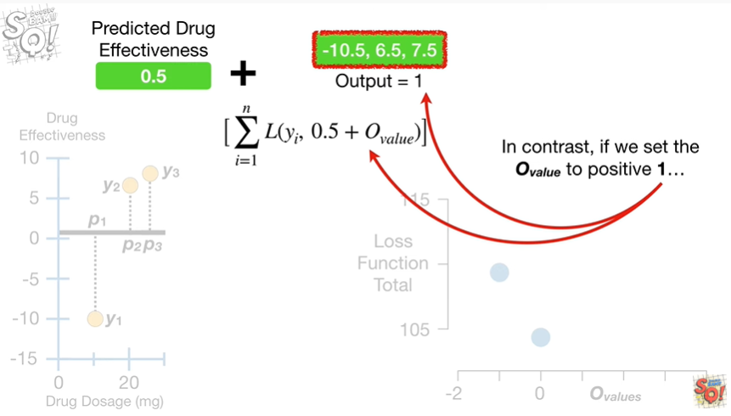

In contrast, if we set the output value to positive one

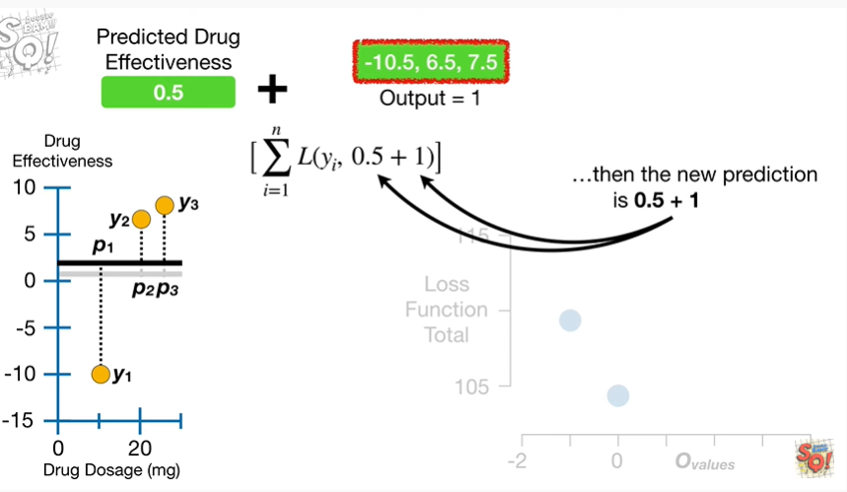

then the new prediction is 0.5 plus 1 which equals 1.5

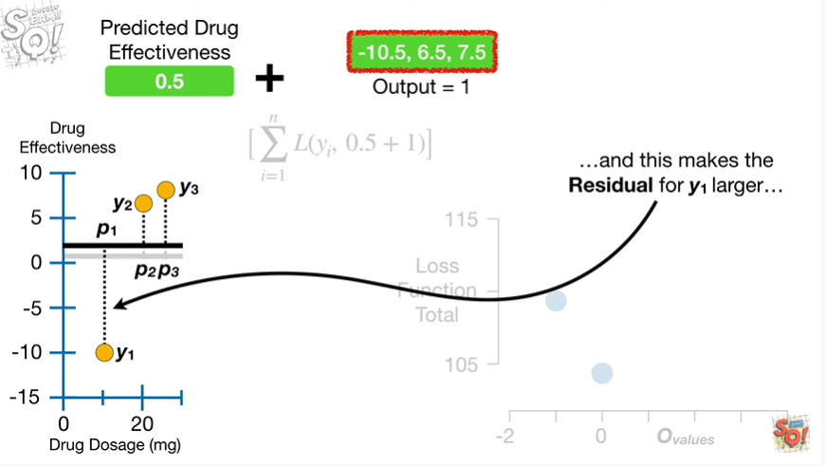

and that makes the residual for y sub 1 larger

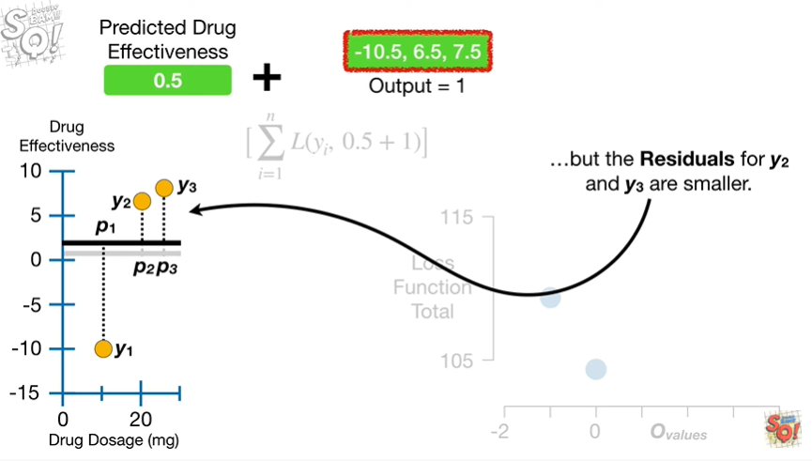

but the residuals for y sub 2 and y sub 3 are smaller.

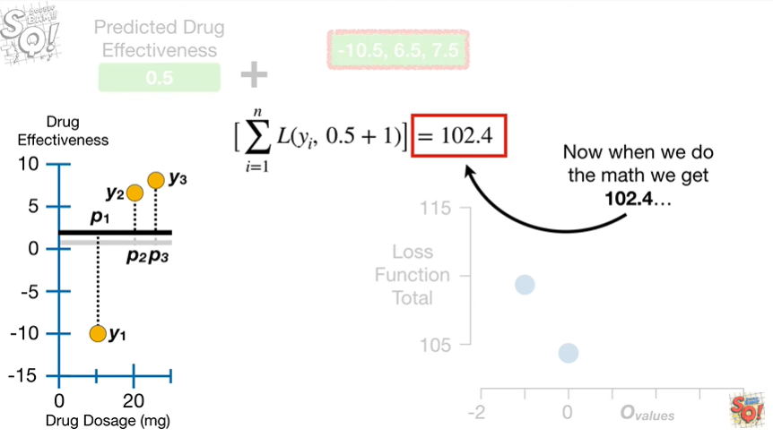

Now when we do the math we get 100 2.4

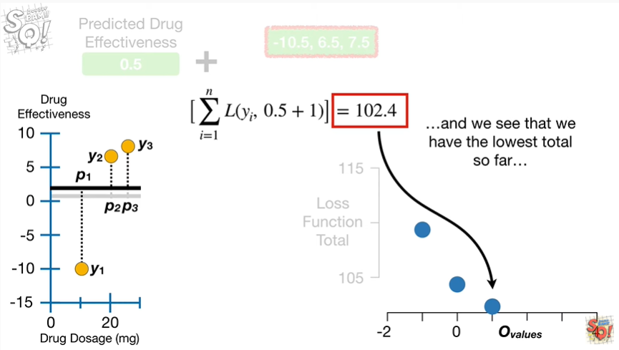

and we see that we have the lowest totals so far

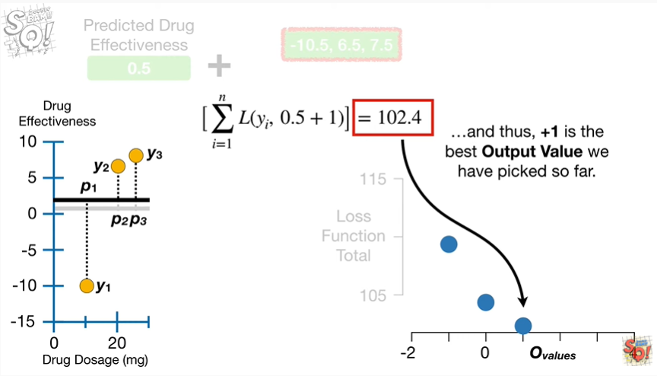

and thus, positive 1, is the best output value we have picked so far.

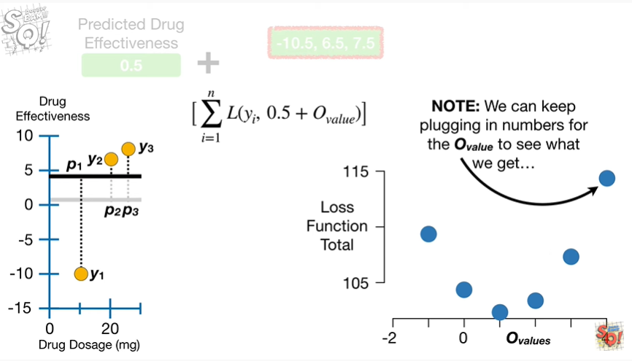

Note : we can keep plugging in numbers for the output value to see what we get

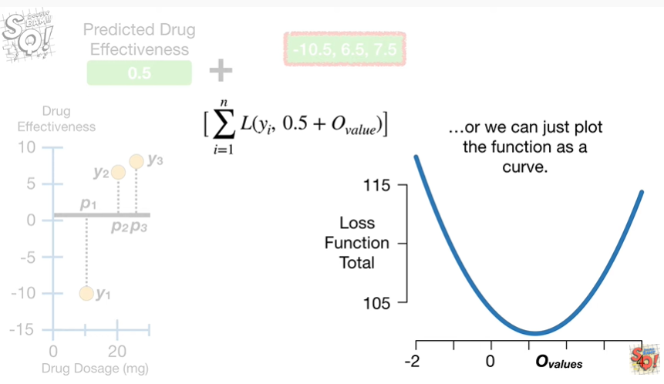

or we can just plot the function as a curve.

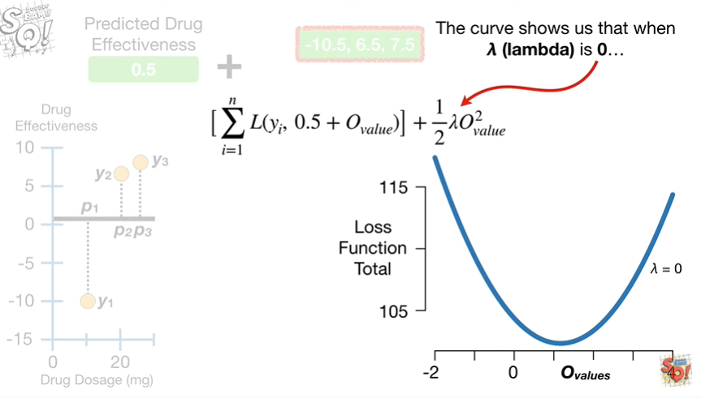

The curve shows us that when lambda is zero

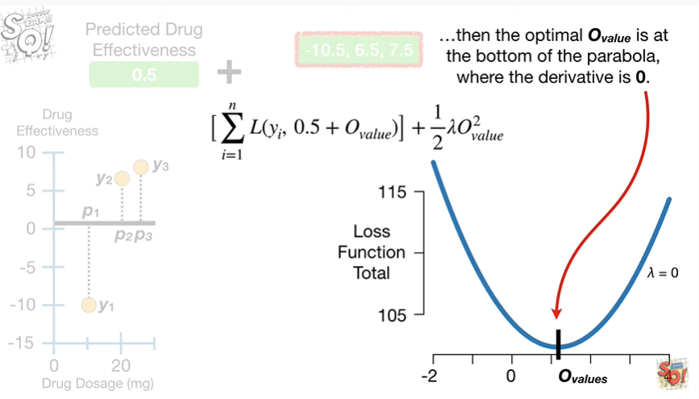

then the optimal output value is at the bottom of the parabola where the derivative is zero.

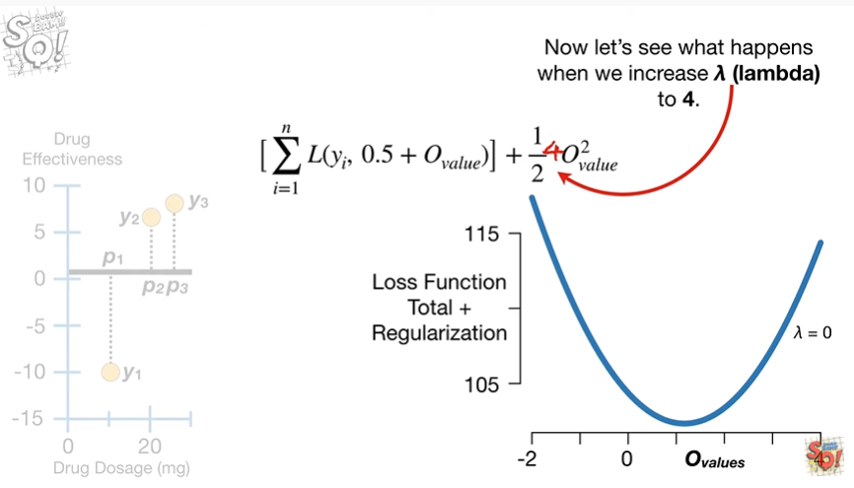

Now let's see what happens when we increase lambda to 4.

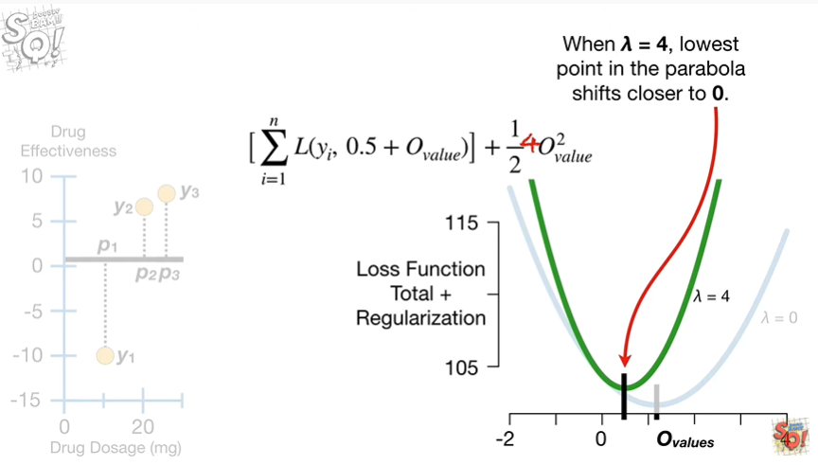

When lambda equals 4 the lowest point in the parabola shifts closer to 0.

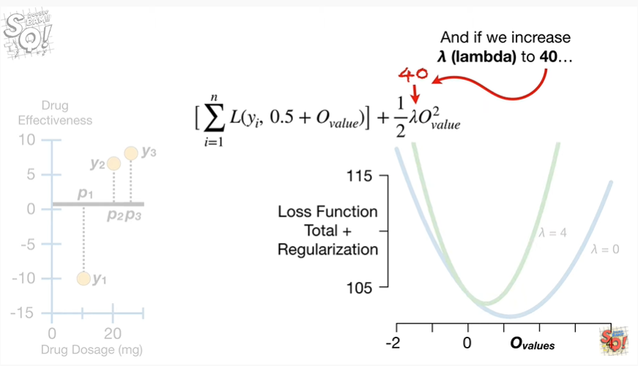

And if we increase lambda to 40

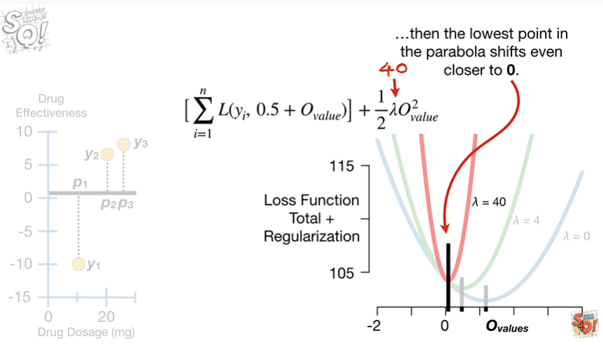

then the lowest point in the parabola shifts even closer to 0.

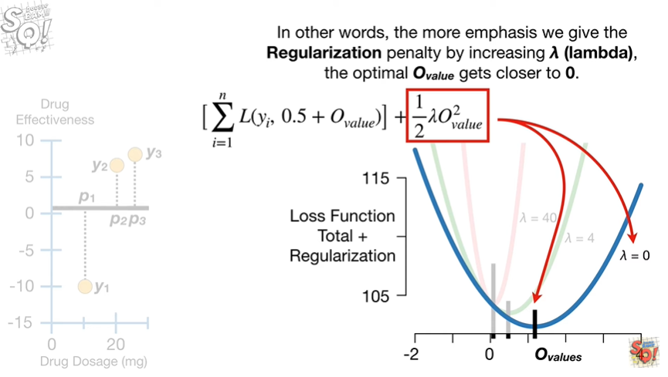

In other words, the more emphasis we give the regularization penalty by increasing lambda, the optimal output value gets closer to zero.

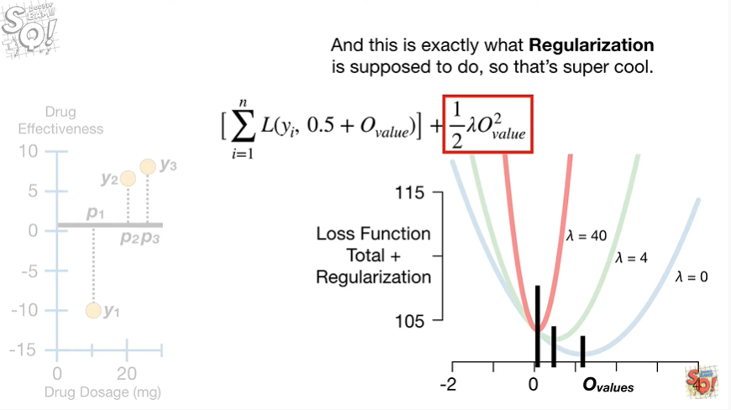

And this is exactly what regularization is supposed to do so that's super cool.

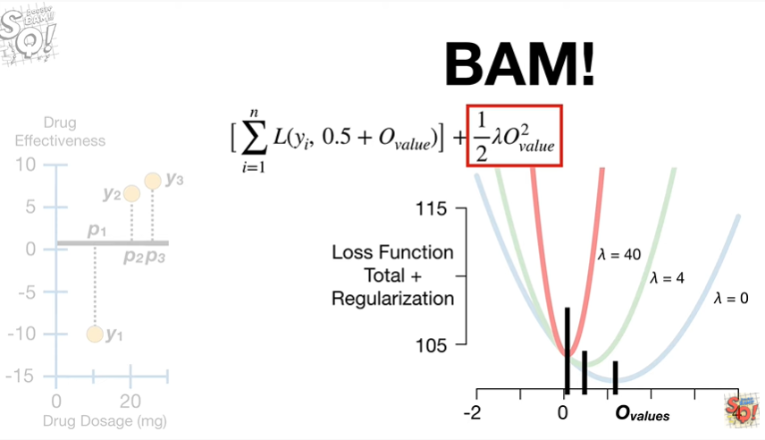

BAM !!!

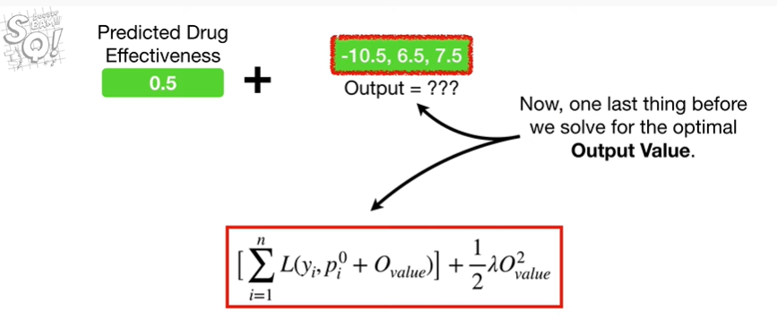

Now, one last thing before we solve for the optimal output value.

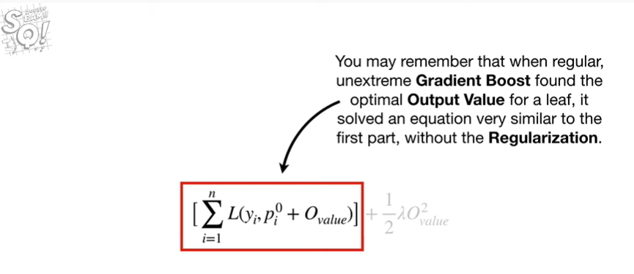

You may remember that when regular, unextreme gradient boost found the optimal output value for a leaf, it solved an equation very similar to the first, part without regularization.

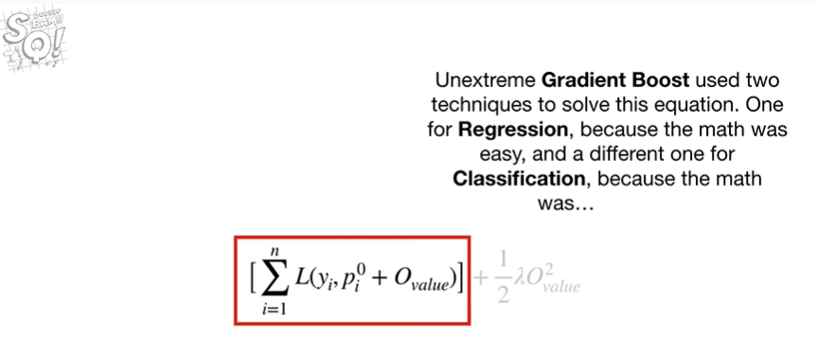

Unextreme gradient boost used two techniques to solve this equation.

One for regression, because the math was easy, and a different one for classification because the math was

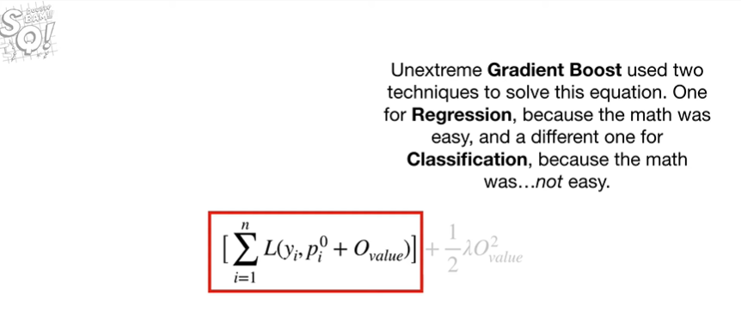

not easy.

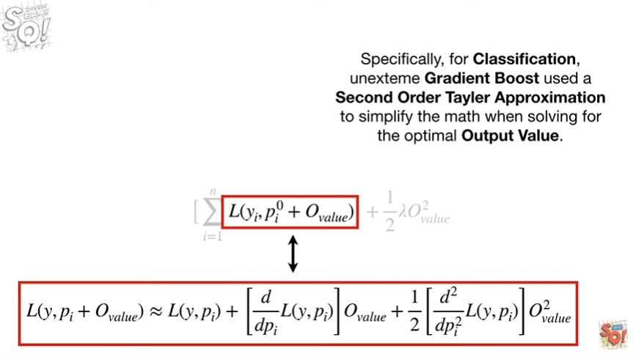

Specifically for classification on extreme gradient boost use a second-order Taylor approximation to simplify the math when solving for the optimal output value.

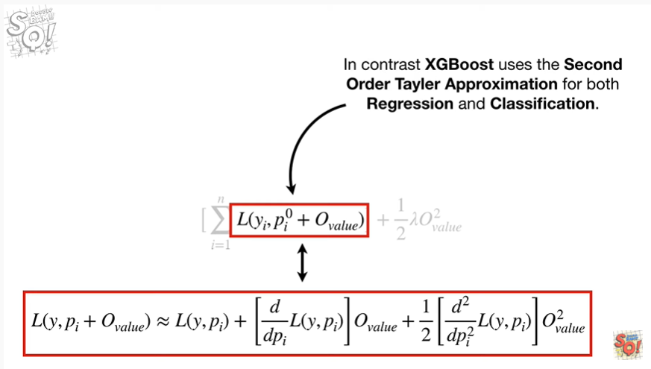

In contrast, XGBoost uses the second-order Taylor approximation for both regression and classification.

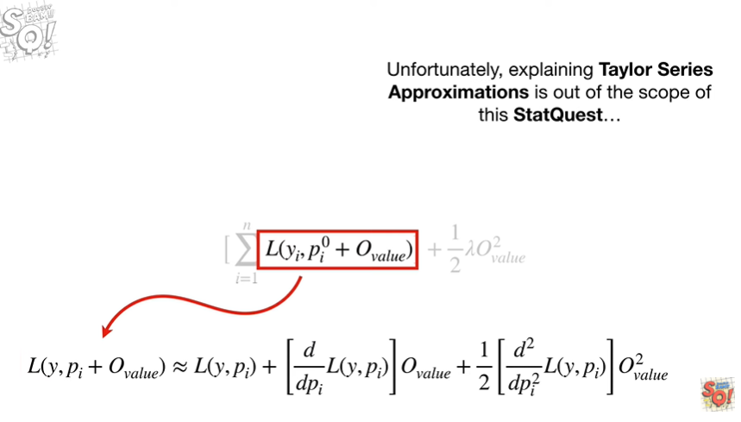

Unfortunately explaining Taylor series approximations is out of the scope of this stat quest

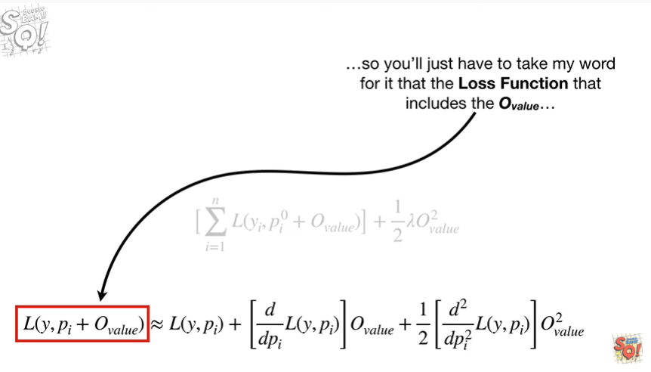

so you'll just have to take my word for it that the loss function that includes the output value

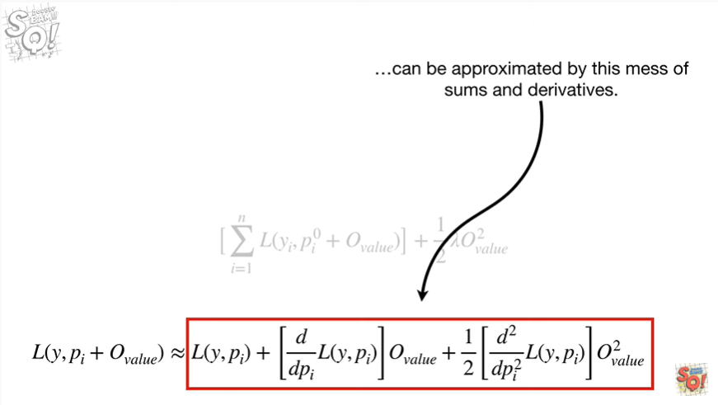

can be approximated by this mess of sums and derivatives.

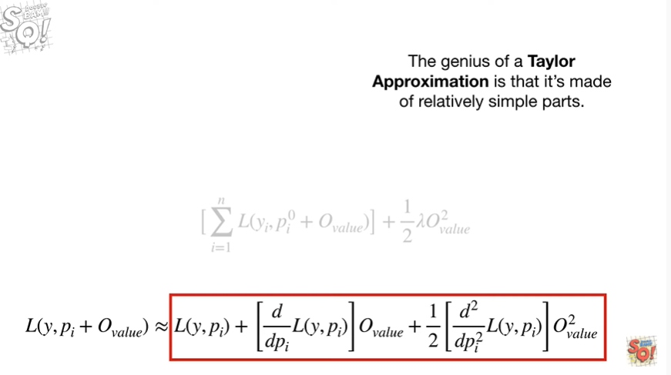

The genius of a Taylor approximation is that it's made of relatively simple parts.

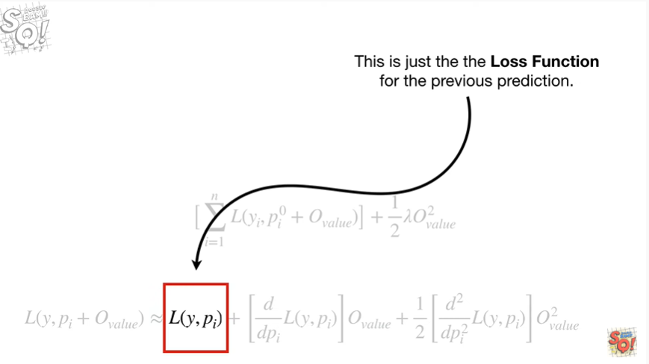

This part is just the loss function for the previous prediction.

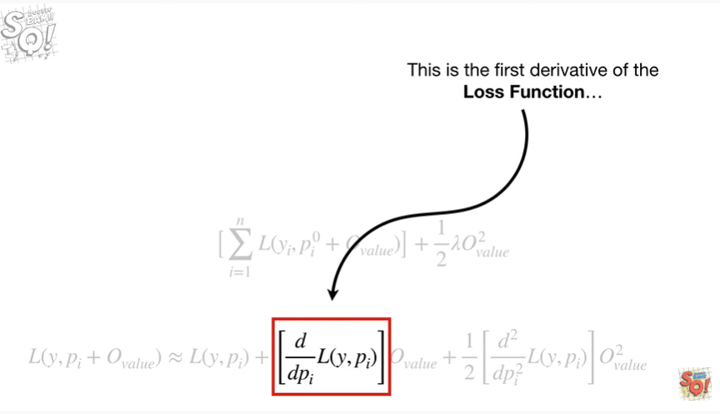

This is the first derivative of that loss function.

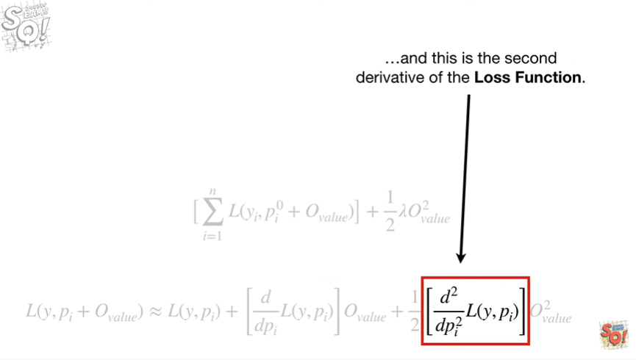

And this is the second derivative of that loss function.

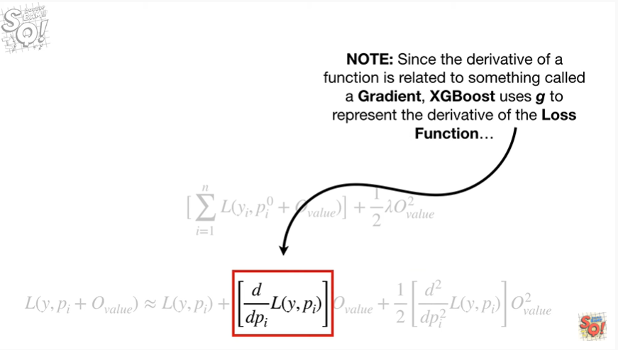

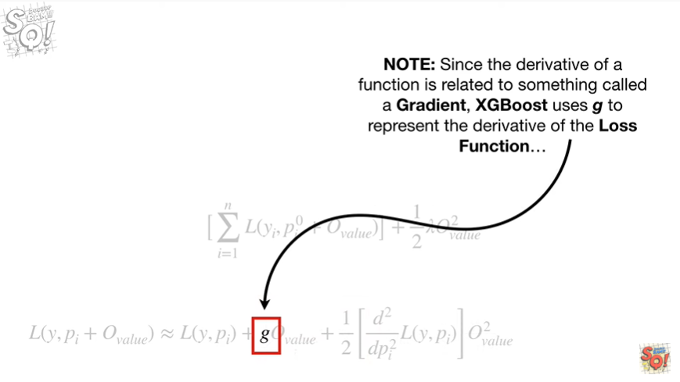

Note : since the derivative of a function is related to something called a gradient, XGBoost uses G to represent the derivative of the loss function.

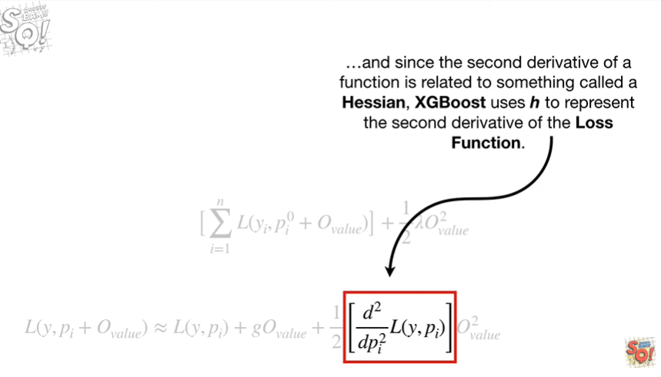

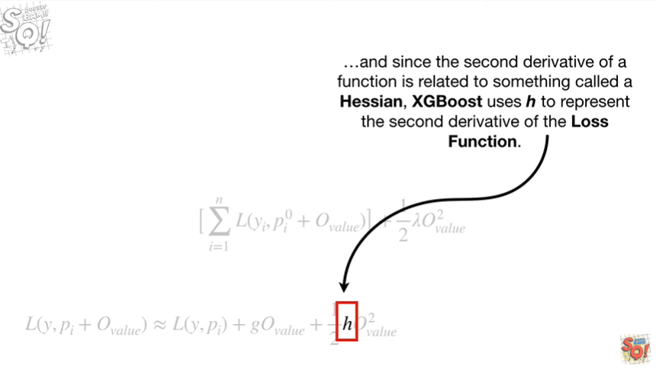

And since the second derivative of a function is related to something called a hessian, XGBoost uses h to represent the second derivative of the loss function.

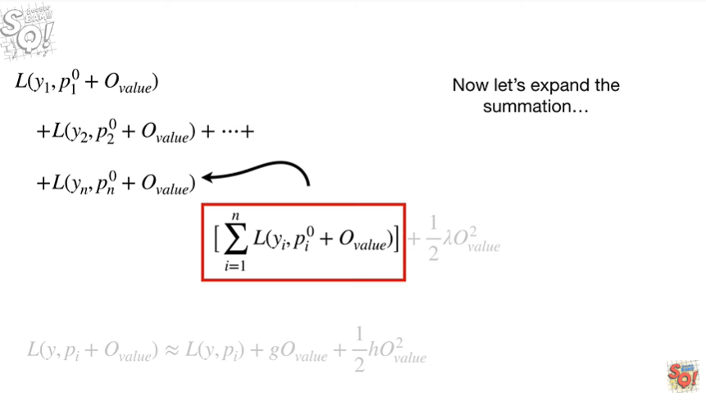

Now let's expand the summation

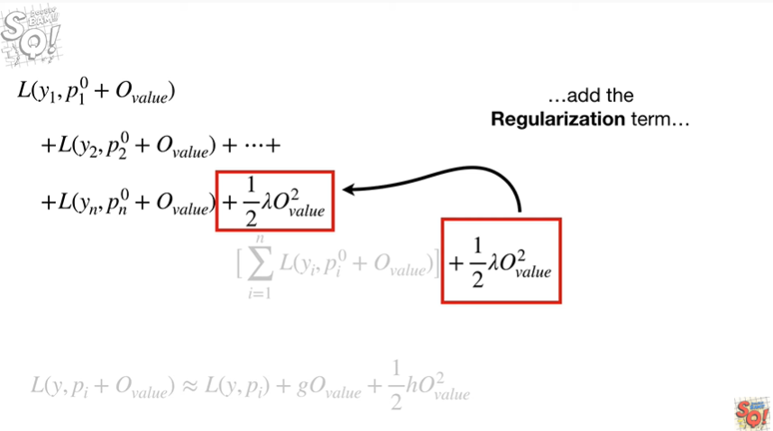

add the regularization term

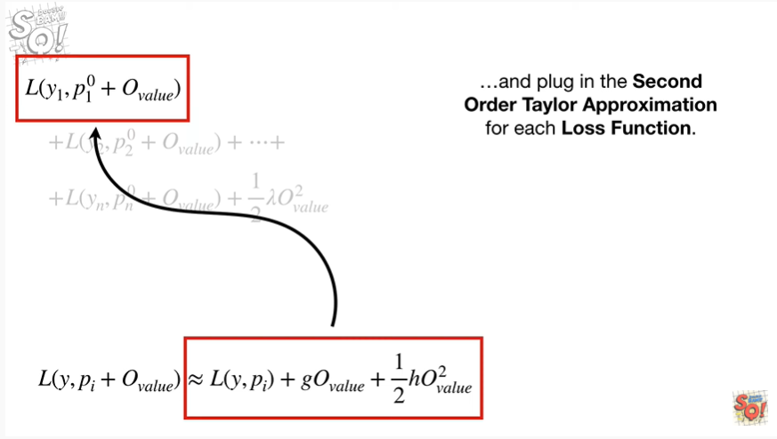

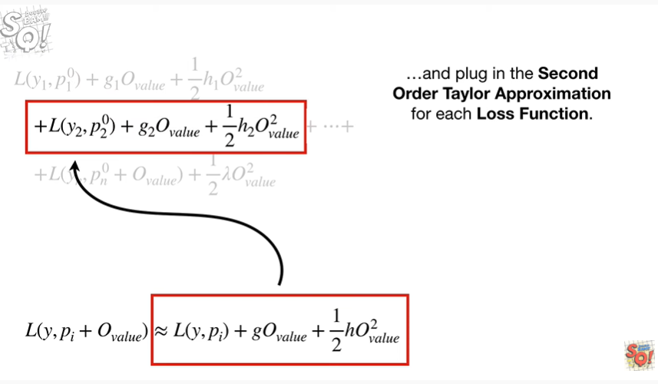

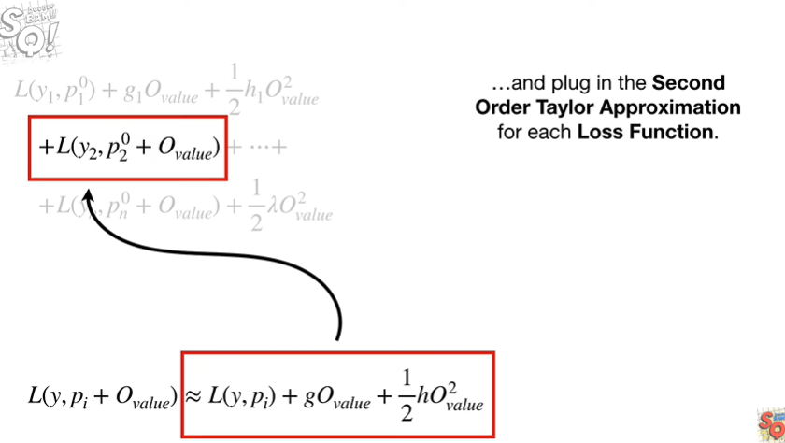

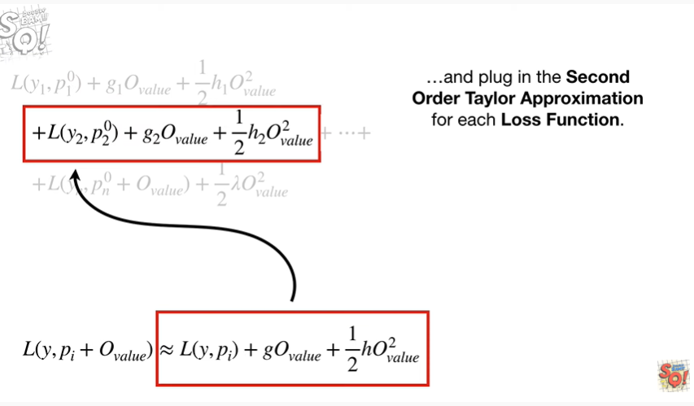

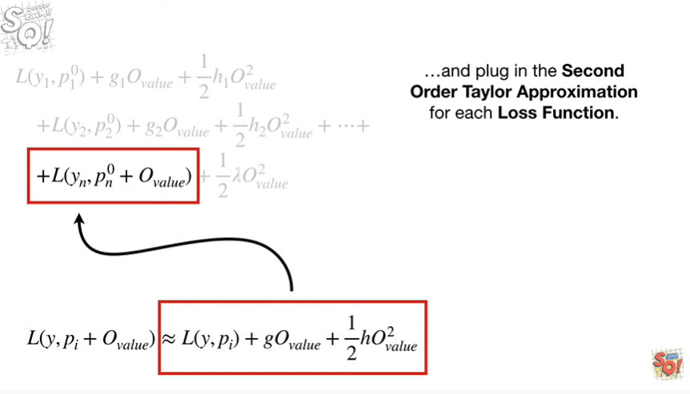

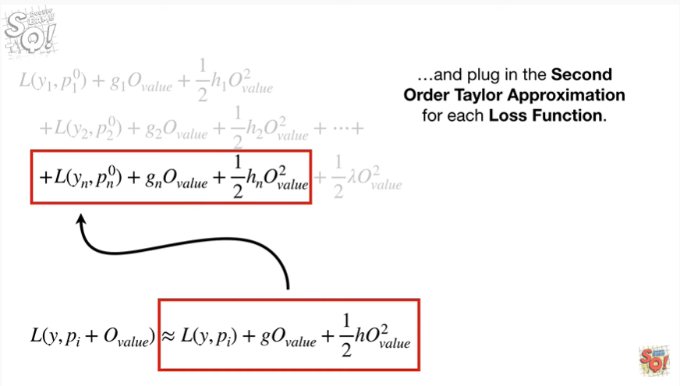

and plug in the second-order Taylor approximation for each loss function.

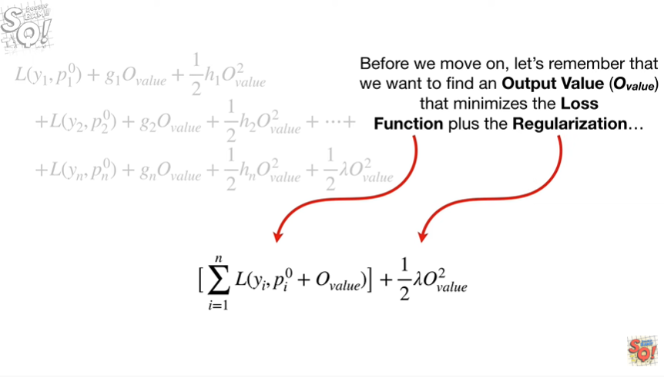

Before we move on, let's remember that we want to find an output value that minimizes the loss function plus the regularization

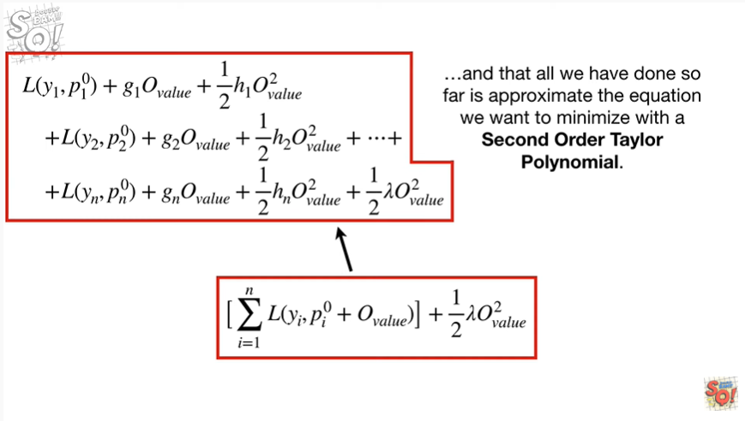

and that all we have done so far is approximate the equation we want to minimize with a second-order Taylor polynomial.

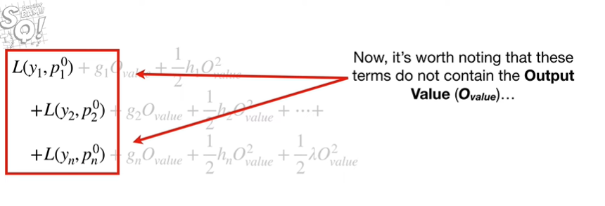

Now it's worth noting that these terms do not contain the output value

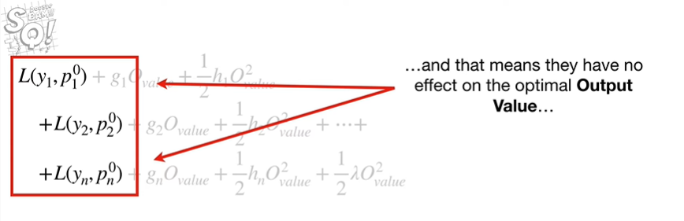

and that means they have no effect on the optimal output value

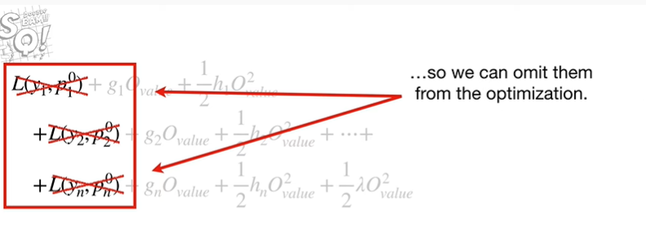

so we can omit them from the optimization.

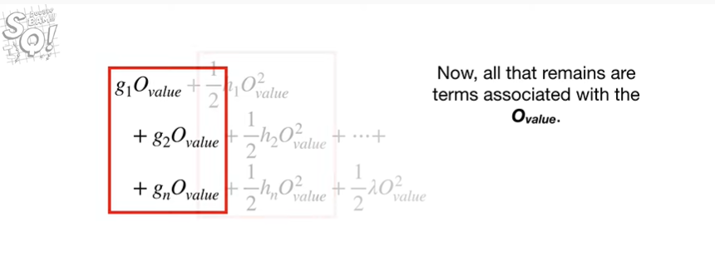

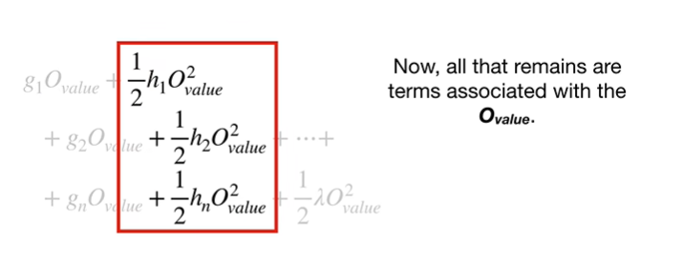

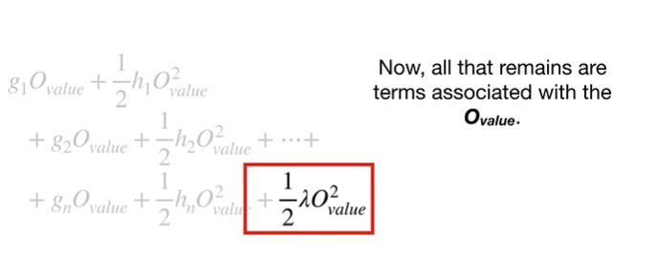

Now, all that remains are terms associated with the output value.

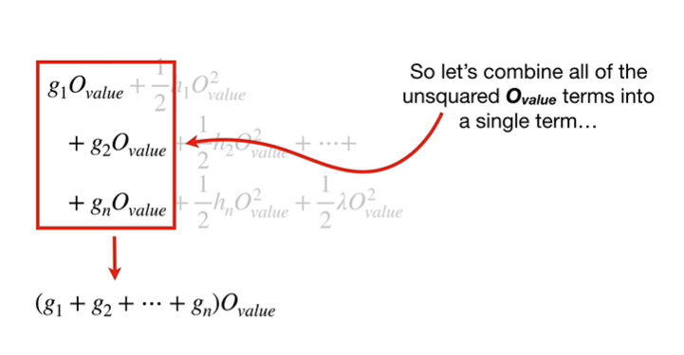

So let's combine all of the unsquare output value terms into a single term

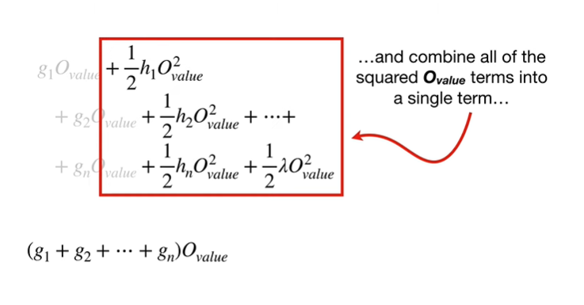

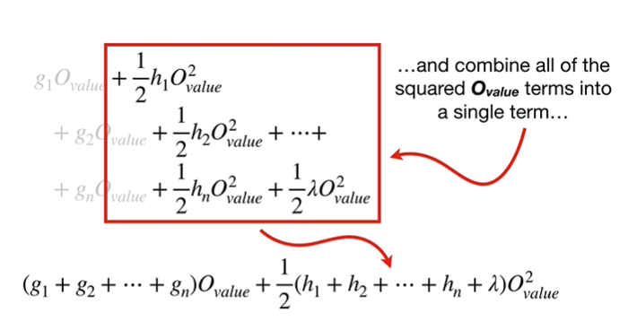

and combine all of the squared output value terms into a single term

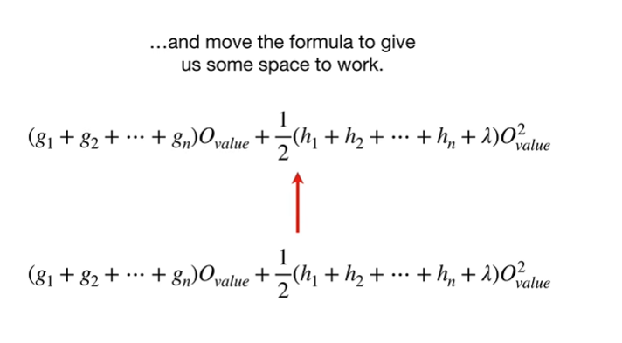

and move the formula to give us some space to work.

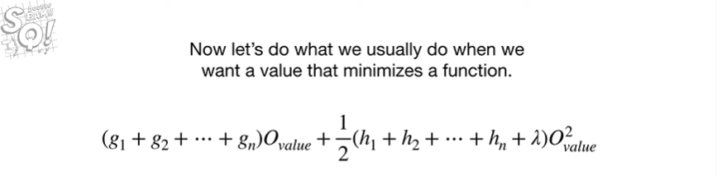

Now let's do what we usually do when we want a value that minimizes a function :

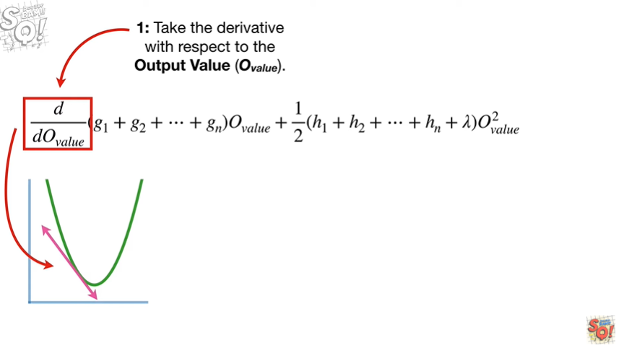

1. take the derivative with respect to the output value

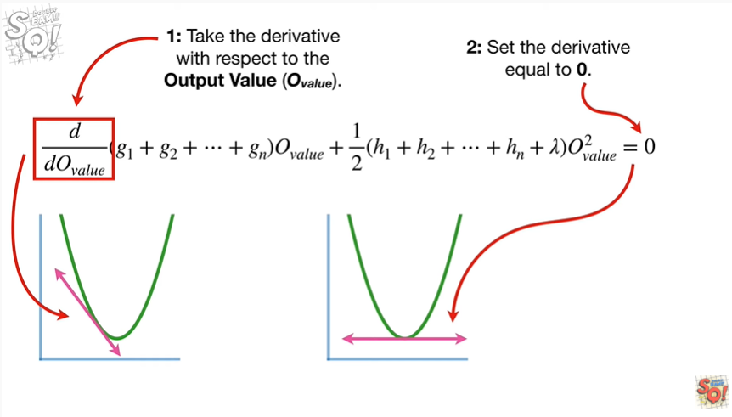

2. set the derivative equal to zero

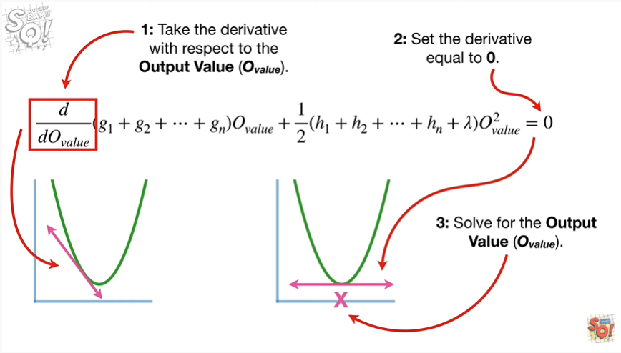

And 3. solve for the output value.

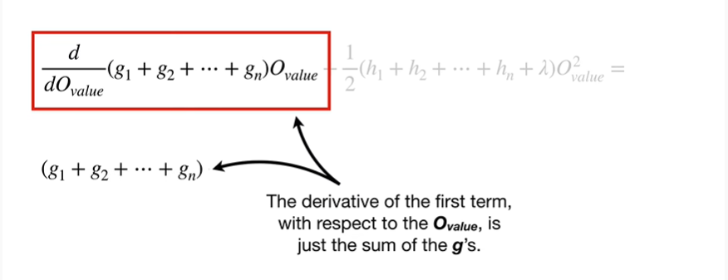

The derivative of the first term with respect to the output value, is just the sum of the g's.

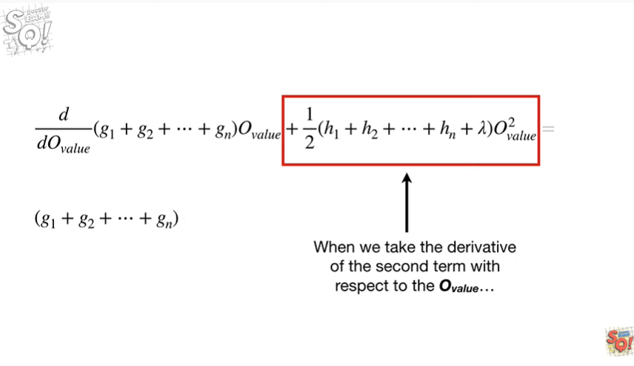

When we take the derivative of the second term with respect to the output value

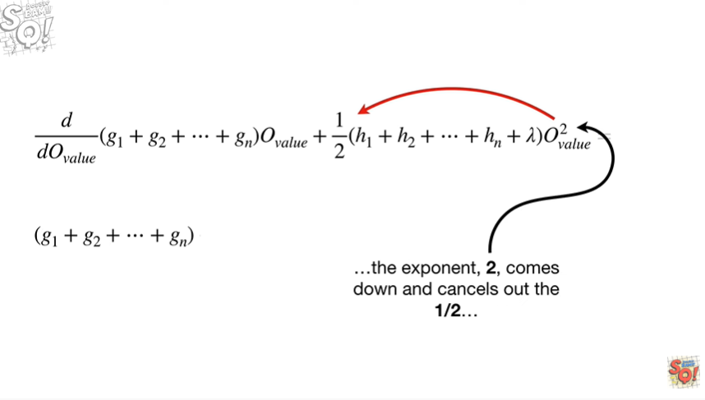

the exponent two comes down

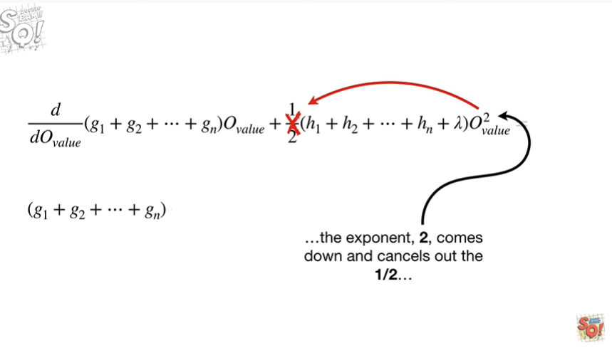

and cancels out the one-half

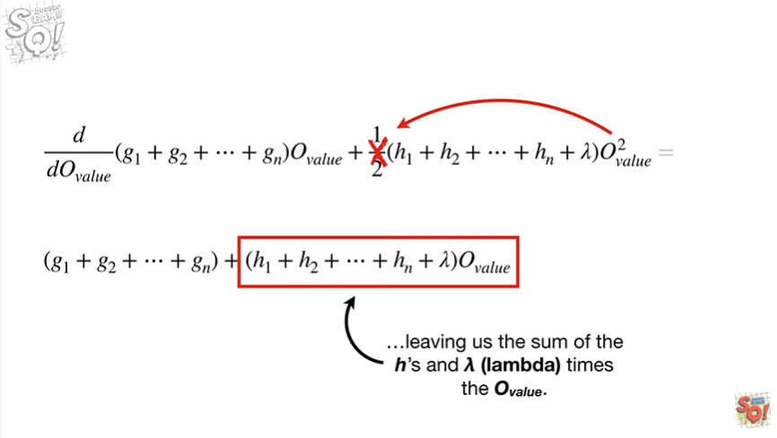

leaving us with the sum of the H's and lambda times the output value.

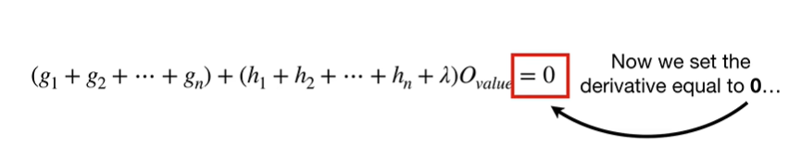

Now we set the derivative equal to zero

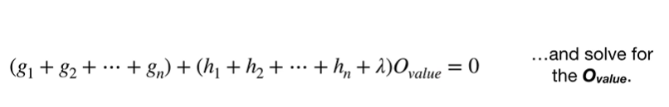

and solve for the output value.

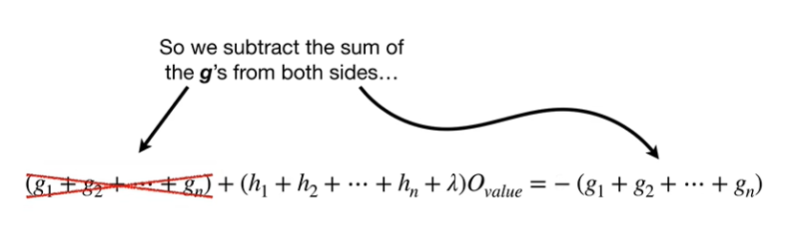

So we subtract the sum of the g's from both sides

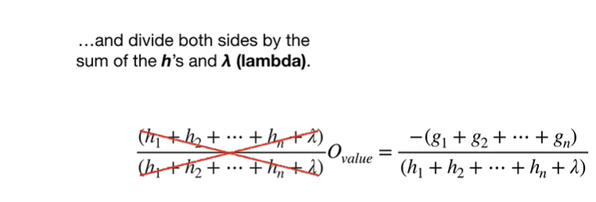

and divide both sides by the sum of the h’s and lambda.

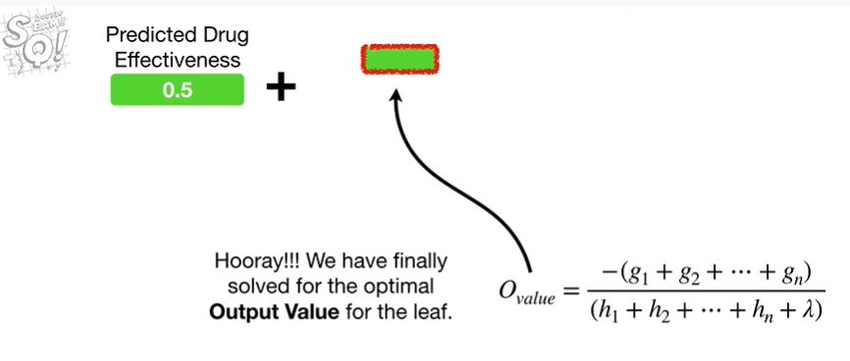

Hooray !!!

We have finally solved for the optimal output value for the leaf.

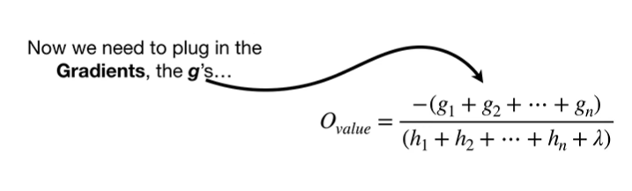

Now we need to plug in the gradients the g's

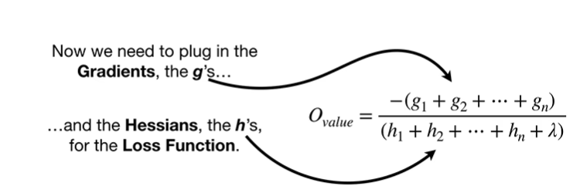

and the Hessians the h's for the loss function.

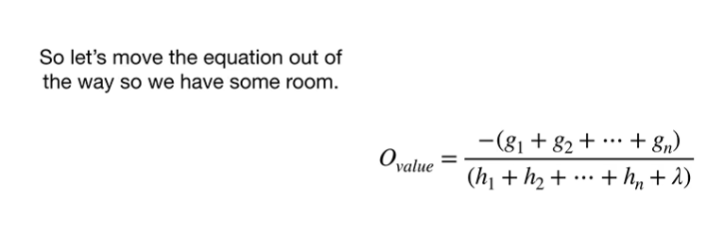

So let's move the equation out of the way so we have some room.

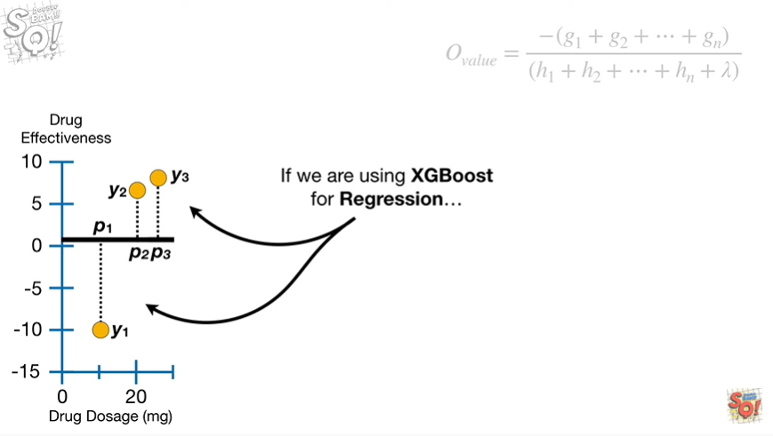

If we're using XGBoost for regression

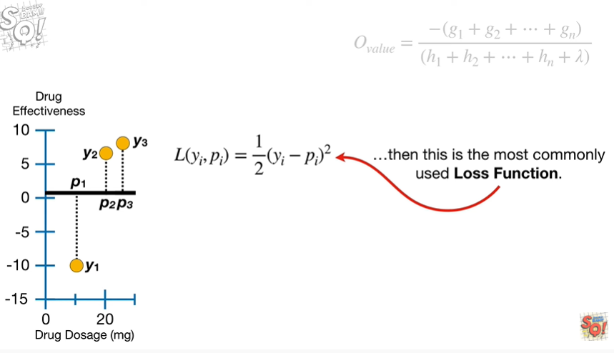

then this is the most commonly used loss function.

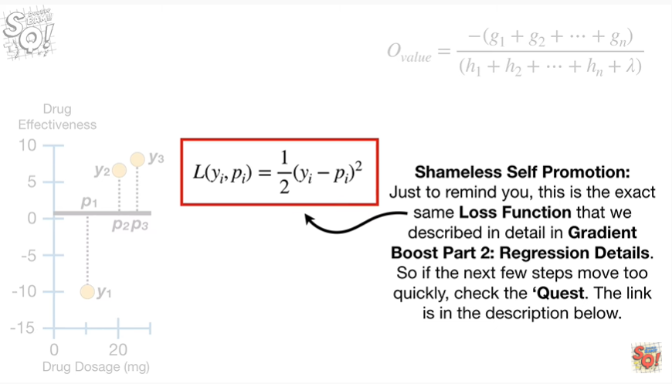

Shameless self-promotion : just to remind you, this is the exact same loss function that we described in detail in gradient boost part two, regression details .

So if the next few steps move too quickly, just check out the quest, the link is in the description below.

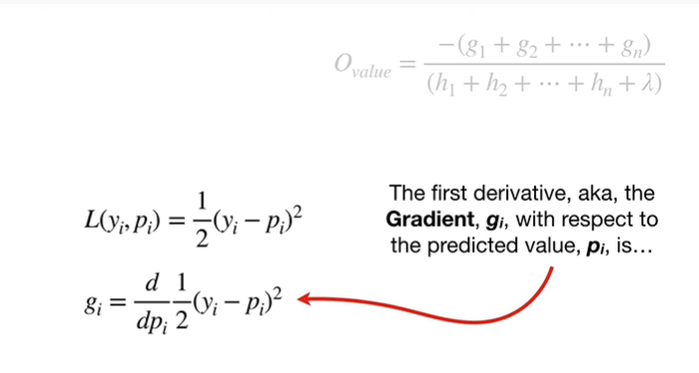

The first derivative aka the gradient G sub I with respect to the predicted value P sub I is

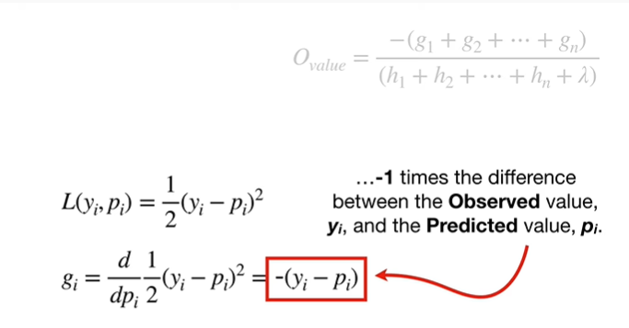

negative one times the difference between the observed value y sub I and the predicted value P sub I.

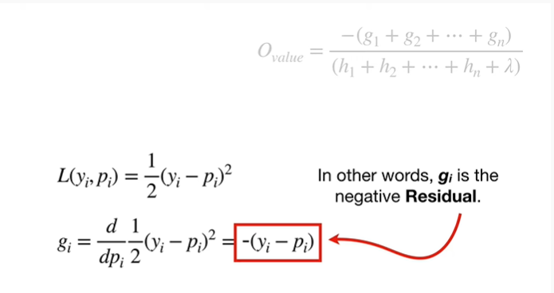

In other words, g sub I is the negative residual.

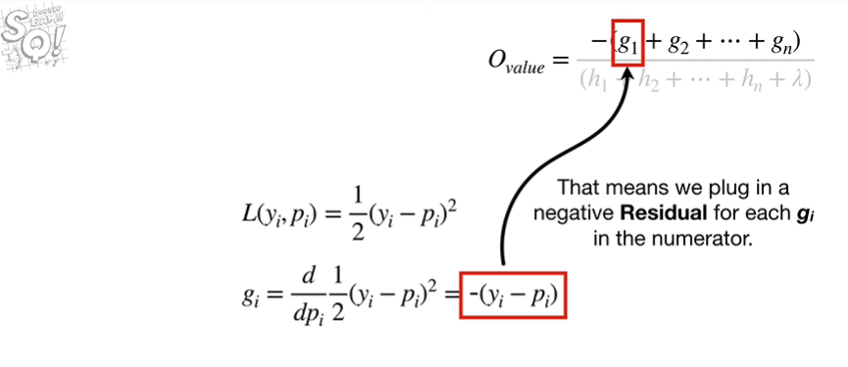

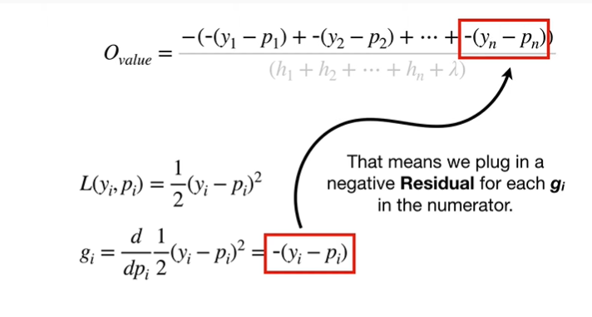

That means we plug in the negative residual for each g sub I in the numerator.

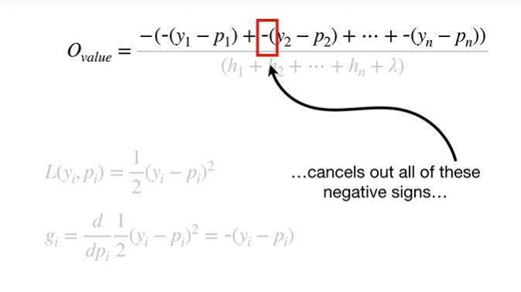

Note : this negative sign cancels out all of these negative signs

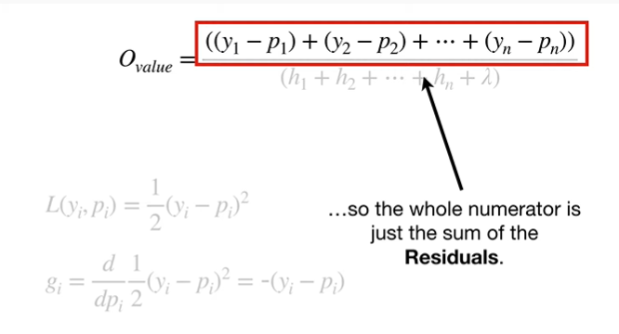

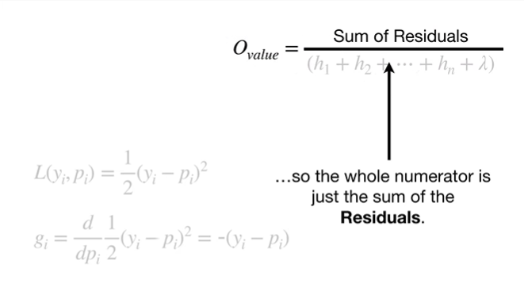

so the whole numerator is just the sum of the residuals.

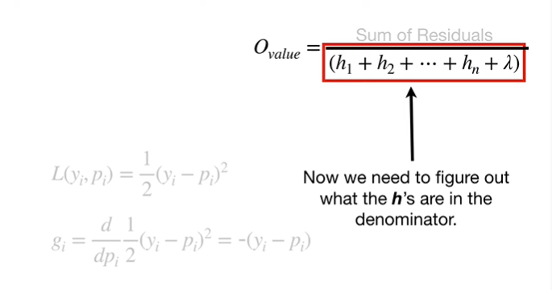

Now we need to figure out what the ages are in the denominator.

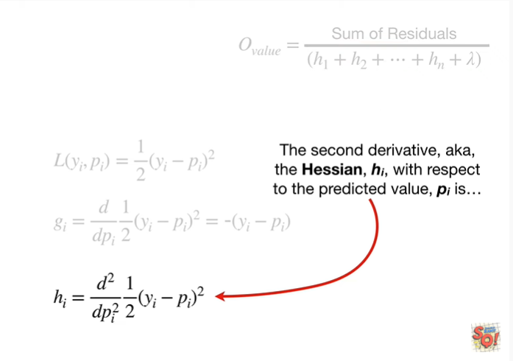

The second derivative aka the Hessian H sub I ,with respect to the predicted value P sub I is

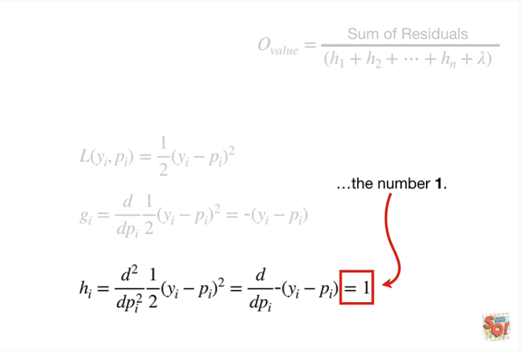

the number one.

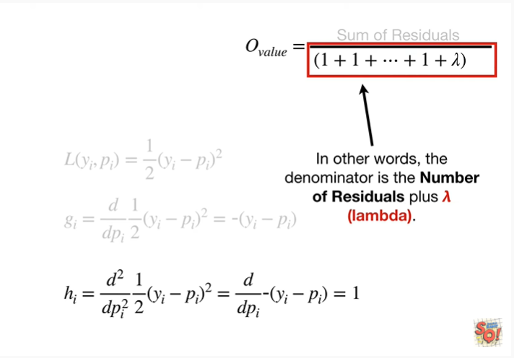

So that means we replace all in H's in the denominator with the number one.

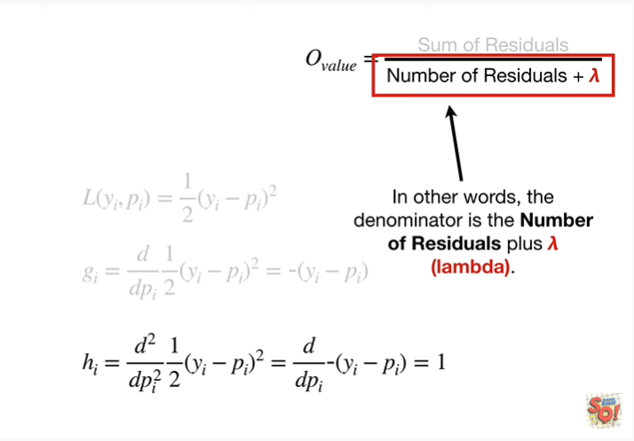

In other words the denominator is the number of residuals plus lambda.

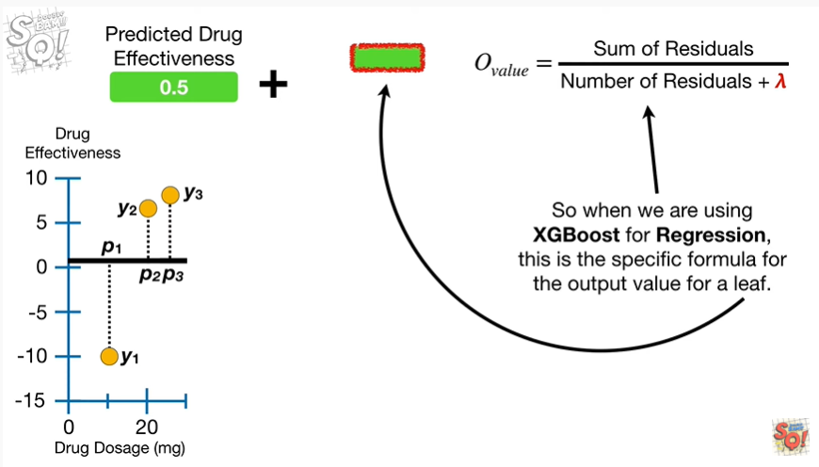

So when we are using XGBoosts for regression this is the specific formula for the output value for a leaf.

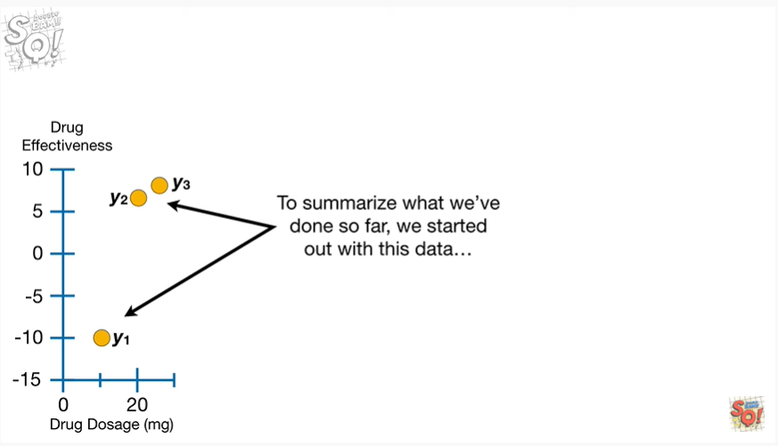

To summarize, what we've done so far, we started out with this data

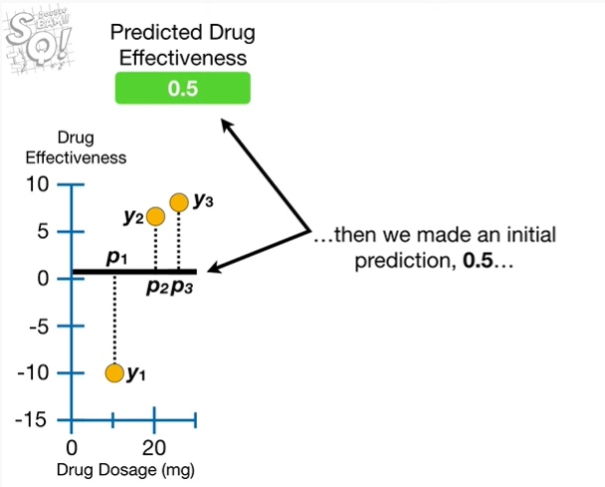

then we made an initial prediction 0.5

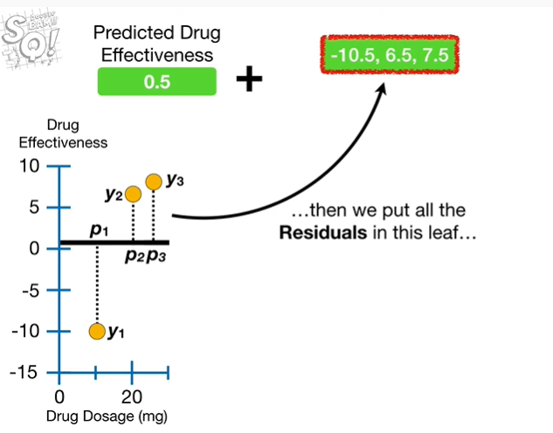

then we put all of the residuals in this leaf

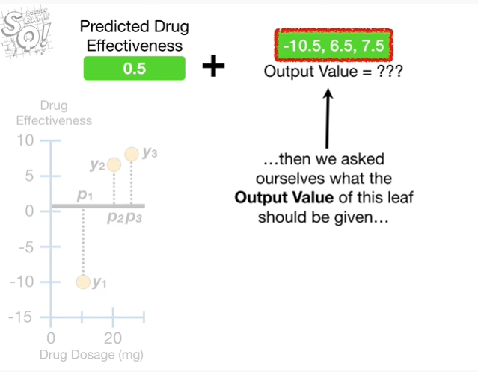

then we asked ourselves what the output value of this leaf should be given

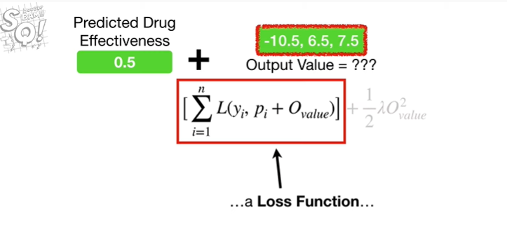

a loss function

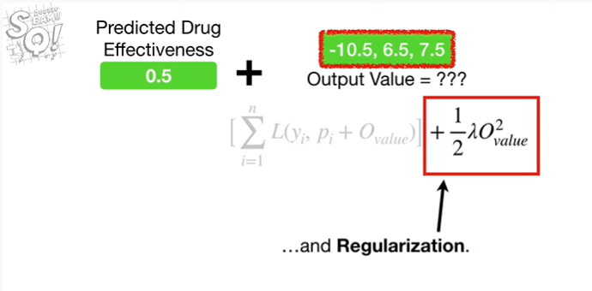

and regularization.

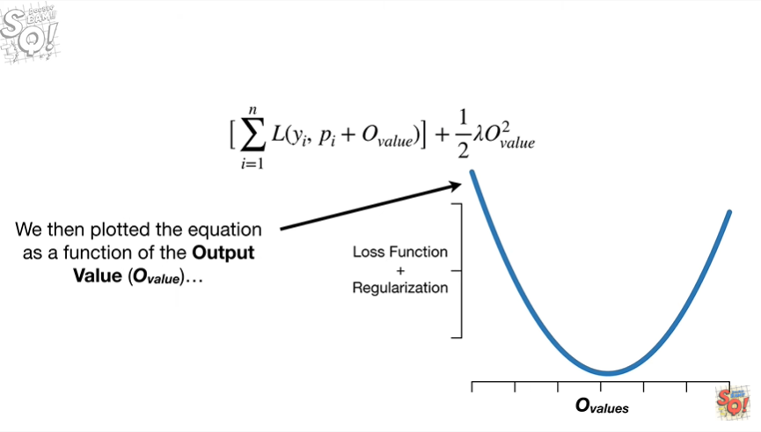

We then plotted the equation as a function of the output value

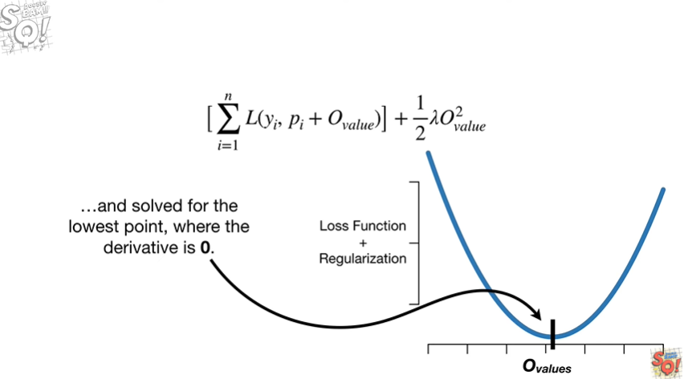

and solve for the lowest point where the derivative is zero

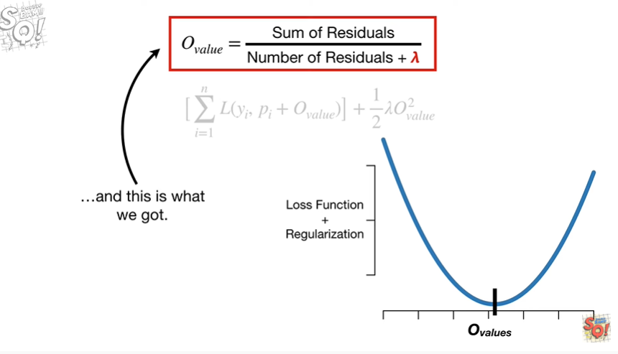

and this is what we got.

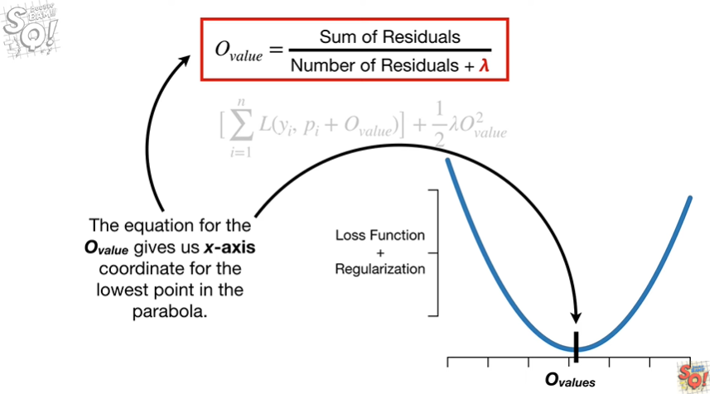

The equation for the output value gives us the X access coordinate for the lowest point in the parabola.

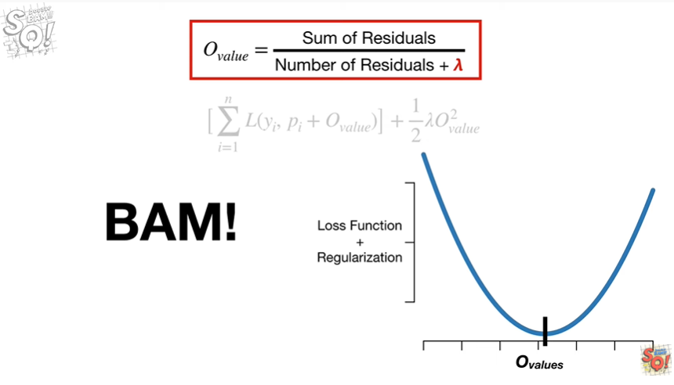

BAM !!!

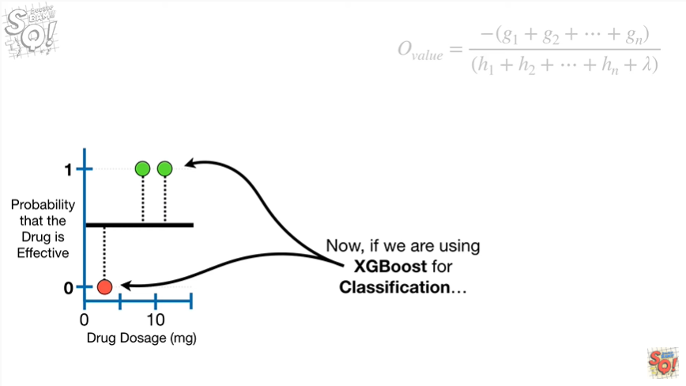

Now if we are using XGBoost for classification

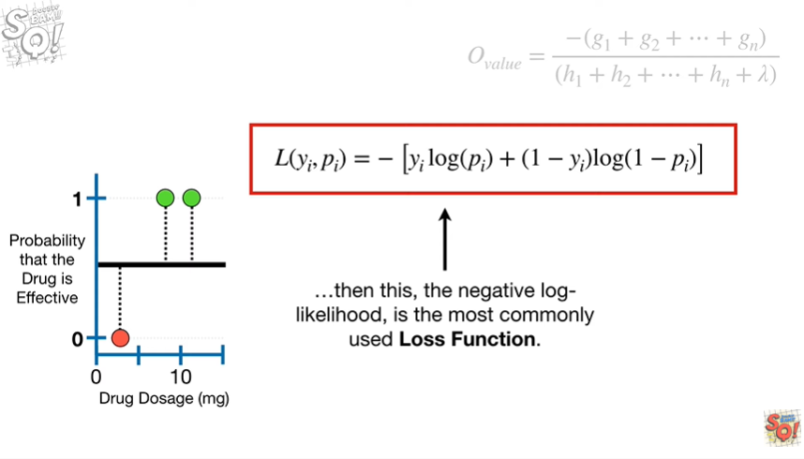

then this the negative log likelihood is the most commonly used loss function.

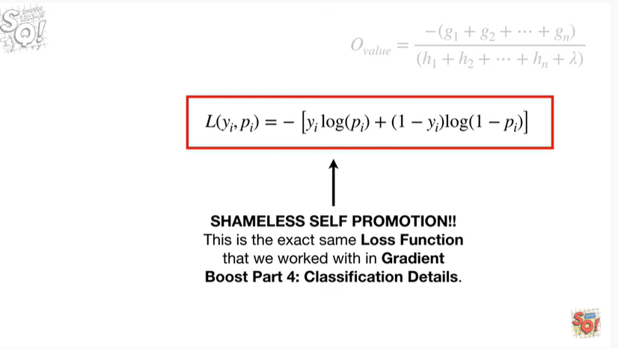

Shameless self-promotion this is the exact same loss function that we worked with in gradient boost part 4 : classification details.

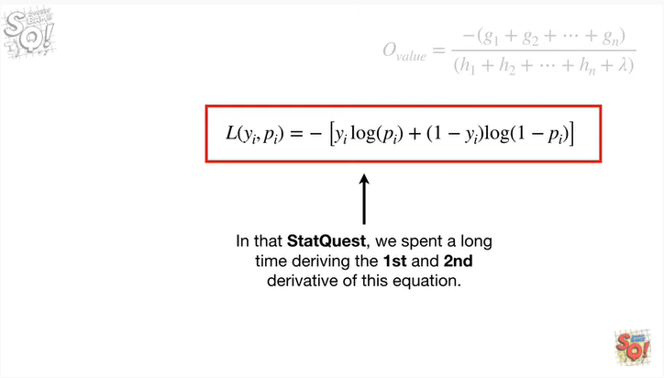

In that stat quest, we spent a long time deriving the first and second derivative of this equation calculating the derivatives took a long time because the output values are in terms of the log odds

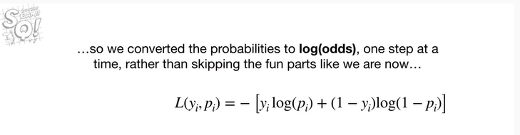

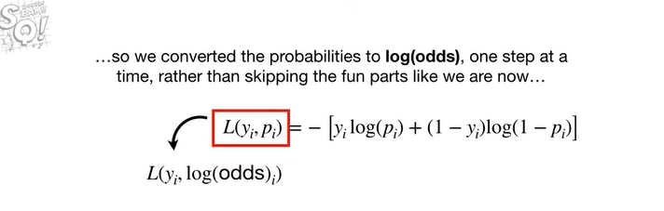

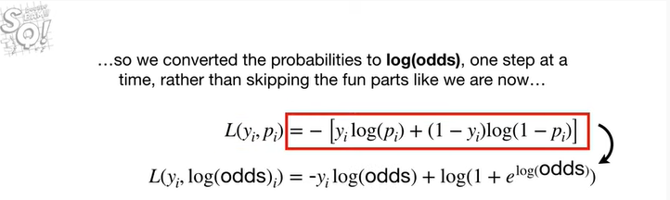

so we converted the probabilities to log-odds one step at a time rather than skipping the fun parts like we are now

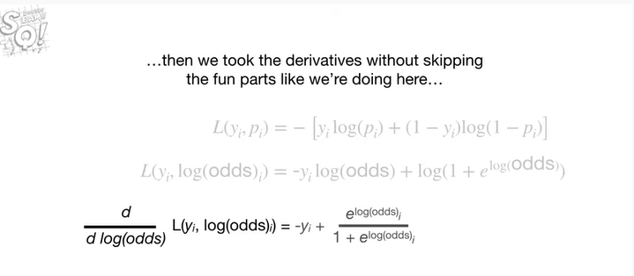

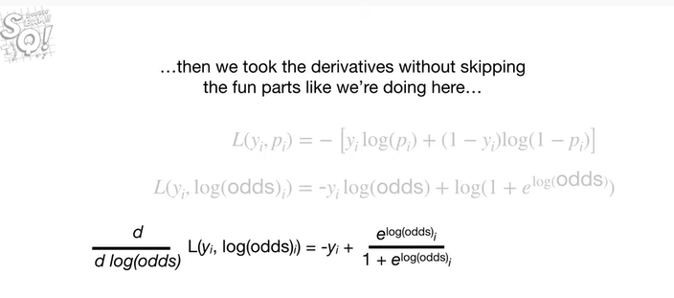

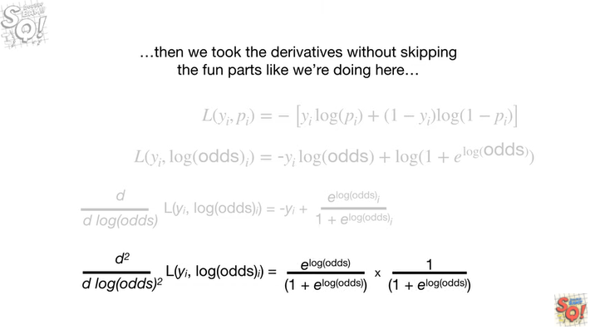

then we took the derivatives without skipping the fun parts like we're doing here

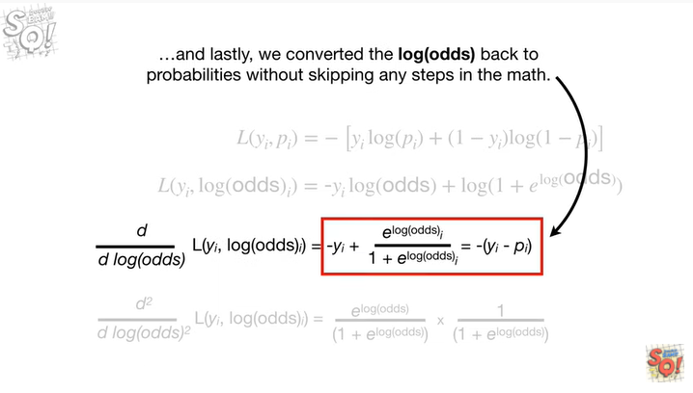

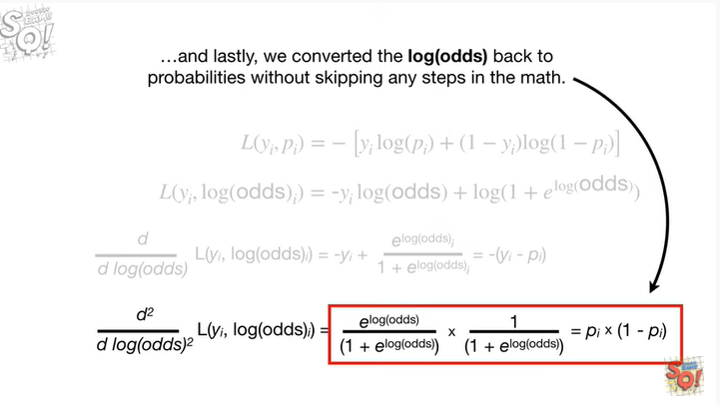

and lastly we converted the log-odds back to probabilities without skipping any steps in the math.

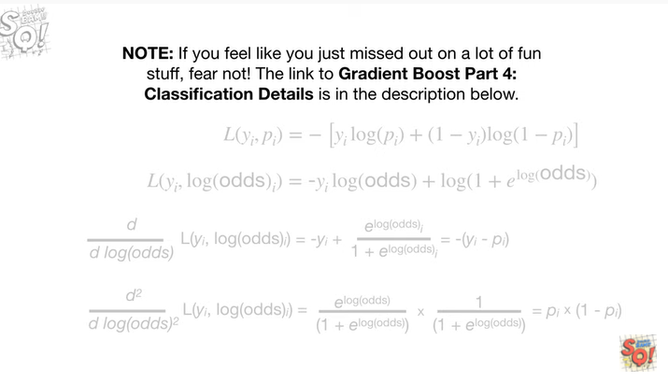

Note : if you feel like you just missed out on a lot of fun stuff fear not !

The link to gradient boost part for classification details is in the description below.

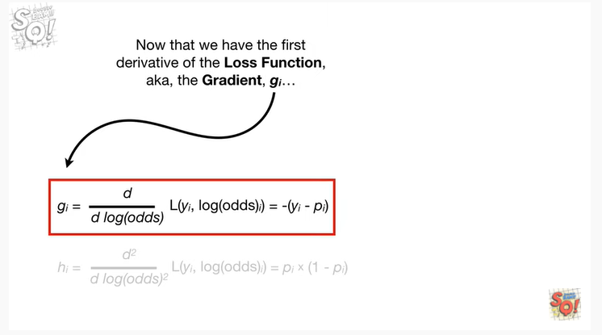

Now that we have the first derivative of the loss function aka the gradient g sub i

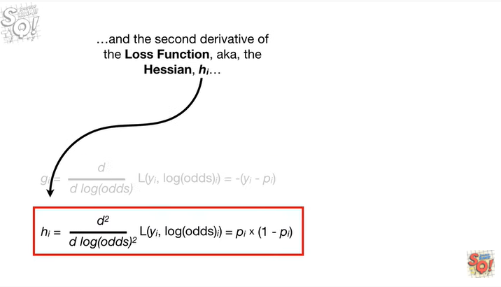

and the second derivative of the loss function aka the Hessian h sub i

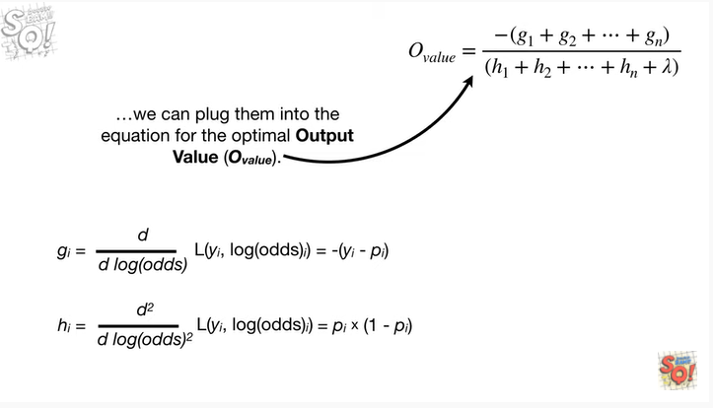

we can plug them into the equation for the optimal output value.

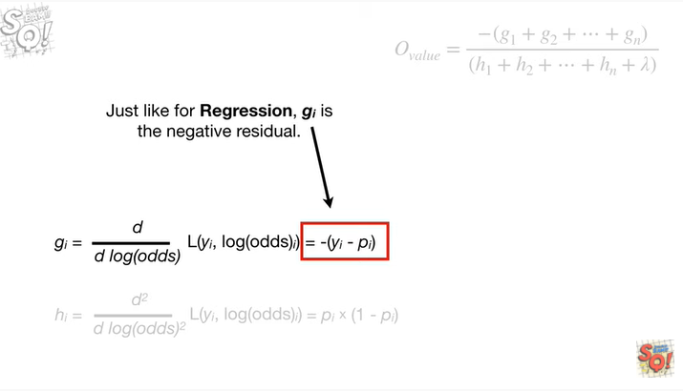

Just like for regression g sub i is the negative residual.

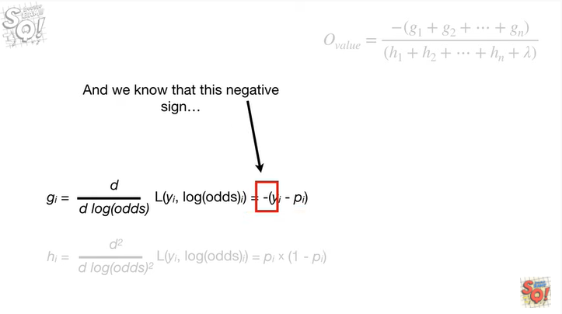

And we know that this negative sign

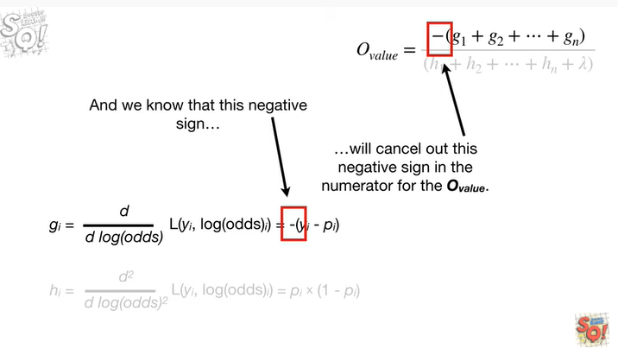

will cancel out this negative sign in the numerator for the output value.

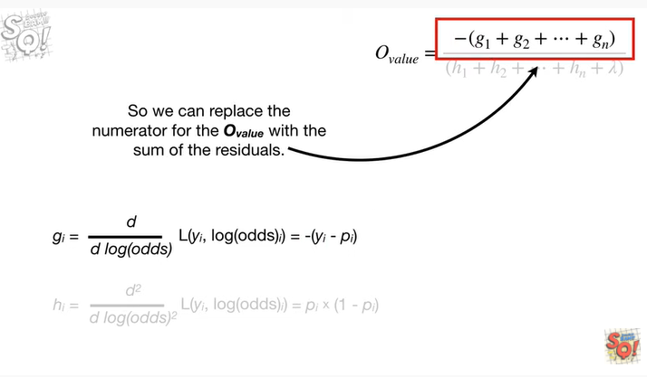

So we can replace the numerator for the output value

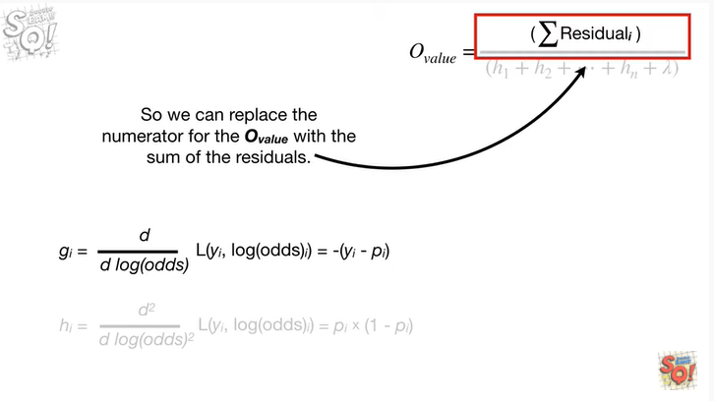

with the sum of the residuals.

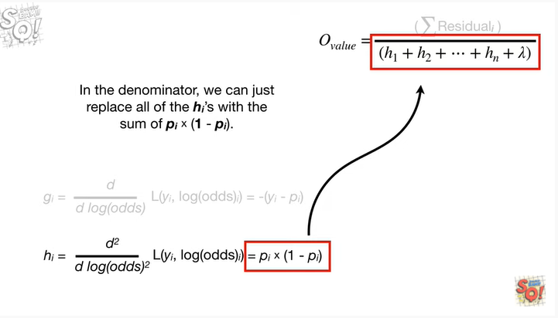

In the denominator, we can just replace all of the H sub i's with the sum of P sub I times 1 minus P sub I.

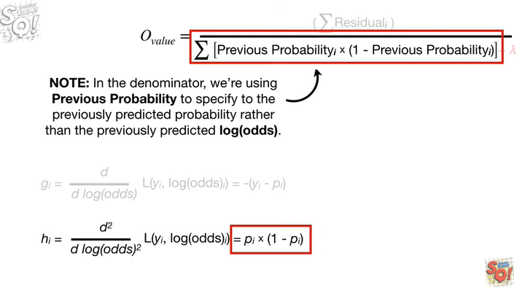

Note : in the denominator we're using previous probability to specify the previously predicted probability rather than the previously predicted log odds.

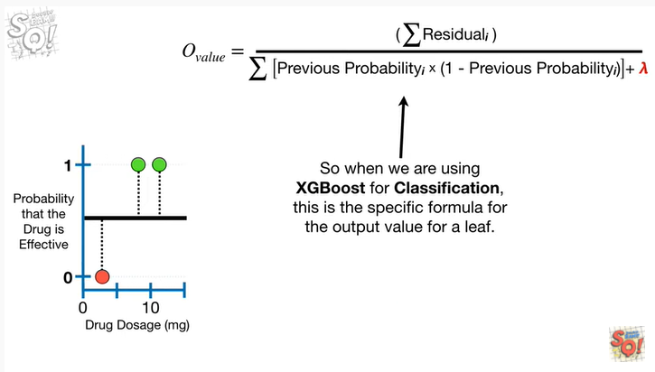

So when we are using XGBoost for classification, this is the specific formula for the output value for a leaf.

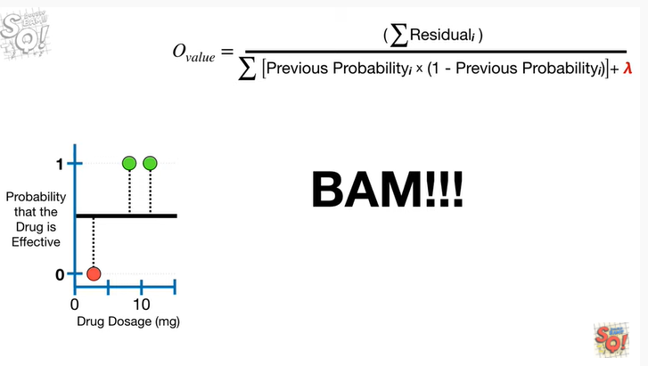

BAM !!!

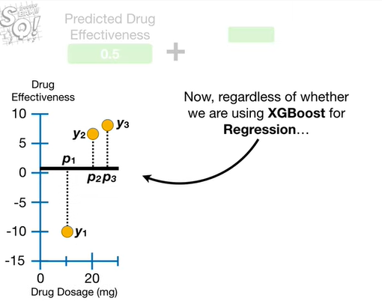

Now regardless of whether we are using XGBoosts for regression

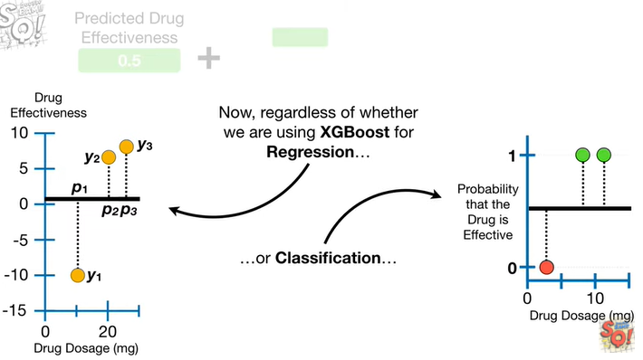

or classification

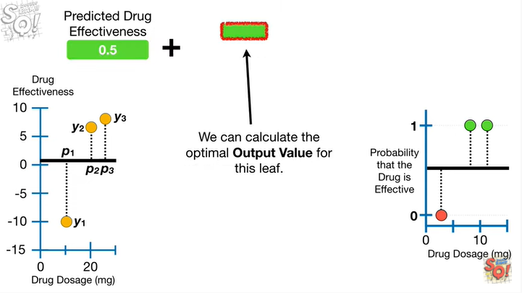

we can calculate the optimal output value for this leaf.

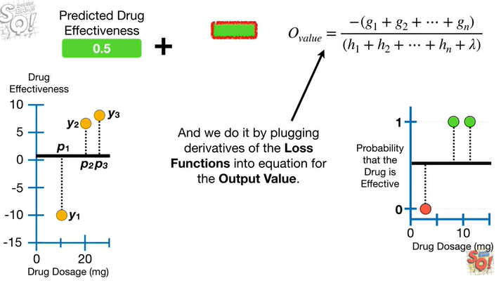

And we do it by plugging derivatives of the loss functions into the equation for the output value.

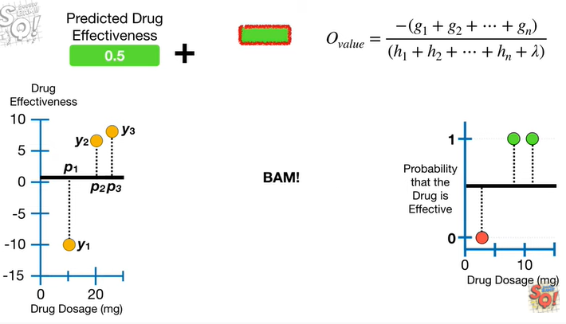

BAM !!!

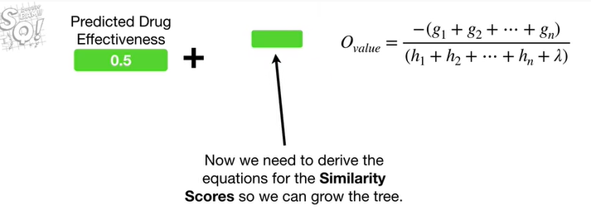

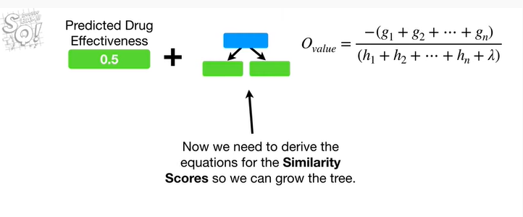

Now we need to derive the equations for the similarity score so we can grow the tree.

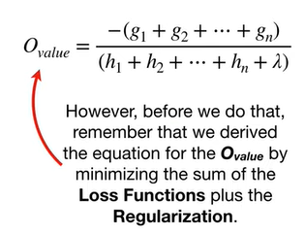

However, before we do that remember that we derived the equation for the output value

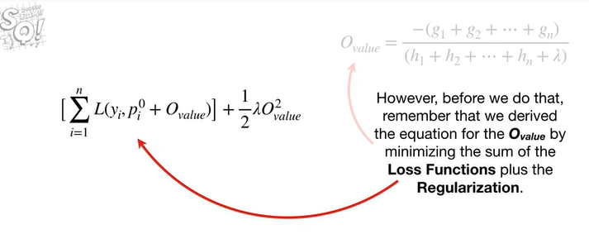

by minimizing the sum of the loss functions

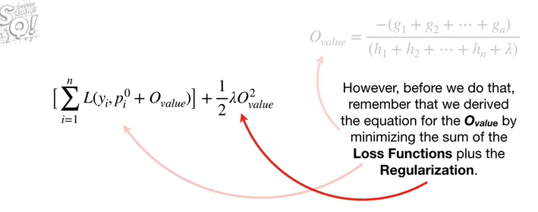

plus the regularization.

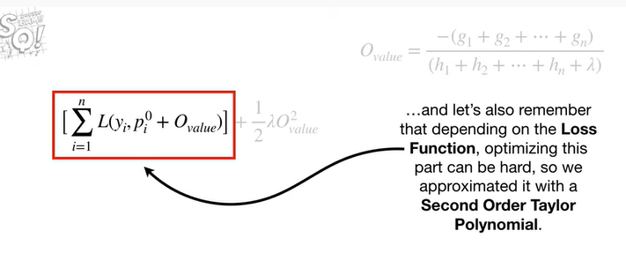

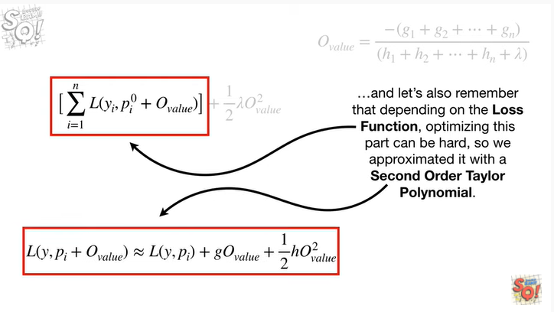

and let's also remember that depending on the loss function, optimizing this part can be hard so we approximated it with a second-order Taylor polynomial.

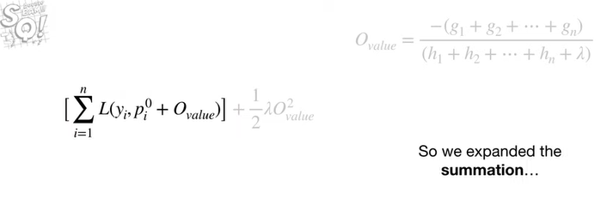

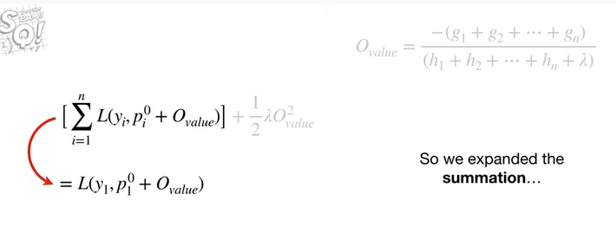

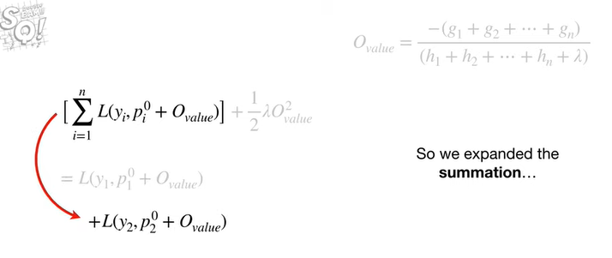

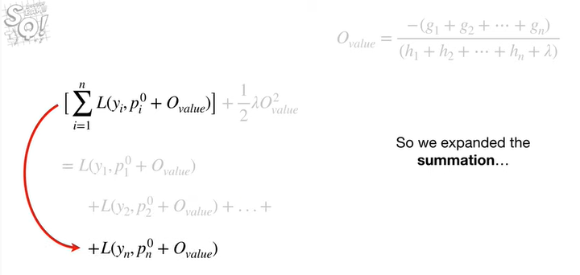

So we expanded the summation

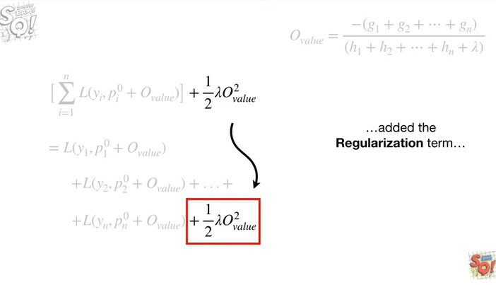

added the regularization term

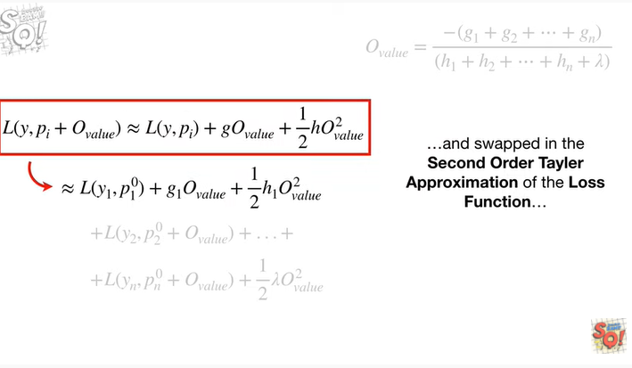

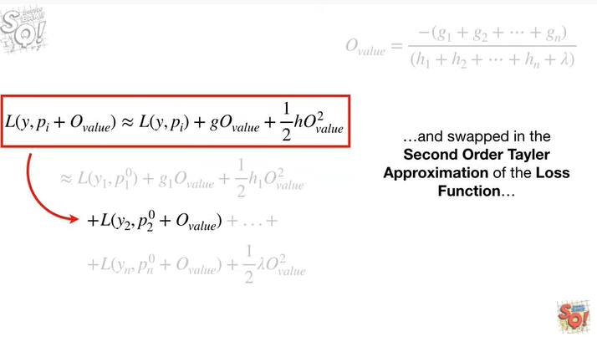

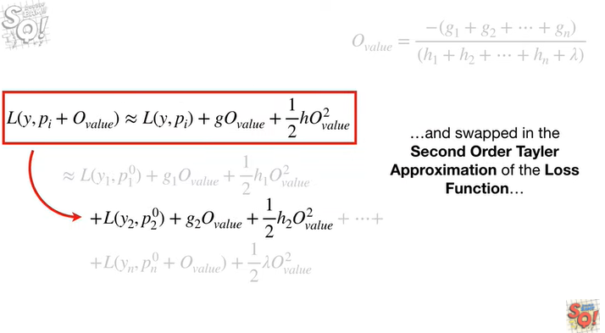

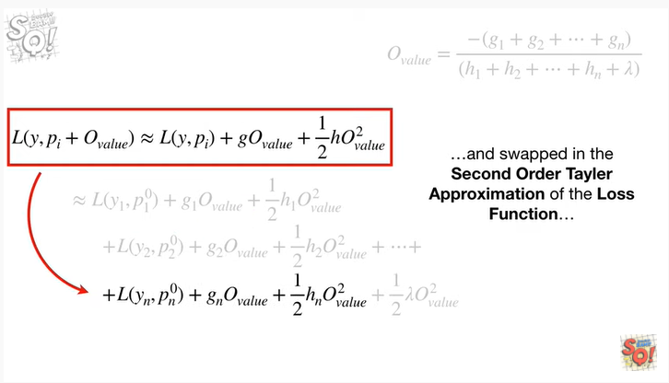

and swapped in the second-order Taylor approximation of the loss function

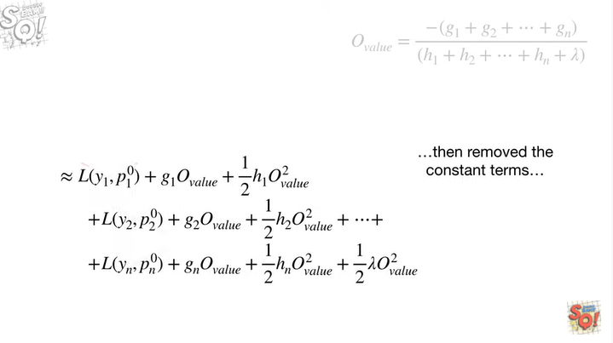

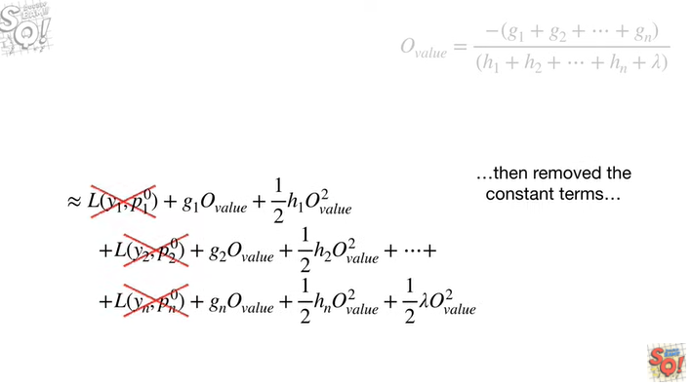

then removed the constant terms

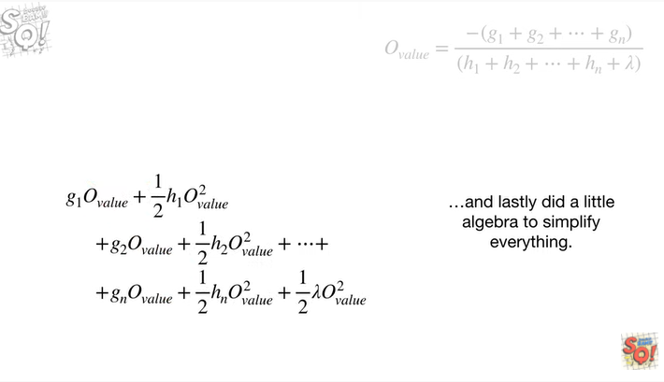

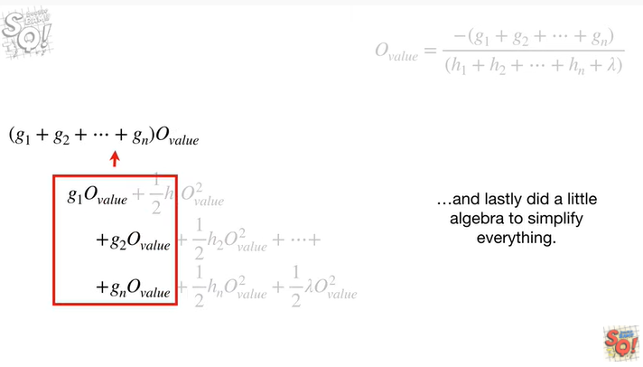

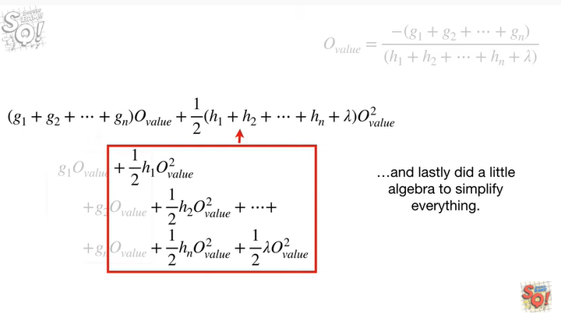

and lastly did a little algebra to simplify everything.

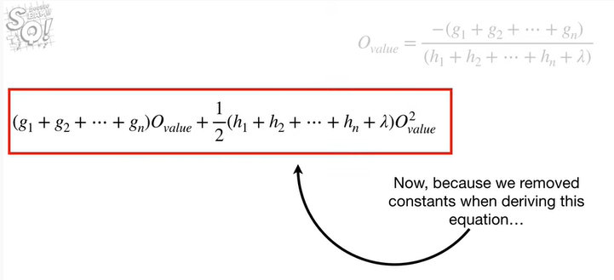

Now because we removed constants when deriving this equation

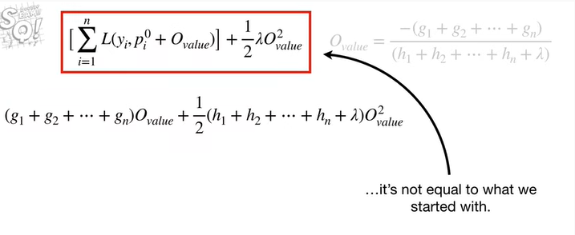

it's not equal to what we started with.

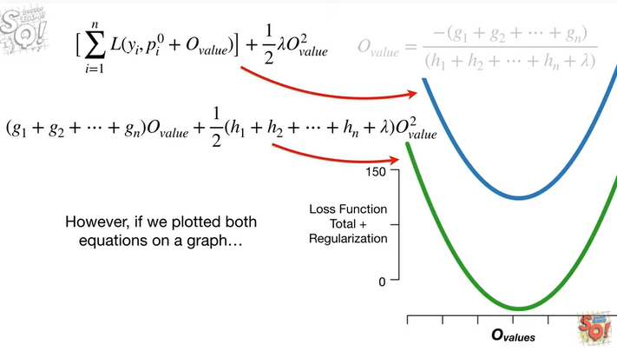

However, if we plotted both equations on a graph

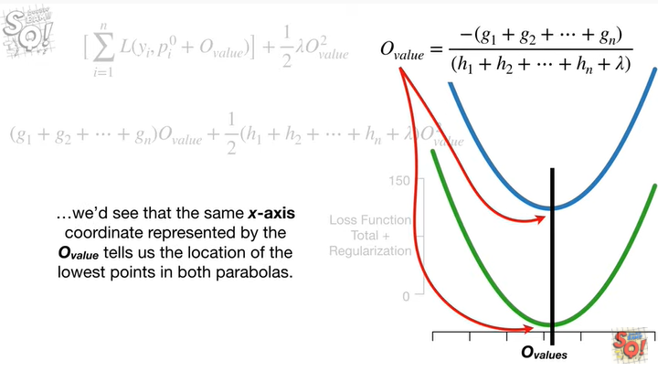

we'd see that the same X access coordinate represented by the optimal value tells us the location of the lowest points in both parabolas.

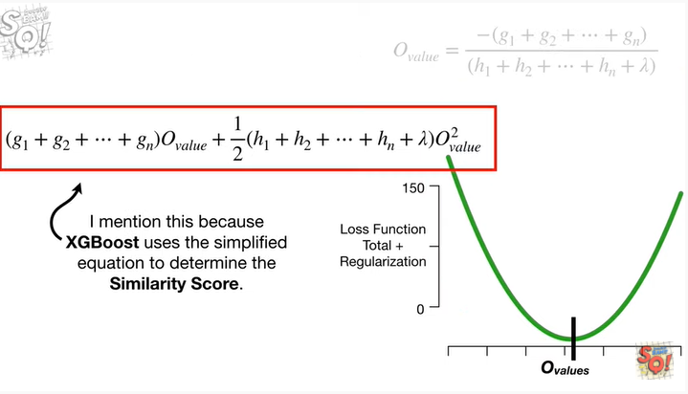

I mention this because XGBoost uses the simplified equation to determine the similarity score.

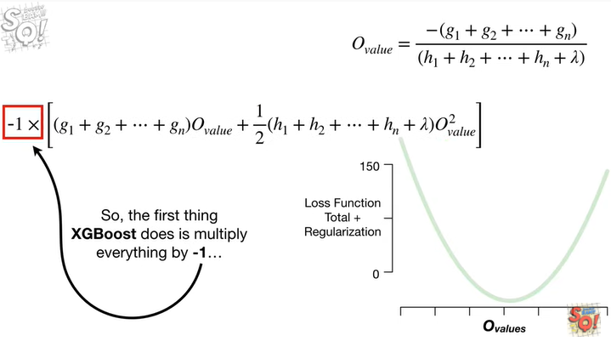

So, the first thing XGBoost does is multiply everything by negative one

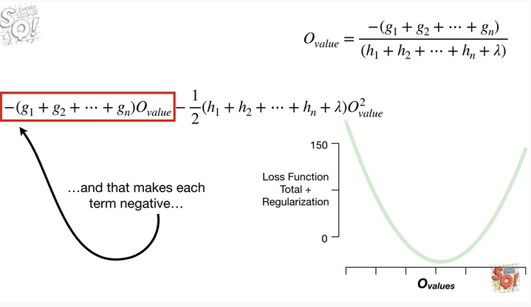

and that makes each term negative

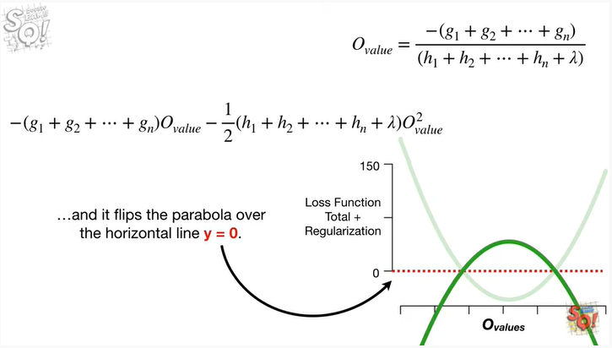

and it flips the parabola over the horizontal line y equals zero.

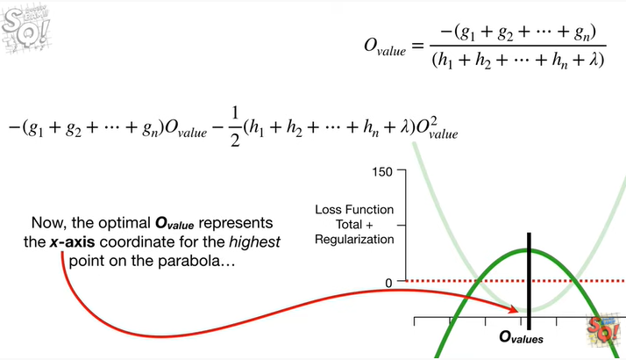

Now, the optimal output value represents the X access coordinate for the highest point on the parabola

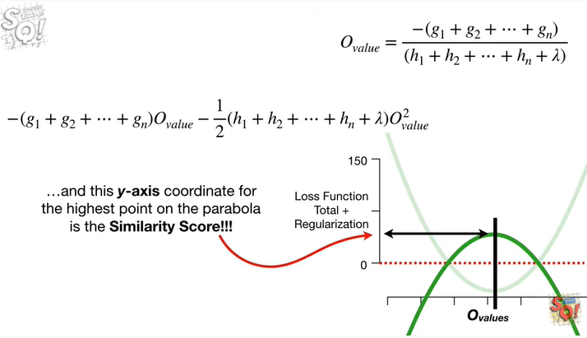

and this y-axis coordinate for the highest point on the parabola is the similarity score !

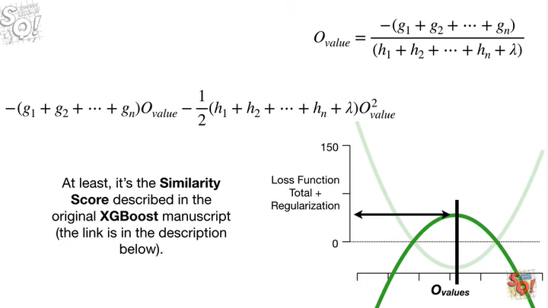

At least, it's the similarity score described in the original XGBoost manuscript (this link is in the description below).

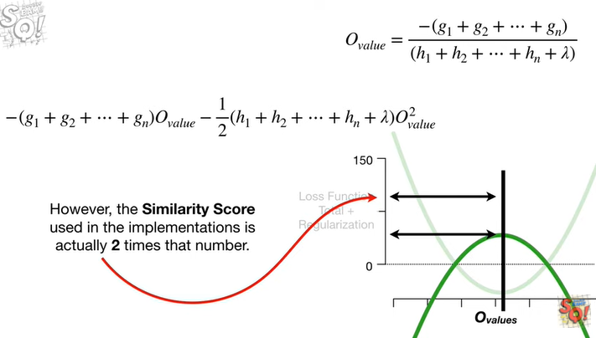

However, the similarity score used in the implementations is actually two times that number.

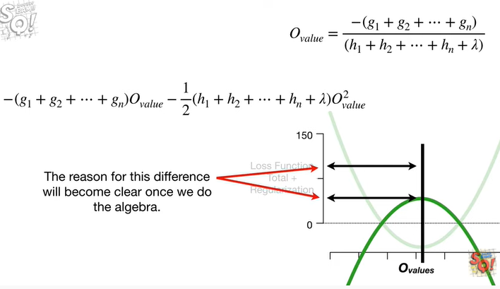

The reason for this difference will become clear once we do the algebra.

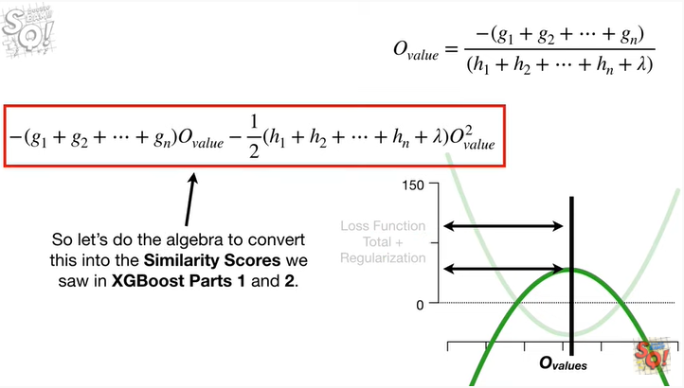

So let's do the algebra to convert this into the similarity scores we saw an XGBoost parts 1 & 2.

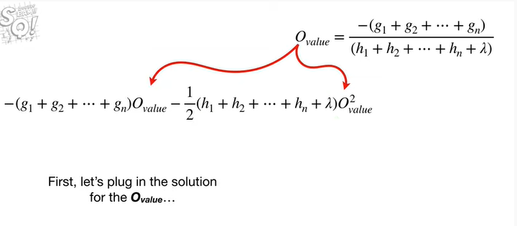

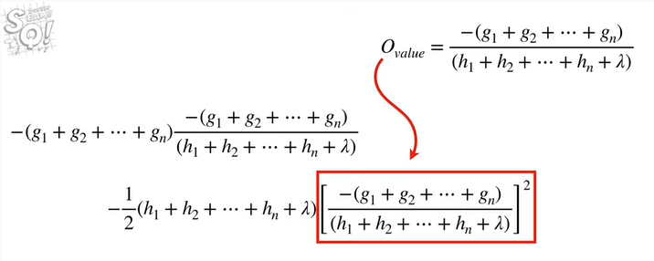

First let's plug in the solution for the output value

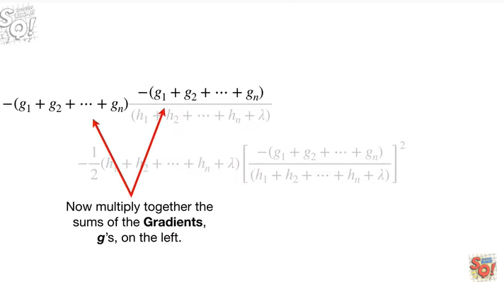

Now multiply together the sums of the gradients g's, on the Left.

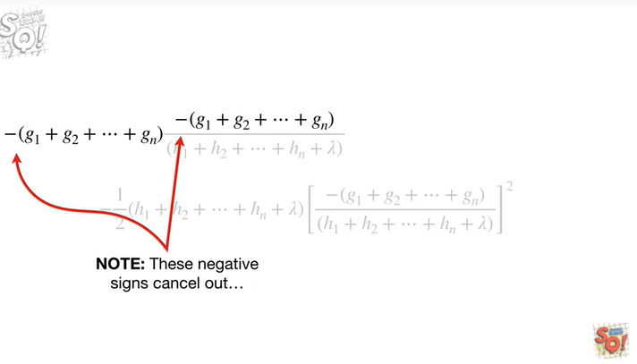

Note : these negative signs cancel out

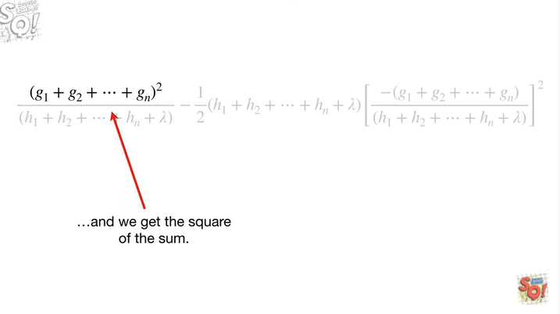

and we get the square of the sum.

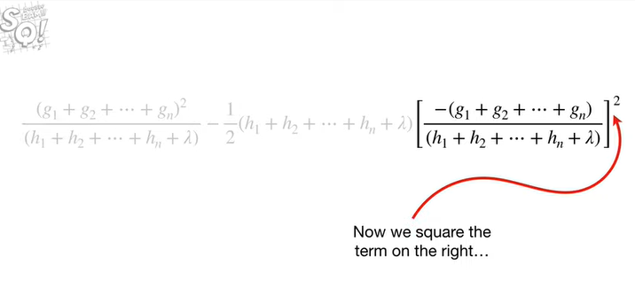

Now we square the term on the right

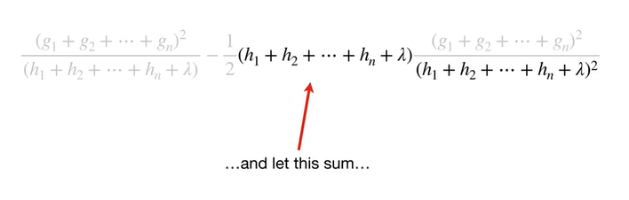

and let this sum

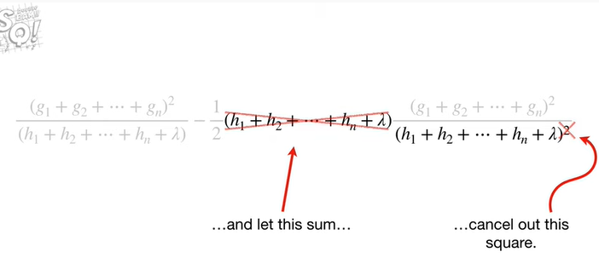

cancel out this square

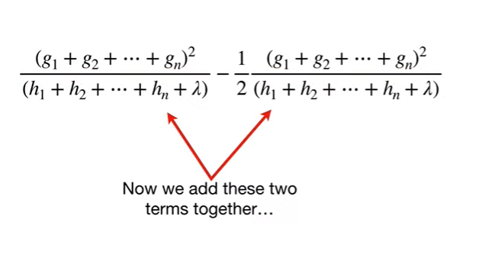

now we add these two terms together

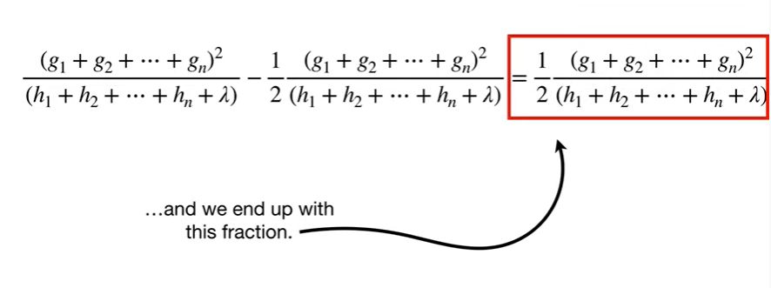

and we end up with this fraction.

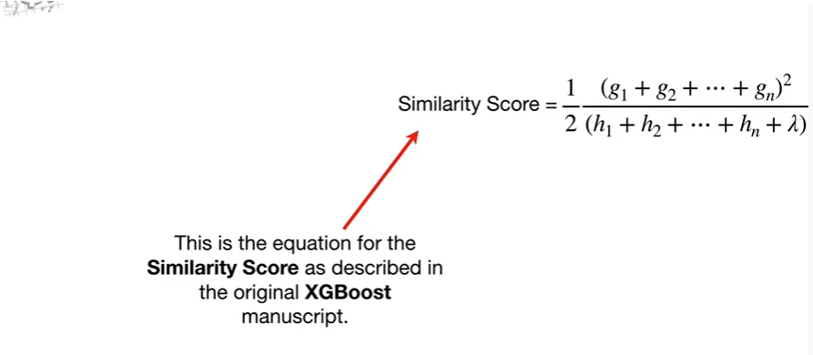

This is the equation for the similarity score as described in the original XGBoost manuscript.

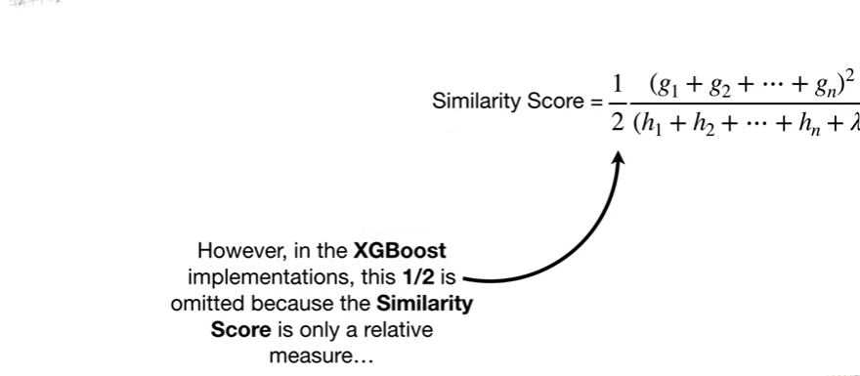

However, in the XGBoost implementations, this 1/2 is omitted because the similarity score is only a relative measure

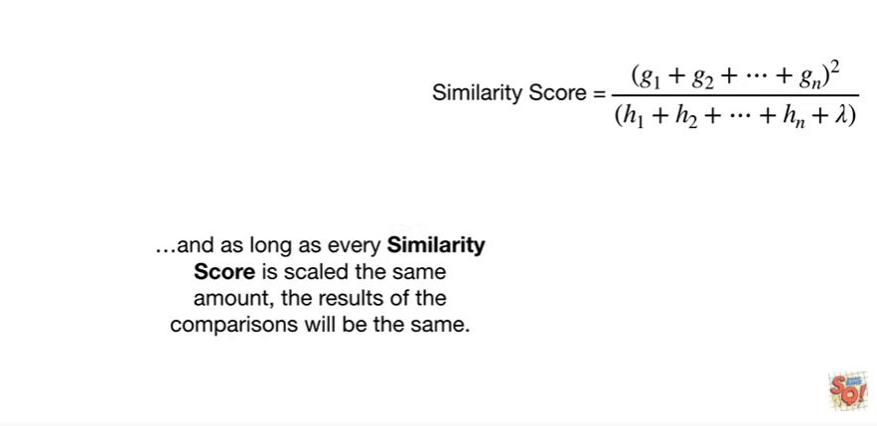

and as long as every similarity score is scaled the same amount, the results of the comparisons will be the same.

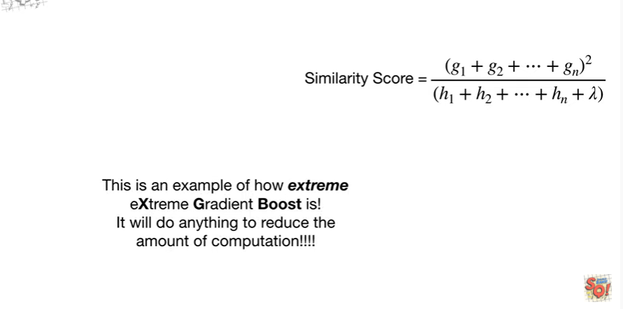

This is an example of how extreme extreme gradient boost is !

It will do anything to reduce the amount of computation !!!!

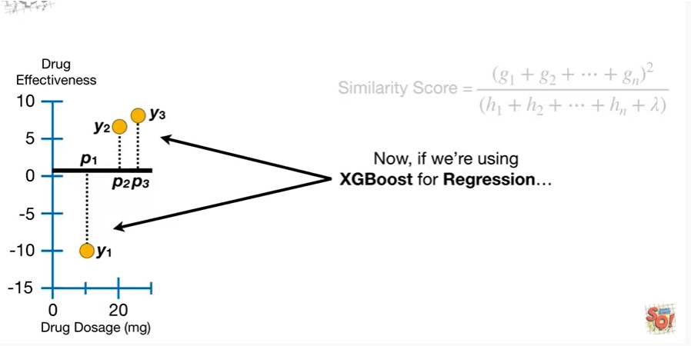

Now if we're using XGBoost for regression

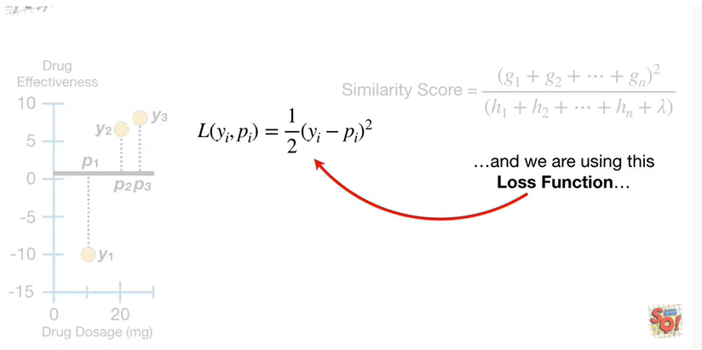

and we're using this loss function

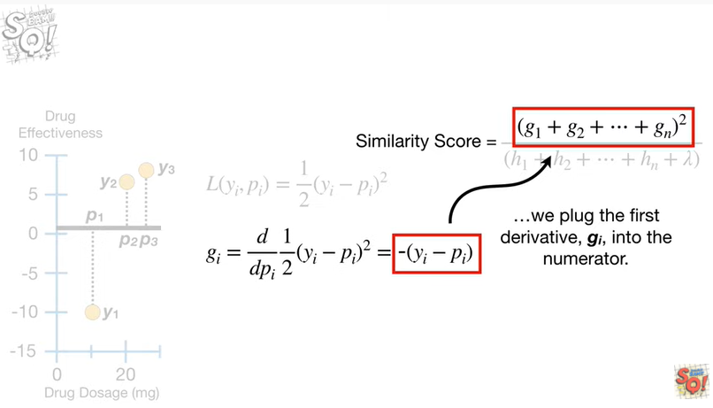

we plug the first derivative, g sub i, into the numerator.

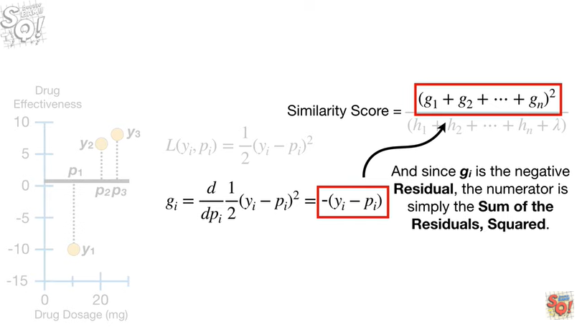

And since g sub I is the negative residual, the numerator is simply the sum of the residuals, squared.

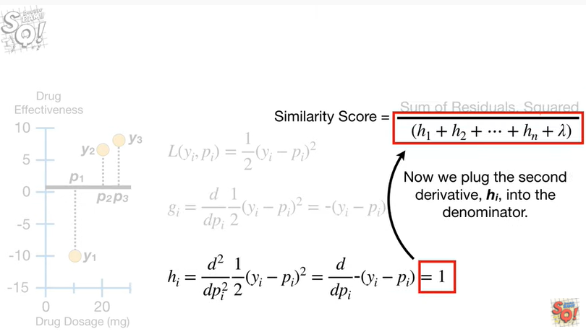

Now we plug the second derivative, h sub i, into the denominator.

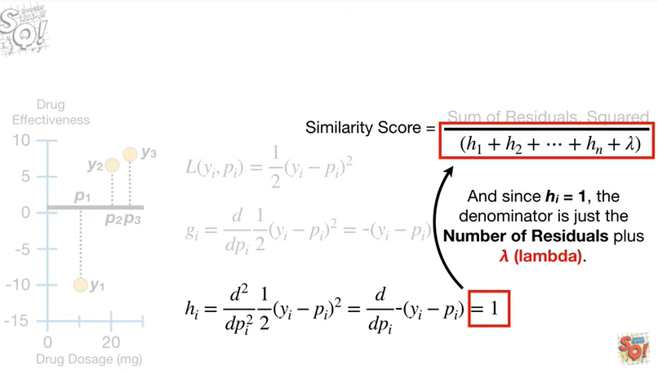

And since h sub i equals 1, the denominator is just the number of residuals plus lambda.

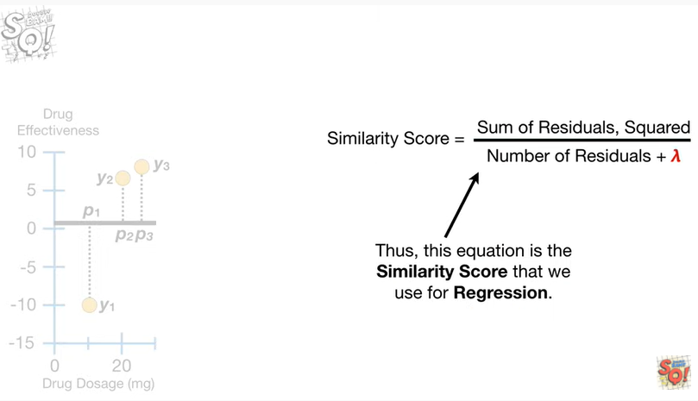

Thus this equation is the similarity score that we use for regression.

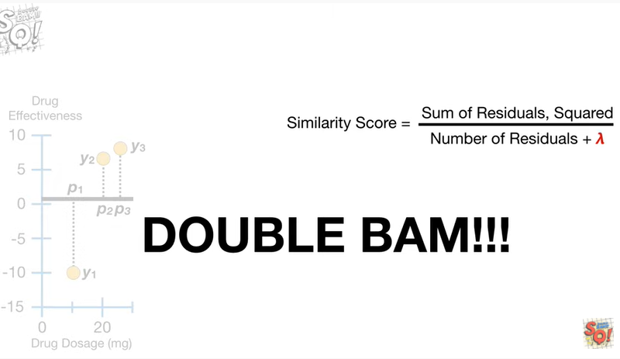

Double bam !!!

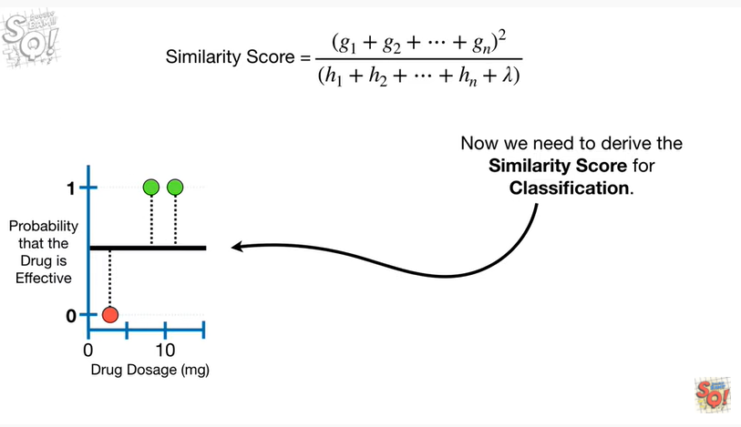

Now we need to derive the similarity score for classification.

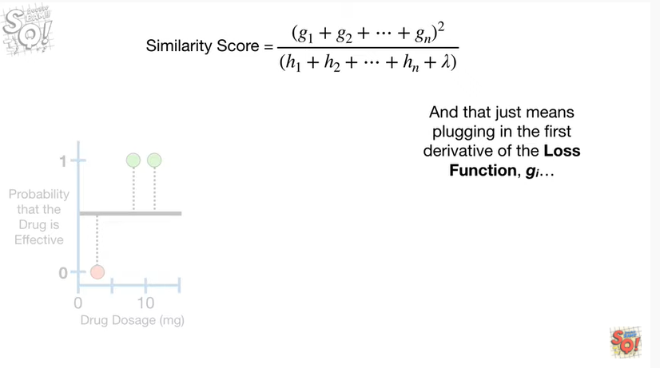

And that just means plugging in the first derivative for the loss function g sub i

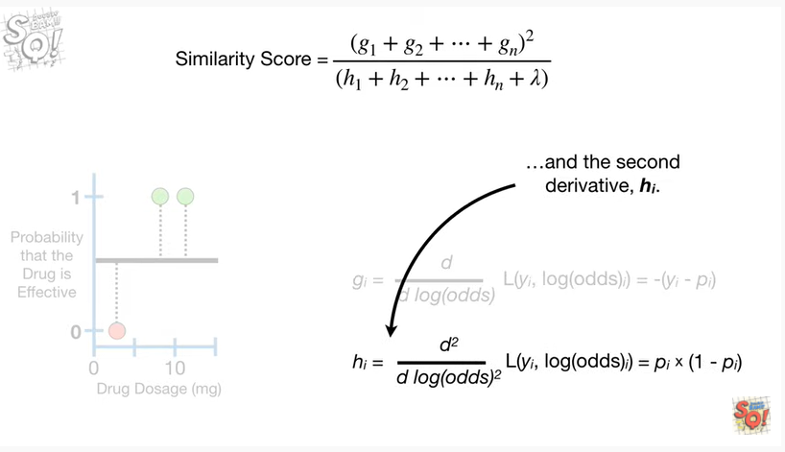

and the second derivative h sub i.

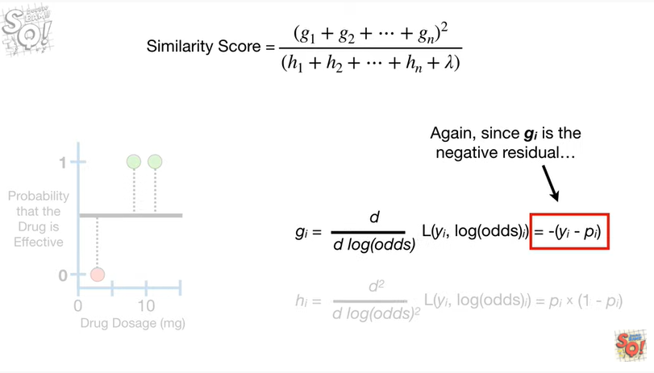

Again, since g sub i is the negative residual

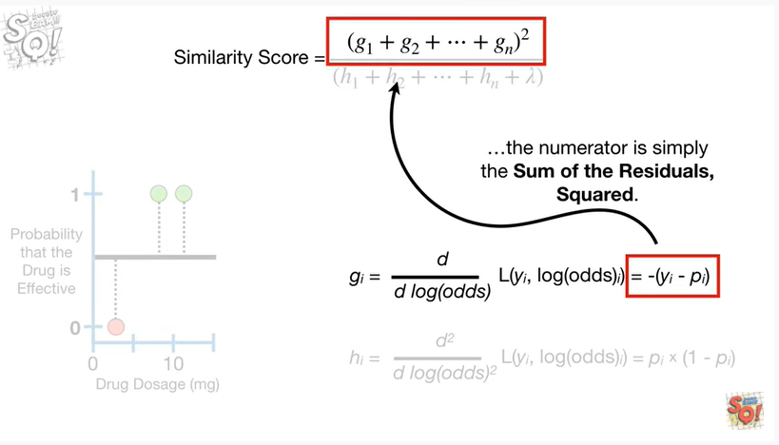

the numerator is simply the sum of the residuals squared.

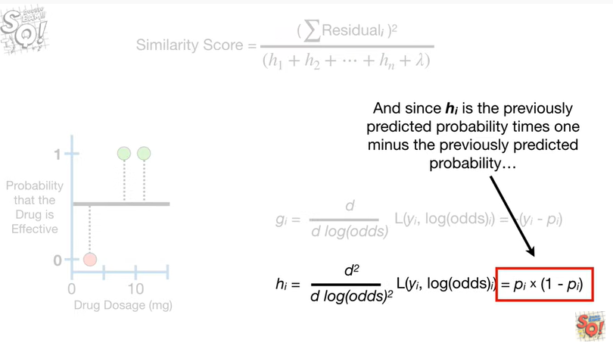

And since h sub i is the previously predicted probability times 1 minus the previously predicted probability

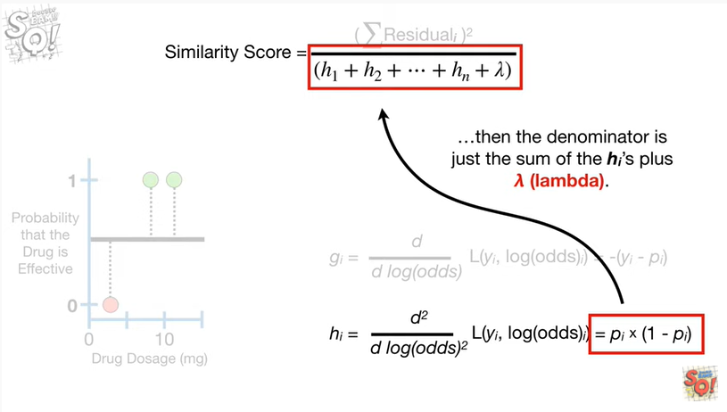

then the denominator is just the sum of the H sub i's plus lambda.

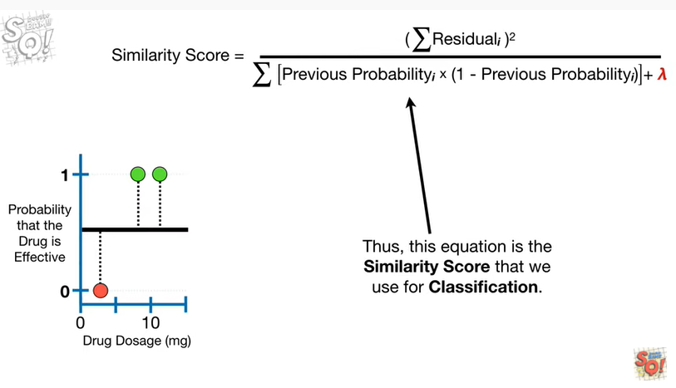

Thus, this equation is the similarity score that we use for classification.

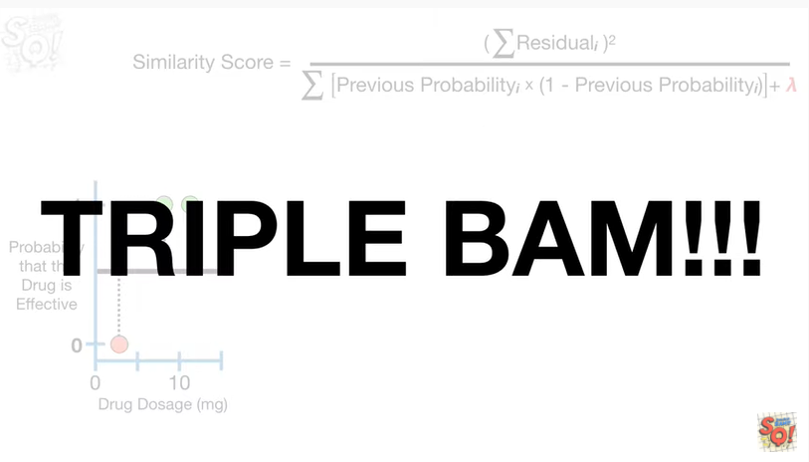

Triple bam !!!



Now for one little annoying detail.



In part two of this series, we talked about cover.

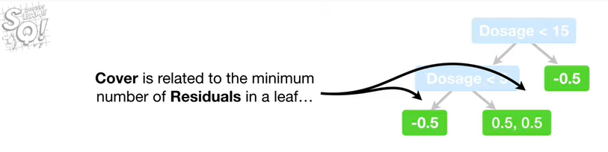

Cover is related to the minimum number of residuals in a leaf

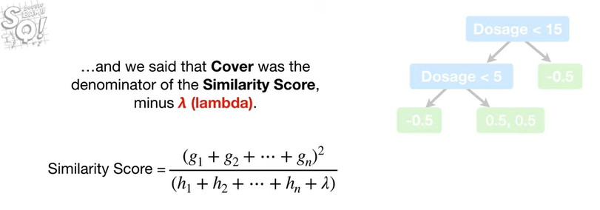

and we said that cover was the denominator of the similarity score minus lambda.

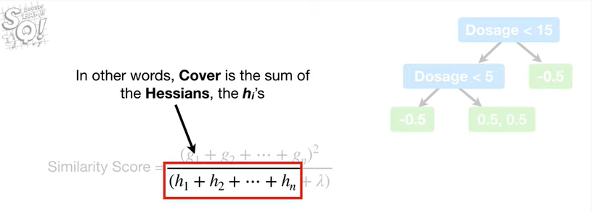

In other words, cover is the sum of the Hessians the h sub i's.

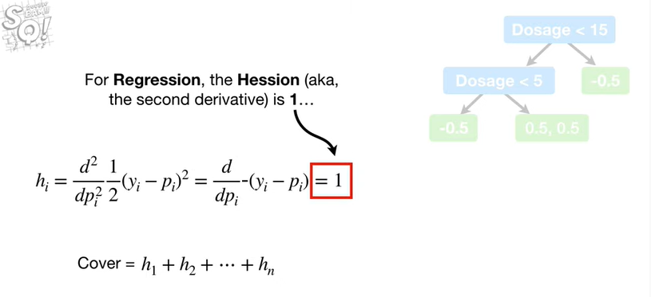

For regression, the hessian AKA the second derivative of the loss function is 1

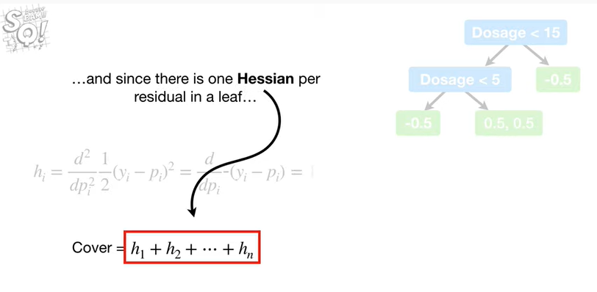

and since there is one hessian per residual in a leaf

Cover for regression is simply the number of residuals in a leaf.

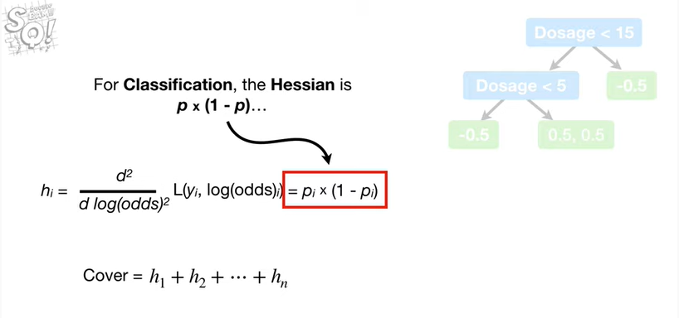

For classification, the hessian is P times 1 minus P

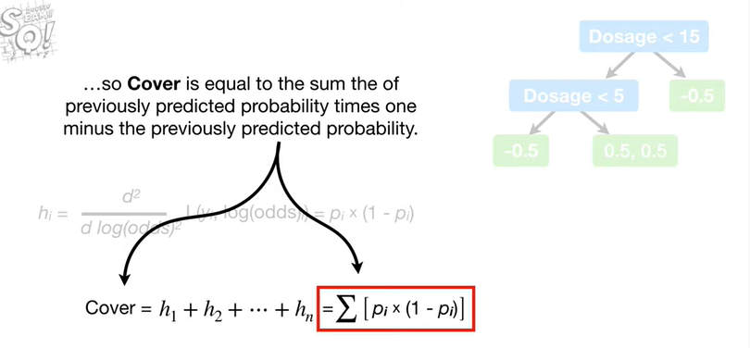

so cover is equal to the sum of the previously predicted probability times 1 minus the previously predicted probability.

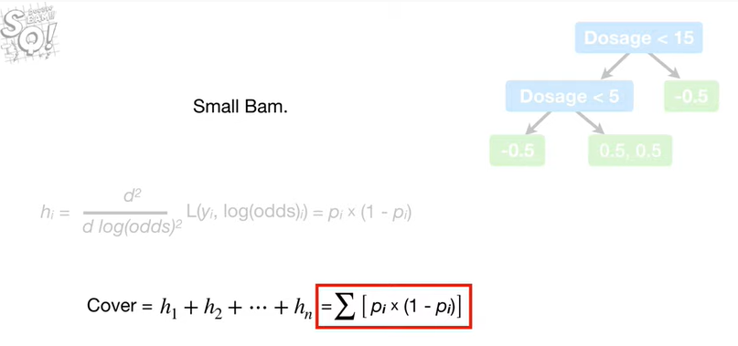

Small bam.



In summary :

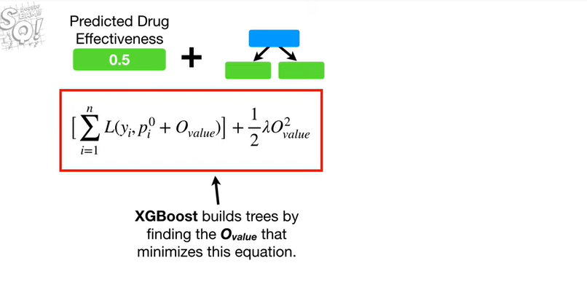

XGBoost builds trees by finding the output value that minimizes this equation.

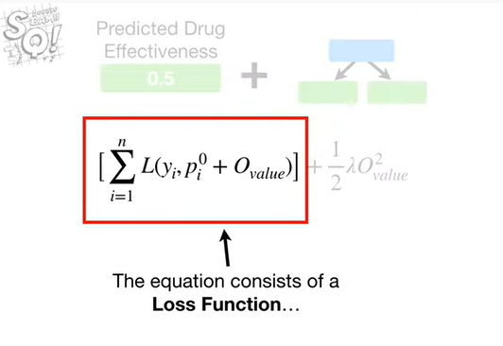

The equation consists of a loss function

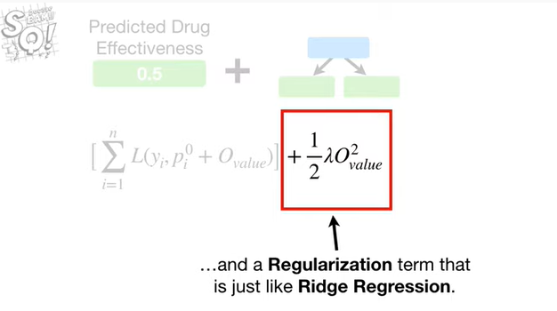

and a regularization term that is just like Ridge regression.

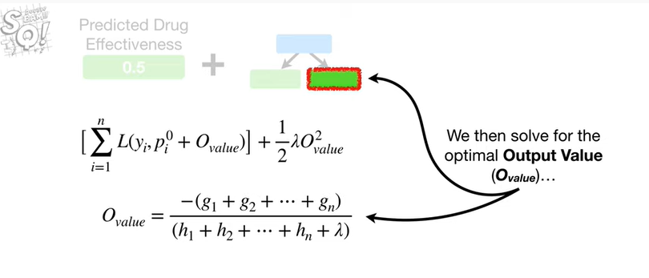

We then solve for the optimal output value

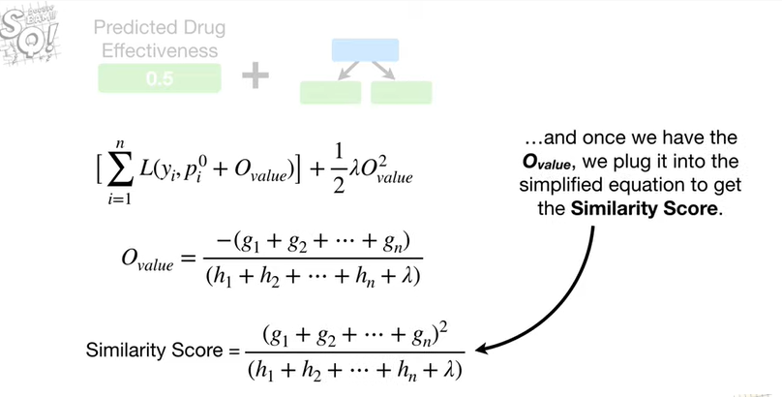

and once we have the output value we plug it into the simplified equation to get the similarity score.

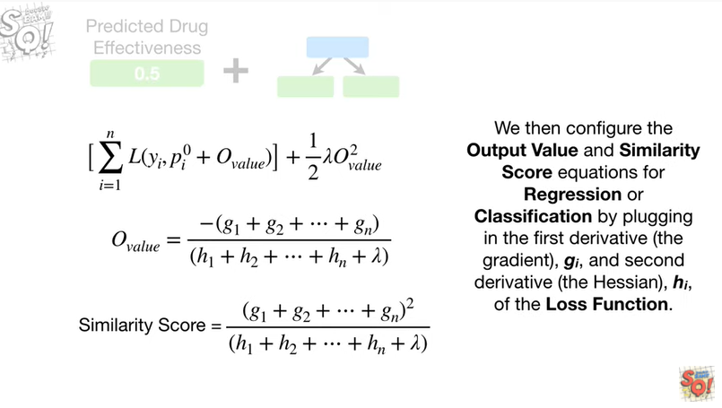

We then configure the output value and similarity score equations for regression or classification by plugging in the first derivative g sub i and the second derivative h sub i of the loss function.

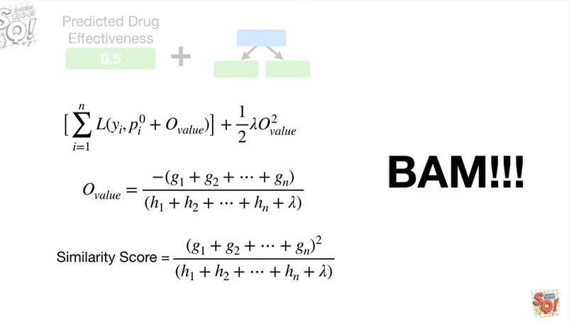

BAM !!!